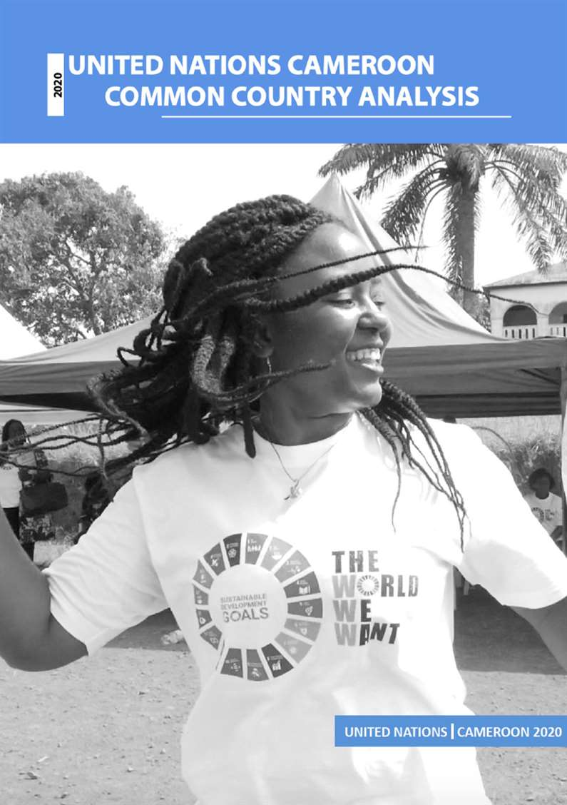

Contents

Contents 3
Acronyms 5
Executive Summary 9
1. Country Context 13
2. National vision for sustainable development 46
3. Country Progress Towards the 2030 Agenda 56
4. Leave No One Behind 67
5. Commitments under international norms and standards 76
6. Cross-boundary, regional and subregional perspectives 86
7. Financing landscape and opportunities 94
8. Analysis of risks 99
9. Gaps and challenges towards achieving the 2030 Agenda 1
References 7
Annexes 9

Acronyms

AfCFTA | African Continental Free Trade Area
ACNPD | National Civic Agency for Participation in Development
AFD | Agence Française de Développement
ART | Antiretroviral therapy
ARV | Antiretroviral
AU | African Union
BEAC | Bank of Central African States
CADH | Commission nationale des droits de l'Homme et des peuples
CAR | Central African Republic
CEA | Economic Commission for Africa
CEA, STEPS | Economic Commission for Africa, Structural Transformation, Employment, Production and the Society
CEDAW | Convention on the Elimination of All Forms of Discrimination Against Women
CEMAC | Economic and Monetary Community of Central Africa
CFSVA | Comprehensive Food Security and Vulnerability Analysis
CHRC | Cameroon Human Rights Commission
CMPJ | Multifunctional Centres for the Promotion of Youth
CNJC | National Youth Council of Cameroon
CNPBM | National Commission for the Promotion of Bilingualism and Multiculturalism
CNPS | National Social Welfare Fund
CNPS | Caisse Nationale de Prévoyance Sociale
CoHA | Cost of Hunger in Africa
CONAC | National Anti-Corruption Commission
CONAJEP | National Committee for Youth and Popular Education
COP | Conference of Parties
COVID-19 | Coronavirus Disease-19
CPDM | Cameroonian People’s Democratic Movement
CSO | Civil Society Organisation
CTD | Decentralised Territorial Collectivities
DHIS | National Health Information Systems
DHS | Demographic and Health Survey
DISJEV | Department of Youth Social Integration and Volunteerism
DPC | Directorate of Civil Protection
DRC | Democratic Republic of Congo
DSCE | Strategy Document for Growth and Employment
DSSEF | Document de Stratégie du Secteur de l’Education et de la Formation
DTP | Diphteria-tetanus-pertussis
EC | European Commission
ECA | Economic Commission of Africa
ECAM | Cameroonian Household Survey
ECCAS | Economic Community of Central African States
EDS | Enquête Démographique et de Santé
EDS MICS | Enquête Démographique et de Santé et à Indicateurs Multiples - Multiple Indicator Cluster Survey
ISWAP | Islamic State in West Africa
EIS | Environmental Impact Assessment
EMIS | Education Management Information System
EPA | Economic Partnership Agreement
ESIA | Environment and Social Impact Assessment - World Bank
ESU | Education in Emergencies
EU | European Union
FAO | Food and Agriculture Organization of the United Nations
FDI | Foreign direct investment
FEICOM | Special Council Support Fund
FPT | Fonction publique territoriale
FTP | Financial and Technical Partners
GCRI | Global Conflict Risk Index
GDN | Major National Dialogue
GDP | Gross Domestic Product
GHG | Greenhouse gas
GHI | Global Hunger Index
HDPN | Humanitarian-development-peace nexus
HDR | Human Development Report
HIV/AIDS | Human Immunodeficiency Virus / Acquired Immune Deficiency Syndrome
HSS | Health Sector Strategy
ICCPR | International Covenant on Civil and Political Rights
ICZM | Integrated Coastal Zone Management
IDP | Internally Displaced Persons
IED | Improvised Explosive Device
IHR | International Health Regulations
ILO | International Labour Organization (United Nations)
IMF | International Monetary Fund
INFORM | Index For Risk Management
INS | Institut National de la Statisitique
IOM | International Organization for Migration
IPCC | Intergovernmental Panel on Climate Change
IPU | Informal Production Units
JMP | UNICEF/WHO Joint Monitoring Programme
LGBTI | Lesbian Gay Bisexual Transgender and Intersex
LNOB | Leave No One Behind
M&E | Monitoring and evaluation
MDG | Millennium Development Goal
MICS | Multiple Indicator Cluster Survey
MINADER | Ministry of Agriculture and Rural Development
MINAT | Ministry of Territorial Administration
MINDDEVEL | Ministry of Decentralisation and Local Development
MINEF | Ministry of Forestry and Wildlife
MINEP | Ministry of Environment and Nature Protection
MINEPAT | Ministry of the Economy, Planning and Regional Development
MINEPDED | Ministry of Environment, Nature Protection and Sustainable Development
MINEPIA | Ministry of Livestock, Fishery and Animal Husbandry
MINFI | Ministry of Finance
MINHDU | Ministry of Housing and Urban Development
MINJEC | Ministry of Youth and Civic Education
MTEF | Mid-Term Expenditure Framework
NCCAPC | National Climate Change Adaptation Plan for Cameroon
NDDRC | National Disarmament, Demobilization and Reintegration Committee
NDP | National Development Plan
NGO | Non-Governmental Organisation
NGP | National Gender Policy
NHDR | National Human Development Report
NIC | Newly Industrialised Country
NPM | National Mechanism for the Prevention of Torture
NW/SW | Northwest / Southwest regions
NYO | National Youth Observatory
OCEAC | Organisation de Coordination pour la lutte contre les Endémies en Afrique Centrale
OCHA | UN Office for the Coordination of Humanitarian Affairs
OECD-DAC | Organisation for Economic Cooperation and Development - Development Assistance Committee
ONR | National Risk Observatory
PAJER-U | Programme of Support for Rural and Urban Youth
PANEJ | National Youth Employment Pact
PARI-Jedi | Return and Integration Assistance Programme for the Youth of the Diaspora
PES | Price elasticity of supply
PIAASI | Integrated Projects to Support Youth Entrepreneurship and Socio-Economic Integration
PIFMAS | Project for the Socio-Economic Insertion of Young People through the Creation of Microenterprises for the Manufacture of Sports Equipment
PLAVOLCAM | Platform of Actors working in volunteerism in Cameroon
PLHIV | Person living with HIV
PNA | National Literacy Programme
PNGC | National Programme for Disaster Prevention and Management
PNPS | National Social Protection Policy
PNUD | United Nations Development Programme
PPBS | Cameroon Planning, Programming, Budgeting and Monitoring
PPJC | Platform for the Promotion of Cameroonian Youth
PPSAC | Projet Prévention VIH/Sida en Afrique Centrale
PRO-ACTP | Programme of Support for the Technological and Professional Component of Higher Education
PRSP | Poverty Reduction Strategy Paper
PVID | Invalidity and Death Pension
REDD | Reducing Emissions from Deforestation and Forest Degradation
RGPH | General Population and Housing Census
RNDH | National Human Development Report
RPC | Recovery and Peace Consolidation Strategy
RSF | Reporters Without Borders
SDG | Sustainable Development Goal
SME | Small and Medium-Sized Enterprise
SNDC | Cameroon National Development Strategy
SNePS | National Strategy for the Extension of Social Protection
SNIS | National Statistical Information System
SSC | South-south cooperation
SUN | Scaling Up Nutrition
UDHR | Universal Declaration of Human Rights
UN | United Nations
UNAIDS | Joint United Nations Programme on HIV/AIDS
UNCAC | United Nations Convention against Corruption
UNCHRD | United Centre For Human Rights and Democracy
UNCT | United Nations Country Team
UNCTAD | United Nations Conference on Trade and Development
UNDAF | United Nations Development Assistance Framework
UNDP | United Nations Development Programme
UNEP | United Nations Environment Programme
UNESCO | United Nations Educational, Scientific and Cultural Organization
UNFCCC | United Nations Framework Convention on Climate Change
UNFPA | United Nations Populations Fund
UN-Habitat | United Nations Human Settlements Programme
UNHCR | United Nations High Commissioner for Refugees
UNS | United Nations System
UNSDCF | United Nations Sustainable Development Cooperation Framework
UNV | United Nations Volunteers
UPR | Universal Periodic Review
VIO | Volunteer-Involving Organizations
VNR | Voluntary National Review
VSE | Very Small Enterprises
WASH | Water, Sanitation and Hygiene
WFP | World Food Programme
WHO | World Health Organisation
XAF | Central African CFA Franc

Executive Summary

The Common Country Analysis (CCA) is an independent, impartial and collective analysis of the sustainable development context in Cameroon. The CCA examines the progress, gaps and opportunities vis-à-vis Cameroon’s commitment to achieving the 2030 Agenda, African Union 2063 Agenda, UN norms and standards, and the principles of the UN Charter. Undertaken by the United Nations Country Team in Cameroon in a participatory approach and enriched through multi-stakeholder consultations, the CCA serves to inform the development of the United Nations Sustainable Development Cooperation Framework 2022-2026 that will guide the cooperation between the Government of Cameroon and the UN system until 2026.

The Analysis was conducted during the global pandemic of Coronavirus disease 2019 (COVID-19), which is placing economic, health, education, housing, food security and other critical sectors under enormous capacity and resource strains. Current forecasts estimate that COVID-19 will reduce Cameroon´s Gross Domestic Product (GDP) growth to –1.2% due to, among others, declining global and domestic demand, and import-dependent supply. While the pandemic is a major challenge, it also offers unique opportunities for Cameroon to build back better by fostering people centrered interventions, promoting clean and green transitions, accelerating the digital transformation and economic diversification, creating green jobs, building resilient economies and fostering sustainable growth.

The Cameroon CCA arrives at four multi-sectoral and interlinked recommendations:

- Transform the economy to achieve inclusive and sustainable growth;
- Promote comprehensive investments in quality and inclusive human development to counter long-term impacts of the ongoing crises;
- Prioritise conflict resolution and peacebuilding, and strengthen democratic governance processes and protection of human rights;
- Continue the good progress on climate change action and invest in sustainable management of natural resources.

Economic transformation
Cameroon´s commitment to become a newly industrialised country is enshrined in its Vision 2035. In 2020, the country started implementing the second phase of its Vision, with a fully SDG-aligned National Development Strategy. The 2020-2030 Strategy is structured around four pillars: 1) Structural transformation; 2) Human development; 3) Employment policy; and 4) Governance and strategic management of the State. The promotion of youth and gender equality are identified as national priorities. Initiatives to combat inequality, corruption and promote accountability are central to the strategy.

While Cameroon´s GDP has been growing at around 3% per year during the past two decades, the growth rate is below the 5.5% envisioned in the National Development Strategy and insufficient to realise Cameroon´s aspiration of becoming an industrialized, upper-middle income country by 2035. Cameroon´s economic progress has also not translated into poverty reduction; in fact, between 2007 and 2014 the number of poor people increased by over 13% and the poverty rate reached 37.5% nationally, with regional peaks of over 70%. Growing inequalities are also a rising challenge. The main challenges impeding Cameroon’s growth include i. weak industrialisation, ii. unfavourable business environment climate, iii. limited performance of public corporations and iv. disruptions in production and trade due to the on-going insecurity affecting several regions of the country. Achieving Agenda 2030 and 2063 will require a drastic economic transformation, despite Cameroon’s potential for harnessing its demographic dividend and the country´s abundant natural resources. 90% of Cameroon´s labour market is informal and most of the working-age population is self-employed. The secondary (industry) and tertiary sectors (services) employ barely 9% and 29% of the labour force respectively. The primary sector (mostly agriculture) still employs 62% of the labour force, including 80% of women. Unless the structure of the labour market changes, Cameroon could remain in the lower middle-income category for several more decades.

Quality and inclusive human development
Cameroon continues to underachieve in human capital and there are widespread inequalities. The main challenges are acute and chronic food and nutrition insecurity in areas affected by conflict and climate shocks, low access to safe drinking water, inadequate sanitation facilities coupled with poor hygiene practices and insufficient health care. Maternal mortality remains high; malaria is the main cause of mortality (18%), while the prevalence of HIV/AIDS is 2.7% among adults aged 15-49 years. Furthermore, persistent gender inequalities and gender-based violence are still observed throughout all sectors.

Conflict resolution, peacebuilding, democratic governance and protection of human rights
Cameroon is experiencing three simultaneous protracted crises – namely Boko Haram attacks in the Far North, spill over effect from the crisis in the Central African Republic in terms of refugees influx, and an armed insurgency in the Northwest and Southwest regions. These conflicts heighten human rights violations and vulnerabilities, reduce space for civic participation, and have caused large-scale displacement impacting nine out of Cameroon´s ten regions. Cameroon’s path towards decentralisation has remained slow with a highly centralised governance system and a limited transfer of resources to decentralised entities. This situation hampers grassroot capacity to deliver locally on the SDGs, and has caused grievances among the population in the poorest regions of the country. To minimize risks to the attainment of the SDGs, Cameroon must address conflict drivers, such as the lack of employment, insufficient investment in infrastructure and the poor quality of and access to basic services, which contribute to perceptions of marginalisation.

Climate change action and sustainable management of natural resources
Cameroon is experiencing changing and decreasing rainfall patterns, and climate projections show an increase in the frequency and amplitude of floods, rising sea level, storms, mudslides and soil erosion. The country´s greenhouse gas emissions are expected to increase over the next years. Anthropogenic deforestation and degradation are threatening the existence of the Cameroon´s vast and important forests, and subsequently the survival of diverse natural ecosystems and the livelihoods of forest populations. Cameroon must continue its work to combat climate change, and transition to sustainable natural resource management.

Achieving the SDGs requires a concerted effort by all stakeholders in Cameroon, ensuring the country's adherence to its national and international commitments. As a fist priority, efforts to build sustained peace should be stepped up as a prerequisite for development. As the 2019 Global Sustainable Report highlighted, strengthening governance and respect for human rights, including civic participation, is a strong lever towards the 2030 transformation agenda. Second, the most vulnerable must be identified, prioritised and holistically supported to build inclusive societies and leave no one behind and reach the furthest behind first. This requires strengthening of the statistical system to guarantee the availability of high quality, gender disaggregated information on vulnerable populations. Third, sustainability criteria should be strengthened across all national and foreign development investments.

The findings of the CCA underscore Cameroon’s wealth and development potential and identify several entry points to accelerate inclusive and equitable growth and deliver on the Agenda 2030 through the implementation of the new UNSDCF 2022-2026. It will guide the work of the United Nations in Cameroon and its Cooperation Framework in support of the Government of Cameroon’s emergence objectives.

Cameroon is a country of great wealth and fantastic potential. The United Nations in Cameroon remain committed alongside the Government to support transformation and, in this particular time when development is challenged, accelerate on the delivery of Agenda 2030 and the Africa We Want Agenda.


Signed by:

Allegra Maria Del Pilar Baiocchi
United Nations Cameroon
Resident Coordinator
Humanitarian Coordinator

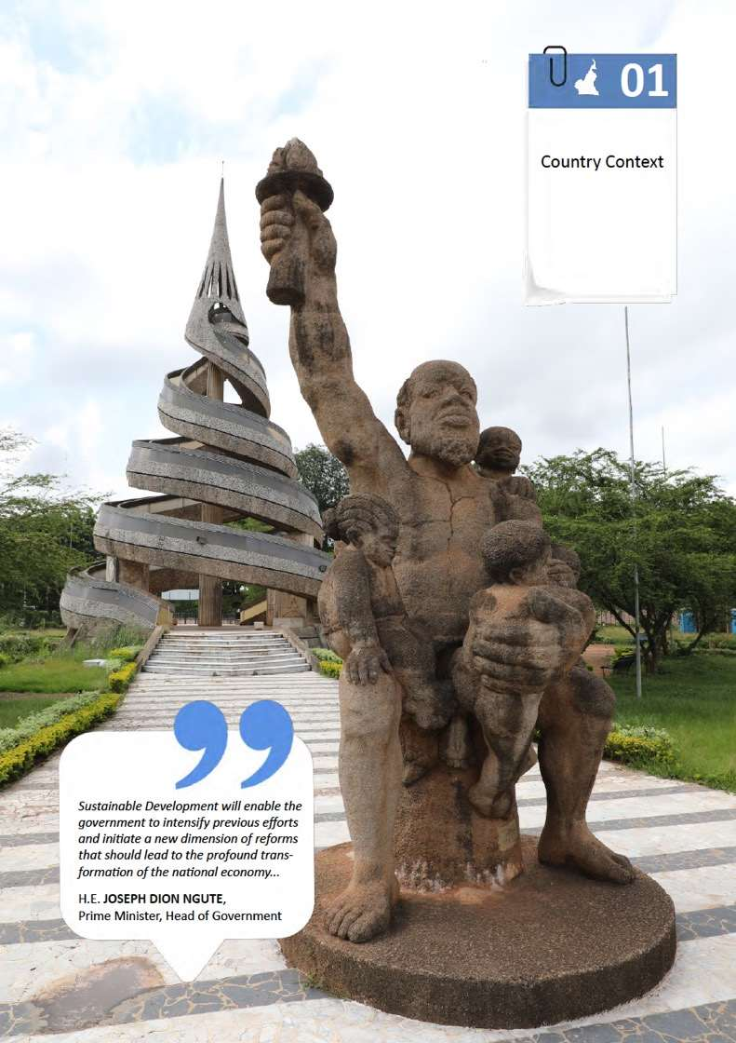

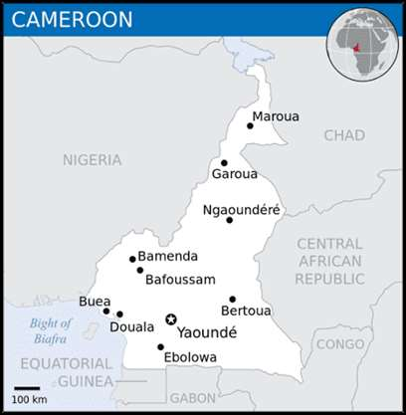
Country Context

Political Situation and Trends

Political situation and conflict trends
The aftermath of the 2018 presidential elections and the lingering conflict in the Northwest and Southwest regions contribute to a tense political environment in Cameroon. In October 2018, President Paul Biya was re-elected as Head of State. However, the electoral campaign was marked by violent speeches, and the campaign to contest the results launched by the Cameroon Renaissance Movement (MRC), the candidate of which came in second place, led to numerous arrests in January 2019, including that of its leader Maurice Kamto. After the Major National Dialogue, organised in Yaoundé in September - October 2019, the President of the Republic ordered to stop the prosecution and to release Mr Kamto, as well as 102 other members of his party.
These political tensions coincided with ongoing security crises in the country. Cameroon is experiencing three successive and juxtaposed crises on its territory: 1) increased Boko Haram attacks in the Far North region; 2) a spillover effect from the crisis in the Central African Republic in the North, Adamawa and East regions; and 3) the conflict in the Northwest and Southwest regions where non-state armed groups with separatist demands oppose the Government. At the core lie governance challenges in an inherently plural society. Main conflict drivers include:
- Governance systems, including grievances related to the distribution, access and quality of public services;
- Perceptions of political marginalisation and unequitable access to power particularly among elites from the Northwest and Southwest regions;
- Competition over natural resources.
These different crises have shaken the Cameroonian social fabric in recent years, deepening inter-community divides, and led to an increase in human rights violations and abuses, preventing development to make progress. The Major National Dialogue recommended measures to address the situation, i.e. laws on bilingualism, decentralisation and the amendment of the Penal Code provisions on tribalism, which were adopted by the National Assembly. However, preserving the ancestral “vivre ensemble” will hinge on addressing conflict drivers and empowering conflict transformation agents. Furthermore, lingering hindrances to governance as well as individual and collective action undermine the attainment of sustainable development goals.

Women, Peace and Security
The United Nations Security Council Resolution 1325 (SCR1325) recognised the unique impact of armed conflict on women and girls. It acknowledged the contributions women make to conflict prevention, peacekeeping, conflict resolution and peacebuilding, and highlighted the importance of their equal and full participation as active agents in peace and security. Upon its adoption in 2000, SCR 1325 highlights the important role women play in the process of peacebuilding and consolidation, and urges member states to increase women’s representation at all levels of decision-making within national, regional and international institutions, as well as within mechanisms put in place to prevent, manage and resolve conflicts. Women’s limited presence in decision-making at all levels is frequently subject to setbacks, and women remain significantly under-represented at the highest levels of global peacekeeping. Ten percent of the UN police forces and less than three percent of signatories to peace agreements are women. To bridge the existing gap regarding direct involvement of women in conflict management, it is urgent to help women acquire training in conflict mediation.
In Cameroon, the current crisis context that is reigning in the East, Far North, Southwest and Northwest regions clearly shows the urgent need to further involve women in the process of peacebuilding and restoration, from the grassroots to the national level. Peace challenges are compounded by profound gender equality challenges. In Cameroon, the participation of women in decision-making positions remains weak, with a significant difference between the national and the local levels.

Effectiveness and inclusiveness of institutions
Institutions play a key role in the planning, financing and implementation of the SDGs. In Cameroon, the perceived inequality in the distribution and the delivery capacity of public goods coupled with centralised decision-making processes is a common grievance across conflict situations.
Despite an average GDP growth of 4.3 percent between 2013 and 2019, 55.3% of the population live in multidimensional poverty, with 37.7% in severe multidimensional poverty. Outside urban areas, access to and the quality of public services is limited. Furthermore, the 2019 National Human Development Report (NHDR) highlights significant regional disparities, with the Far North, North, Northwest, and Adamawa regions having poverty rates above the national average. Given the unavailability or poor quality of public goods and services, individuals turn to the private sector for health, education, and other services. The 2019 NHDR report attributes this situation to multiple factors, including the inadequate alignment of public expenditures with development priorities, and the weak safety nets for poorer households.
Furthermore, the responsiveness of local public policies remains hampered by challenges affecting the decentralisation process. Decentralisation was introduced in the 1972 Constitution, and regions were instituted in the 1996 Constitution. However, the regions and the various laws on decentralisation passed since 1996 were never fully implemented. The main gaps comprised the transfer of resources and the limited capacity strengthening offered to decentralised entities. The outbreak of violence in the Northwest and Southwest regions highlighted the need for more responsive local governments. In December 2019, Cameroon adopted a new General Code of Regional and Local Authorities. The code provides for the transfer of competencies to municipalities and regions. Also, the portion of state revenue allocated to them as general decentralisation grants may not be less than 15%. With regard to the Northwest and Southwest regions, the code institutes a special status, in accordance with the recommendations of the Major National Dialogue. In addition to the common jurisdictions of all regions, those of the Northwest and Southwest will be able to participate in: (i) the development of national public policies relating to the English-speaking education and justice subsystem, in accordance with the Common Law subsystem, (ii) the creation and management of regional development missions, and (iii) the status of the traditional chiefdom. Finally, the law establishes an ombudsman appointed by the President of the Republic, to hear the citizens’ grievances. It is too early to determine the extent to which the new decentralisation framework will be implemented. Interestingly, the conflict in the Northwest and Southwest creates a political incentive to show progress. Moreover, decentralisation and local development remain a priority in the country's emerging policy for 2035.
The organisation of the February 2020 local and municipal elections paved the way for the implementation of the new decentralisation code. Provided that the COVID-19 pandemic does not disrupt the holding of the regional elections, the newly elected municipal councils are scheduled to elect the members of the regional councils in 2020. Despite this progress, the 2020 elections illustrated challenges affecting many public institutions: (i) a relatively low voter turnout and a small number of registered voters; (ii) the absence of real consultations at the national level; (iii) provisions of the Electoral Code were contested by the opposition and recommended for revision by international missions, such as the electoral age (20 years), the voting system (first-past-the-post majority), and the multiple ballots.
Following the annulment of results in 11 constituencies in the Northwest and Southwest regions, rerun elections were organised on 22 March. The last senatorial elections (indirect elections) were organised on 25 March 2018. The next presidential, legislative, and municipal elections will take place in 2025, while regional elections are expected to take place in 2020.
The 2020 elections saw a greater participation of women and youths compared to the 2013 elections. Women's participation in political life is improving, but it is still far from an equal representation. In the February 2020 twin municipal and legislative elections, the number of women elected at the national assembly grew from 58 to 61 out of 180 parliamentarians (to 34%). Women constitute only 24% of municipal councils, and only 11 councils out of 360 are headed by women (9%). At the senate, women represent 26% of senators.
A positive development has been observed regarding the political participation of indigenous peoples. The Electoral Code article 151(3) requires political parties to consider "the different sociological components of the constituency concerned" in the composition of each list of candidates. Consequently, the participation of indigenous communities in elections, both as voters and candidates, could increase.

Transparency of institutions
The governance and corruption issues that have been relevant in Cameroon in recent decades remain a concern for the country's emergence by 2035. Corruption undermines people's access to quality public services, which are considered a right. Corruption prevents the satisfaction of people's basic needs in terms of health, education, energy, water and various other productive goods and services (land, financial resources), which are essential to the fight against poverty and the achievement of the SDGs.
Furthermore, the low capacity of public services to provide free, complete and accurate information on the services they provide, the absence of planned and measurable objectives for their services, and the absence of minimum quality standards, or standards of performance of their agents negatively affect the overall performance and responsiveness of public services. The lack of a charter of public services, the dysfunction of institutional control mechanisms, and the absence of an independent and local appeal mechanism are the main evils that facilitate the existence and perpetuation of corruption, as payment for supposedly free services renders the delivery of quality services to users ineffective.
Therefore, efforts to curb corruption should also focus on the corruption that affects citizens from all social strata, on the public highway, at markets, at public services such as health, education, energy, water, transport, police, and justice.

Human rights framework in Cameroon
Cameroon has set up statutorily independent state institutions operating in the field of human rights, such as the National Commission on Human Rights and Freedoms (NCHRF). The NCHRF has been reformed by Law No. 2019/014 of 19 July 2019, which includes the integration of the National Mechanism for the Prevention of Torture (NPM) under the Optional Protocol to the Convention against Torture.
The institutional framework includes the Constitutional Council that has been effective since 6 March 2018, and the National Commission for the Promotion of Bilingualism and Multiculturalism (NCPBM). The NCPBM is responsible for promoting bilingualism and multiculturalism in Cameroon as well as maintaining peace, consolidating national unity, and strengthening the will and daily practice of living together. The Ministry of Decentralisation and Local Development (MINDDEVEL) oversees accelerating the decentralisation process and the promotion of local development, addressing the claims of the Northwest and Southwest regions in particular. The Commission for the Compensation of Victims of Abusive Police Custody and Pre-trial Detention in Cameroon also form part of this framework.
The country’s legal arsenal comprises the much-criticised Law No. 2014/028 of 23 December 2014 on the suppression of crimes of terrorism. The law, as well as the Criminal Code adopted in 2016, still uphold the death penalty, especially for terrorism-related offences. The death penalty has been under moratorium for 23 years; the last known execution having taken place in 1997. The need for the relevant provisions in these laws to be repealed remains a priority.
Cameroon was reviewed by the third cycle of the Universal Periodic Review (UPR) in May 2018, and received 196 recommendations, of which 134 were accepted, three were subject to further clarification and 59 were noted. On 20 September 2018, the Human Rights Council considered and adopted the outcome of the review of Cameroon. However, much effort remains to be done to ensure the effective implementation of all the recommendations. In the absence of a dedicated mechanism for the reporting and follow-up of the recommendations, the implementation of the recommendations remains dormant and suffers of a lack of coordination. A project toward a thematic compilation of all the recommendations is scheduled for 2020 with the aim to render them more accessible and to facilitate the adoption of an implementation plan. In 2020, the UNCHRD is also planning to support the NCHRF to devise a plan for the implementation of the 2018 UPR recommendations, which will finclude monitoring and evaluation of the progress.

Civic space and participation
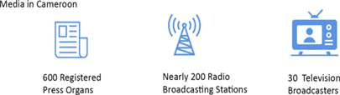
The ability of individuals and interest groups to contribute to the attainment of the SDGs relies upon the quality of civic space and the inclusiveness of decision-making processes. Cameroon hosts a vibrant civil society and domestic laws guarantee the right to freedom of association and peaceful assembly. However, civil society is divided along political lines and has limited influence over political and public policy processes. Civic participation is also limited for many Cameroonians not possessing IDs.

Furthermore, Cameroonian law enshrines the full right and freedom of demonstration subject to conditions of legality, legitimacy and necessity. Meaningful citizen participation requires unrestricted access to information and the freedom of the press. The Cameroonian media landscape is pluralistic, diversified and enjoys a certain editorial independence. The country counts over 600 print media organs registered and appearing at various intervals, nearly 200 broadcasting radio stations (commercial, confessional and community radios), about 30 television stations, 1,541 cable distribution operators, and a considerable number of web-based media. However, the exercise of the freedom of demonstration and press freedom have been severely tested in recent years, particularly in the wake of the political crisis following the 2018 presidential elections.
In 2019, restrictions were imposed on public demonstrations denouncing the management of public affairs and the 2018 election results. Hundreds of civil society activists, as well as politicians and their party members were arrested and referred to military courts as a result of the bans on these peaceful demonstrations. In addition to the arbitrary nature of these arrests, the use of military courts to try civilians under the pretext of disturbances to public order is an obstacle to the exercise of civil liberties.
Media outlets remain marked by the economic precariousness that hinders their ability to express themselves and to freely provide information. The professional shortcomings of some journalists are the cause of failures regularly observed in media content. In the Cameroonian press, there is a recurrence of hate speech or strong identity and tribal hints. In legislation a mechanism has been put into place to regulate these freedoms. These are mainly the Law No. 2010/012 of 21 December 2010 relating to cyber security and cybercrime in Cameroon, as well as the provisions of the penal code against defamation, false news, and recently, tribalism and acts of terrorism.
Moreover, structurally, public access to information remains limited as many do not have access to traditional media, print, radio, television, nor the internet. Public information generated by the government remains largely inaccessible to the private press. In the 2019 World Press Freedom Index by Reporters Without Borders, Cameroon was ranked 131st. i.

Culture and cultural diversity
The respect and promotion of cultural diversity is an integral part of social cohesion and inclusive societies. By definition, it refers to the multiplicity of forms of expression of the cultures of groups and societies. These cultural expressions are transmitted within and between groups and societies, as well as from generation to generation. Cultural diversity manifests itself not only in the many forms through which cultural heritage is expressed, enriched and transmitted, but also through various modes of artistic creation, production, dissemination, distribution and enjoyment, regardless of the technologies and means used. Cultural and creative diversity is an untapped human resource, whose economic potential must be harnessed to unleash growth and the potential of youths in Cameroon. Cultural and creative diversity can contribute to prosperity, to cultural exchange and social justice. Empowering young people through the social and economic opportunities that cultural and creative industries can offer is at the heart of the 2005 Convention on the Protection and Promotion of the Diversity of Cultural Expressions. This includes helping young entrepreneurs gain access to professional training in enhancing artistic and creative skills that can foster more dynamic creative sectors.
Cameroon's rich cultural diversity is reflected in its heterogeneous population, its mix of approximately 240 local languages and just as many customs and traditions. The country has four major cultural groups: the Fang Beti in the South, the Sudano-Sahelian in the North, the Sawa in the Coastal region and the Grassfield in the West. Cultural diversity can be observed through the way of life, intangible cultural heritage, folk festivals, arts and craft, architecture, heritage, religion, and other customs. The historical artefacts, objects, and materials of cultural, religious and historical importance that abound in Cameroon are collected in 31 museums. Two natural properties, Dja Faunal Reserve and Sangha Trinational, are inscribed on the UNESCO World Heritage List and 18 natural and cultural properties are on the Tentative List, constituting important resources for tourism and leisure.
From its preamble, the Cameroon Constitution (18 January 1996) recognises the cultural and linguistic diversity within the unity of the country and Cameroon's Vision 2035 highlights the link between culture and school education, with the promotion of common values and the safeguarding of national identity. Domestic laws guarantee the access to, protection and safeguarding of cultural heritage, both in its tangible and intangible forms, and creativity, including copyrights and neighbouring rights. However, the general regime of obligations of artists' rights still remains fragile. It lacks a law on the status of the artists, as prescribed by the UNESCO recommendation concerning the Status of the Artists (1980), which calls upon Member States to improve the professional, social and economic status of artists though the implementation of policies and measures related to training, social security, employment, income and tax conditions, mobility and freedom of expressions.
Cameroon has ratified most UNESCO conventions in the field of culture, as well as that on access and rights to culture and copyright and neighboring rights. Yet, the ratification of the Second Protocol to the 1954 Hague Convention for the Protection of Cultural Property in the Event of Armed Conflict (UNESCO, 1954) is pending.
The COVID-19 pandemic affects the fundamental right of access to culture, and the social rights of artists and creative professionals. Examples of the numerous ways in which the cultural sector is affected by the restrictions resulting from the pandemic include empty World Heritage sites and national listed heritage sites, cancelled cultural events, closed cultural institutions, suspended community cultural practices, heightened risk of looting of cultural sites and poaching at natural sites, artists unable to make ends meet and a decline in cultural tourism. The pandemic has impacted the entire creative value chain – creation, production, distribution and access – and considerably weakened the professional, social and economic status of artists and cultural professionals. The disruption of cultural expressions also affects the viability and transmission of intangible cultural heritage and traditional knowledge.
Finally, entrepreneurs and small and medium-sized enterprises, which often lack the necessary resources to respond to an emergency of this magnitude, are especially vulnerable. For vulnerable groups that already suffer from unequal access to technology, including women and indigenous peoples, the existing “digital gap” further exacerbates their lack of access to culture. The current crisis thus carries the risk of deepening unequal access to culture and limiting the diversity of cultural expressions.

Economic Dimension

Macroeconomic Outlook

Brief Overview
Cameroon is richly endowed with natural resources such as petroleum and mineral resources, millions of hectares of arable/fertile land and forests, wide biodiversity, as well as an immense touristic and hydropower potential. Despite going through several development frameworks and strategies starting from the colonial period, as well as progress made in sub regional integration, Cameroon remains a lower middle-income country. Approximately 62% of the labour force is in the agricultural sector, 9% in the industrial sector and 29% in services.
The 2014 oil crisis, which led to macroeconomic imbalances, slower growth and the adoption of structural adjustment measures with the IMF, underlined the urgency of accelerating the country's structural transformation for sustainable development. A diagnostic analysis of growth places the prevalence of corruption at the forefront of the main challenges affecting private sector development and economic growth, and the improvement of the quality of life in human settlements. In addition, the Cameroonian economy suffers from a lack of quality infrastructure and difficulties in accessing factors of production - including credit, adequate human resources and affordable energy. Furthermore, the economic situation is worsened by the prevailing insecurity and humanitarian problems facing the country.
In fact, the country faces significant challenges in its quest for sustained high growth rates and increased competitiveness, which could render it more attractive to local and foreign investments. To escape from the middle-income trap and to improve the productivity and competitiveness of the productive sectors, Cameroon needs to invest in skills development, particularly in science, technology and innovation (STI).

Growth, Inflation, Budget Deficit and Debt
Cameroon recorded a real GDP growth of 4.0% in 2018, which is 0.5 percentage points higher than that recorded in 2017. Supported by strong foreign demand for forest products, growth in financial services as well as an increase in construction projects linked to sporting events, such as the African Cup of Nations, growth in the non-oil sector remained strong at 4.4%.
The inflation rate rose by 2.6% in March 2019, due to a fall of the Euro to the US Dollar, on the one hand, and the rise in food prices in the English-speaking regions affected by the crisis, on the other. Forecasters expect a slight increase in growth in 2019-2020, to 4.2%, mainly due to an increase in oil and gas production (IMF, 2019).
Cameroon’s overall budget deficit fell from 4.9% of GDP in 2017 to 2.5% in 2018. Domestic government revenue represents 15.7% of GDP, while total expenditure represents 18.2%. In addition, the current account deficit rose from 2.7% of GDP in 2017 to 3.7% in 2018. Total public debt is around 40% of GDP and the IMF ranks Cameroon as at high risk of debt distress.

External Trade
Cameroon’s trade balance deteriorated due to the fall in agricultural exports, which resulted from the disruption of production in the English-speaking regions, on the one hand, and the increase in imports of petroleum products due to the closure of the National Oil refinery (SONARA), on the other. Furthermore, Cameroon's trade with the subregion and the African continent remains weak as only 6% of total exports go to members of the Economic Community of Central African States (ECCAS) and 4% to the rest of the continent. The main destinations for Cameroonian exports are Europe and Asia, with 53% and 33% of the total, respectively (Figure 1). For imports, Asia and Europe account for 43% and 31% of the total respectively. Only 1% of Cameroon's imports come from the ECCAS. However, the rest of the African continent represents the third largest supplier with 18%.

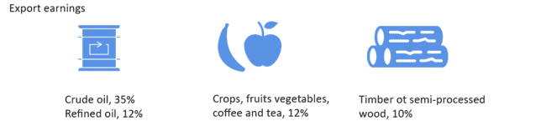

The variety of Cameroon's exports indicates a certain level of economic diversification, which nevertheless remains vulnerable to external shocks. Between 2010 and 2016, crude oil (35%) and refined oil (12%) dominated export earnings, but coffee, cocoa, tea, bananas and timber or semi-processed wood are also important. The low share of the food industry in exports (4%), suggests that the share of locally processed agricultural production remains low. As for imports, the main products are processed food products (14%), energy products (14%), transport equipment (12%) and machinery (10%). Cameroon, therefore, mainly exports primary products and imports processed products, thus exposing itself to international price volatility and terms of trade shocks (CEA, STEPS Cameroon 2018).

Exports | Imports
Distribution of Cameroon's exports and imports by trading partners
Source: http://atlas.cid.harvard.edu/explore, 2016

Structural transformation in Cameroon: situation and challenges

Production
The recent changes observed in the structure of the GDP are mixed, with a shrinking of manufacturing activities, and an increase in construction and certain modern services. The tertiary sector remains the biggest contributor to GDP growth. However, the limited capacity for project planning and absorption, and insufficient resource mobilisation negatively affect the quantity, quality, and impact of investments on growth. The country’s export structure, which remains horizontal and highly concentrated on extractive and agricultural raw materials, leaves it vulnerable to external shocks. Local processing of basic products is, nevertheless, on the rise and the destinations of Cameroonian products are diversifying. However, all of this has not yet led to a substantial sophistication (value-added) of exported products, despite the existence of good potential in this regard. Improving Cameroon’s total factor productivity is key to its access to the higher echelons of regional and global value chains. Skills and technological capabilities need to be improved accordingly by putting innovation at the centre of the country’s development agenda.

Employment
Although the trajectory of Cameroon's economic growth has been satisfactory over the past decade, it has not led to the creation of decent jobs, but rather precarious jobs in the informal sector. The structure of employment has not changed substantially during the last two decades and remains characterised by a concentration of labour in the primary sector and urban activities in the services sector and a very high level of informalisation (90% of employment, ECAM4). The few recorded movements of workers from agriculture and other sectors to manufacturing have not generated significant productivity gains. Labour productivity differs across economic sectors of the national economy. Agriculture in the informal economy has high labour productivity. This is less the case for manufacturing or extractive industries, which have a high potential for added value but low in productive employment creation.
Overall, Cameroon's economy is characterised by a relatively low unemployment rate, but a high underemployment rate of the labour force, in conjunction with the preponderance of the informal economy. Most of the working-age population is self-employed, which is not surprising given the predominance of non-modern and informal services, and engaged in the agricultural sector where women represent 80% of the labour force. This leads to a very high level of underemployment, 77% (INS, 2014), especially among women - 79,2% (UN Women, 2018). Regarding unemployment, 4% of women are jobless compared to 3,1% of men (ECAM4). The youth unemployment rate is moderate at 6%, but the rate of discouraged unemployed people is increasing, indicating a lack of opportunities to find work. According to the recent diagnostic of the employment situation (NEP, MINEFOP, ILO, 2019), the labour market is facing a mismatch between labour supply and demand. The low creation of decent jobs for young graduates is also linked to the absence of right skills and the challenges affecting the public employment service.
Given the contribution of the informal economy to job creation and GDP, decision-makers will have to address constraints faced by informal businesses but also promote formalisation as a key to structural transformation of the economy. Facilitating partnerships with bigger/formal firms, connecting them to business opportunities in marketing/distribution chains, and preparation of appropriate spaces for their activities; and social protection measures like health insurance could be very useful for informal sector firms. This situation requires a multi-institutional approach from the national to the local level.

The growth of the digital economy
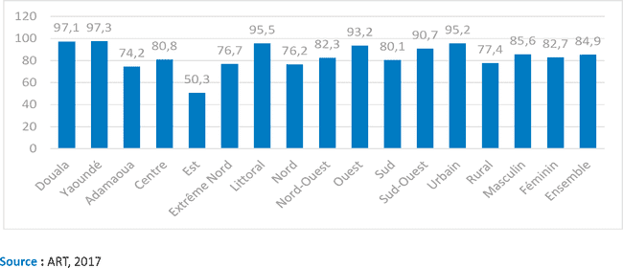
Proportion of households per region, with access to a mobile network in 201

The digital economy is growing in importance in Cameroon, and many initiatives have been undertaken to take advantage of the opportunities it offers in terms of innovation, employment and productivity. In 2016, a digital development strategy (Digital Cameroon 2020) was adopted to make Cameroon a digital country by 2020. The Government's digital economy vision is renewed in the forthcoming National Development Strategy 2020-2030. This strategy aims to make fundamental changes to the economic and social structures of the country in order to make development more inclusive. With a contribution of 5% to the GDP and more than 10,000 direct jobs created in 2016, Cameroon´s digital sector is growing and has not yet achieved its full potential. However, the sector faces many challenges related to: (a) The service offer: quantitative and qualitative insufficiency of infrastructures, including low coverage of 3G and 4G mobile networks; lack of a local digital content development industry; insufficient supervision of research and innovation; (b) The demand: low digital transformation of the Cameroonian society, including very low Internet access by households and businesses, and in particular among refugees and IDPs; low digitisation of public services; (c) Governance: inadequate training in relation to actual job needs, current regulatory framework not suited to the development of the digital economy, and insufficient financial resources. For the digital economy to fully play its role as a provider of jobs, a source of innovation and a growth accelerator, a concerted and multisectoral response is necessary to reduce the digital divide.

The Economic Effects of COVID-19
The COVID-19 pandemic is wreaking havoc in the world, with a huge impact on the economy and the society. At the beginning of March 2020, the OECD (2020) projected that annual global GDP growth will drop to 2.4% in 2020, from an already weak 2.9% in 2019. Global growth could even drop to 1.5%, if COVID-19 lasts longer and becomes more intensive, spreading widely throughout Asia Pacific , Europe and North America. According to ECA (2020) estimates, the pandemic could cost the African continent more than one percentage point of GDP (growth falling from 3.2% to 1.8%), and a 48% decline in employment. Over a decade ago, Africa was largely spared from the brunt of the global financial crisis. Back then, African countries were less integrated with the global financial markets and their lower debt levels meant that most countries had room to implement counter‑cyclical policies by increasing spending. Neither of these conditions applies today. Many countries in sub-Saharan Africa have limited fiscal space to increase spending and most of them are under high debt distress.
Cameroon is among the countries most affected in Africa (as of now), and significant economic ramifications on the country are expected. At this stage, it is difficult to accurately foresee the magnitude of the impact since the intensity, the duration and the extent of the spread in the country is relatively unknown. Nevertheless, many changes are already visible in several areas as a result of the pandemic: disruptions in global and local economic activity, the movement of people, capital, goods and services. There are several channels through which Cameroon could be affected economically by COVID-19, including trade, investment, financial inflows, and government revenue.
Latest IMF projections in June 2020, put the growth rate in Cameroon for 2020 at –1.2%, down from almost 4% in 2019. The effects on GDP growth would result from the decline in global demand leading to a reduction in exports, but also from the decline in domestic demand and the contraction of domestic supply, which relies on imported inputs. In addition, the current containment measures imposed by the government will have impacts not only on the output of these sectors but also on the value-added of the branches of activity that are part of the supply chain. The disruption of supply chains could completely shut down some firms and lead to significant job losses. Such situations engender inflationist pressures as the supply of goods and services, including medicines and other pharmaceutical products, is reduced. However, reduced domestic demand could weaken the effect on inflation. The significance of these effects will depend on the duration and spread of the pandemic and the maintenance, lifting or reinforcement of the precautionary measures.
The table below summarises the results of two surveys evaluating the impact of COVID-19 on firms in Cameroon: one by GICAM (the main business membership organisation in Cameroon) and the other by the Government of Cameroon (with support from the United Nations). Although there are some discrepancies between the surveys, both results have similar trends, and highlight the negative impact of COVID-19 on firms, their turnover, acquisition of inputs, postponement of decisions to invest, and more.
Table: Impact of COVID-19 on enterprises in Cameroon
Description | Share of Enterprises Affected (%)
 | Government Survey | GICAM Survey
- Negative overall impact | 92.5 | 92
- Reduction in turnover | 95.5 | 85
- Difficulties in acquiring inputs | 76 | 48
- Cash flow challenges | 90 | 96.7
- Partially laid off workers or reduced workforce | 58.2 | 87.4
- of which SMEs | 62.2 | 91.3
- Postponed decision to invest | 60.4 | 83.2
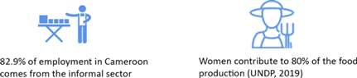
The informal sector will suffer most, as some of the measures such as social distancing and shutting markets earlier could mean the end of their businesses. As noted by the UN (2020 ), “effects are expected to be substantial in economies with a large informal sector, where often social protection systems do not exist or are limited”. About ￼82.9% of employment in Cameroon comes from the informal sector (PNUD 2020, p. 19). Telecommuting is a privilege for few in Cameroon and makes little or no sense to those in the informal sector. Total lockdown will therefore mean that most Cameroonians are confined to their homes with zero output; a good number being civil servants.
Public finance could be hit hard by the virus as revenue is expected to fall and expenditure rise, pulled by the health sector. A contribution of XAF443 billion from the petroleum sector to the budget, was estimated for a barrel of crude at USD57.6 (UNDP, 2020). Today (2 July 2020), a barrel is around USD40, after falling below USD30 for most of the second quarter of 2020. Fiscal and custom revenues are also expected to fall as economic activity slows down and international trade flows reduce. Cameroon’s main trading partners in Europe and Asia are seriously affected by the crisis and the slowdown in major economies means a fall in demand for Cameroon’s export commodities (crude oil, cocoa, timber, cotton) and consequently their prices. The slowdown of economic activity will imply that many private sector firms cannot meet their tax obligations and income tax and VAT will fall as many workers become jobless and demand less goods and services. Fiscal expenses will obviously increase in the health sector as the country struggles to deal with the pandemic. The estimated cost of treating a patient is XAF4.2 million; all supported by the government as of now. CEMAC (2020) has estimated the budget deficit will be -0.4% of GDP if the spread of the virus is transitory and rapidly controlled; but if the spread is rapid and wide-ranging, the deficit could drop to -2.8%.
Tighter global financial conditions will also limit access to financial resources for the country. Foreign direct investment is likely to drop drastically as the heightened uncertainty created by the pandemic make investors to postpone or outrightly cancel investment decisions. Foreign aid may also be affected as donors battle COVID-19 in their countries. It is also likely that capital flight rises as some foreign companies, and even national, consider the risk too high to keep their financial resources in Cameroon. Migrant remittances could decline due to the slowdown of activities in significantly affected host countries. This may, however, not change in the short term as migrants continue to support distressed families from past savings.
The financial sector could also be negatively affected as many businesses face challenges honouring their debt obligations to financial institutions. The increased uncertainty and portfolio of nonperforming loans will cause banks to reduce lending despite the possible reduction in the interest rate following the decision of the sub regional central bank BEAC, to inject more liquidity (XAF500 billion instead of XAF240 billion planned).
As highly anticipated from challenges mentioned above, the President of the Republic signed an ordinance on the 3rd of June 2020 rectifying the 2020 National Budget. The budget has declined by 11% from XAF4951.7 to 4409 billion. All ministerial departments had their budgetary allocations reduced, including the Ministry of Public Health. However, it is worth noting that the rectified budget contains a special fund to address the effects of COVID-19 named “Special National Solidarity Fund to fight against Corona and its socioeconomic repercussions” with a budget of XAF180 billion.
Mitigating the Economic Impact of the COVID-19 Crisis
While the COVID-19 pandemic represents a major challenge, it also offers unique opportunities for Cameroon to build back better by promoting clean and green transitions, accelerating economic diversification, creating green jobs, building resilient economies and fostering sustainable growth. Of urgency is the need to strengthen the digital infrastructure to support e-commerce, e-learning and e-health systems; support local private sector to produce pharmaceuticals and other medical supplies and equipment as well as food by leveraging the AfCFTA as a catalyst for rapid industrialisation.
The latest IMF (2020) debt sustainability analysis classifies Cameroon as being at a high risk of debt distress, making debt restructuring a priority. This should include an immediate waiver on all interest payments for 2020, debt repayment deferral, debt reduction, and other debt reduction instruments. These measures should allow the country to increase its fiscal space and thus mobilise additional resources (largely concessional finance) to fund an expansionary stimulus. Cameroon’s financial and technical partners (FTPs) should play an advocacy role in support of the restructuring of its debt.
The role of fiscal policy in mitigating the shock will be very important. Social measures could take the form of targeted cash transfers to help individuals and households under strain. UNDP (2020) has estimated that it costs between XAF2.3 to 53.7 billion monthly, to assist 81,298 to 1,944,015 vulnerable households confined because of COVID-19.
Government could also target and provide temporary support for hard-hit sectors in the country, for example tourism and transportation. This could take the form of temporary tax relief or deferment, set up a support fund for SMEs, to allow businesses to address cashflow shortfalls, and maintain the flow of essential inputs, final products and services. These are among the 18 proposals submitted by GICAM. Similarly, in the government survey, entrepreneurs asked for suspension of the payment of some taxes, and for financial support to sectors in dire need of assistance.
Measures will need to be taken to support the informal sector, which is generally out of reach of public policies. Any assistance should be properly managed so that the beneficiaries are truly those who have been most impacted by COVID-19. The banking sector should also be encouraged to reschedule the repayment of loans owed by businesses. Easing monetary policy as already announced by BEAC will complement fiscal efforts. Inflation, which is below 3% in the CEMAC subregion, should not be a major concern, at least not for now. Financial measures can help minimise disruptions to much needed credit and liquidity for businesses, including central bank liquidity provision or temporary credit guarantees.
Given the impact from international trade shocks, Cameroon should seriously adopt measures to diversify its economy and make it more resilient to economic occurrences beyond its borders. An inward-looking investment and development strategy centred on AfCFTA will reduce exposure to external shocks.
Multilateral organisations, and especially international financial institutions (AfDB, IMF and The World Bank Group) are putting at the disposal of developing countries like Cameroon huge financial resources largely on concessional terms. For example, the IMF is making USD50 billion available via rapid-disbursing emergency facilities, including USD10 billion on highly concessional terms for low-income countries. Cameroon should position itself to acquire some of these resources to cover the gap created by COVID-19.

Social Dimensions

Food Security and Nutrition
Cameroon continues to face challenges of acute and chronic food and nutrition insecurity. The Global Hunger Index (GHI) ranked Cameroon 76th of the 117 countries assessed, and the severity was classified as serious. Compared to its 68th position in 2015, the country's food security has deteriorated over the last five years (GHI, 2019). There are marked regional disparities in terms of food insecurity. Food insecurity is very high in the conflict-affected regions, particularly in the Far North, Northwest and Southwest regions (WFP, Zero Hunger, Food security and Nutrition Strategic Review , 2017).
The number of food insecure populations in Cameroon has shown cyclical patterns over the last five-year period. The number of food insecure populations (people in crisis, emergency and famine phases) has been reported as 2.66 million for the period of March - May 2020. (FAO, Cadre Harmonisé March, 2020 result)
According to the Global Nutrition Report 2018, Cameroon suffers from a triple burden of malnutrition (stunting, anaemia, overweight in women and children). To this end, the DHS 2018 survey reported that 11% of children under five are overweight and 29% are stunted. Anaemia is common among children under five and women of childbearing age, affecting almost 57% and 40% of them respectively (Statistique, 2018). Cameroon’s adult population faces a malnutrition burden as 41.4% of women of reproductive age have anaemia, and 6.9% of adult women have diabetes, compared to 6.5% of men. In Cameroon, more women suffer from obesity with 16.4% compared to 6.1% of men (GNR, 2018).
Conflict remains one of the main drivers of food insecurity. However, repeated climatic shocks in the northern regions also undermine the resilience of communities, and place a strain on their livelihoods. Approximately 3 million people need food and livelihood related assistance, mainly in conflict-affected areas. In the Far North, Adamawa and North regions, climate shocks (floods and prolonged dry periods) and market disruptions are the main factors of food insecurity. In the Northwest and Southwest regions, the population living in food insecurity is estimated at one million, according to the CH 2020. In addition, internally displaced people and the local population have limited ac cess to agricultural land. According to the Ministry of Agriculture, main crop production has decreased by almost 40% in these regions. Subsequently, food markets are not well supplied, and prices have soared (Ministry of Agriculture, 2019).

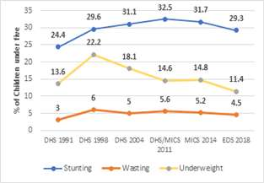
Trends of Malnutrition in Cameroon
Sources: DHS, MICS and EDS

Changes in number of food insecure populations
in Cameroon (Phase 3-5).

Impact of COVID-19 on food security
To understand the overall impact of COVID-19 on food security, data from March 2020 Cadre Harmonisé was modelled by FAO, WFP and MINADER. The analysis revealed that over 4.8 million people in Cameroon, including urban, peri-urban and rural, will be affected in ten regions and will employ crises or emergency coping strategies to ensure household food security. Priority will be given to actions that address short-term food security needs, specifically the provision of unconditional food assistance to meet food and nutrition needs arising from restrictions of movement. WFP and FAO will support the setting-up of a food security taskforce with the Government and key stakeholders to address the immediate consequences of the COVID-19 outbreak on food security and livelihoods. FAO and MINADER will support the setting-up of contingency plans to ensure the continued supply of agricultural inputs - seeds, fertilizer and agro-chemicals.

Water, Hygiene and Basic Sanitation
This socioeconomic snapshot of the country has a direct impact on the Drinking Water, Hygiene and Basic Sanitation (WASH) sector. According to JMP 2019, the rate of access of the population to a source of drinking water is 69% at the national level and 39% in rural areas. The situation is similarly worrying in terms of sanitation, with an open defecation rate of 7% throughout the country and with peaks reaching 22% in the Far North region. In 2017, only 18% of the population in rural areas had access to improved toilets, against 59% in urban areas.

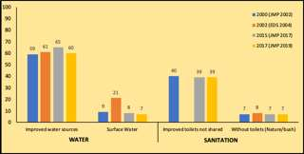
Access to safe drinking water and basic sanitation services between 2000 and 2017
Low access to safe drinking water and inadequate sanitation facilities coupled with inadequate hygiene practices significantly undermine the efforts of improving the social and economic wellbeing of the population. This has an additional burden on women and girls as they must fetch water instead of going to school or engaging in income generating activities. Limited access to safe water affects family health and nutrition and contributes to under-five mortality. Approximately 20% of children are affected by diarrhoea (23.2% in rural areas, 15% in urban areas), contributing to early childhood deaths. Similarly, from 1971 to 2019, the country reported 86,811 cases of cholera, including 3,337 deaths.
Poor or unequal access to WASH services is exacerbated by the humanitarian situations affecting Cameroon. These situations include: i) the spillover from the conflict in Central African Republic (CAR), the Northwest and Southwest regions, and the Boko Haram insurgency that have increased internal displacement and led to an influx of refugees from Nigeria and CAR, ii) the nutritional crisis in key hotspots, iii) floods, iv) the high prevalence of epidemics and water-related diseases.
In recent decades, Cameroon has been facing an abnormal recurrence of extreme climatic phenomena such as violent winds, high temperatures, long periods of drought and heavy rainfall that endanger human communities, ecosystems and the services they provide. The effects climate change , particularly in the North and Far North, contribute to a reduction in the available water and threaten the sustainability of water-related activities. Climate change disproportionately impacts women and girls given their situation as primary agriculture sector workers, their reliance on agriculture for their families' survival, and their poverty. The consequences of climate change undermine Cameroon's efforts to reduce poverty, develop a strong diversified and competitive economy, strengthen national unity and the consolidation of the democratic process, and thus undermine the objective of the "Vision 2035" to become an emerging country.

Social Protection
. Women and girls are the most left behind group in social policies. Action must be taken to address their needs given that they represent most of the poor. People living with disabilities are also among the physically, socially and economically vulnerable populations and therefore deserve special attention in government development programmes and in cooperation programmes between the government and its bilateral and multilateral partners. The 2011 Multiple Indicator Cluster Survey (MICS) revealed that people living with disabilities represent 5.4% of the country's population overall, with an unequal distribution between rural (6%) and (peri)-urban (4%) areas. The main sources of data on people living with disabilities in Cameroon are sociodemographic sample surveys, general population and housing censuses.
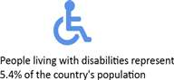The social security system in Cameroon consists of two main schemes: (i) a general social security scheme managed by the National Social Welfare Fund (CNPS) for salaried workers in the private sector, which in 2018 had 740,745 affiliated workers, with 117,628 beneficiaries in the PVID (Invalidity and Death Pension) branch and 70,417 in the family benefits branch; (ii) the general scheme for civil servants and government employees managed by the Ministry of Finance, which in 2016 had a total of 246,000 affiliated workers and 164,500 beneficiaries in the PVID branch. In addition to these two main schemes, there is a special social security scheme for members of parliament, a voluntary insurance scheme for the self-employed managed by the CNPS, company schemes and social mutual societies.

Health
In Cameroon, the share of the state budget allocated to health is low and has been fluctuating between 5.01% and 3.89% between 2015 and 2020. This is much lower than the 15% recommended by the Abuja Declaration adopted by African states in 2001. In fact, the bulk of health expenditure is borne by households (70%).
In terms of health, the epidemiological profile is dominated by parasitic and infectious diseases despite a strong surge in non-communicable diseases. According to the DHS (2018), the prevalence of HIV/AIDS is 2.7% among adults aged 15-49 years. In 2019, there were an estimated 510,000 people living with HIV (PLHIV), 17,000 new HIV infections and 14,000 AIDS-related deaths (Spectrum). Young women and adolescent girls aged 10-19 are 6 times more infected with HIV than their male counterparts. Vertical mother-to-child transmission of HIV is still high (14.2%). Key populations at a higher risk of HIV infection are female sex workers, with an HIV prevalence of 24,6%, and men who have sex with men (20,4%) (IBBS 2017). HIV prevalence in pregnant women is 5.7%. TB/HIV co-infection occurs in 38% of HIV positive persons. At the end of 2019, 79% of adult PLHIV had tested and knew their HIV status, 78% of them were on antiretroviral treatment, and 73% had achieved viral load suppression. There is much less progress with paediatric care due to persisting stigma and discrimination, which limit access to services and significantly hamper progress toward the goal of ending the AIDS epidemic by 2030.

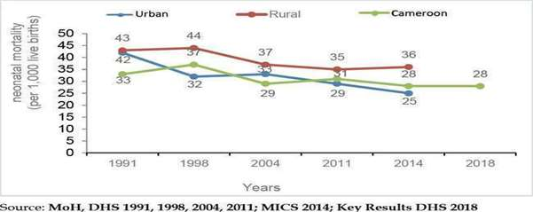
Evolution of neonatal mortality per 1,000 live births by residence in Cameroon from 1991 to 2018

Malaria is the leading cause of mortality (18% of institutional deaths in 2019, DHIS2) and morbidity (24% of consultations and 62% of hospitalisations in 2019, DHIS2), with a parasite prevalence of 24% (DHS, 2018). Thanks to achievements in sexual and reproductive health and family planning, EmONC and child health, the maternal mortality ratio has significantly decreased, from 782 maternal deaths per 100,000 live births in 2011, to 406 maternal deaths in 2018. With regard to child health, mortality rates have continued to decline, with neonatal mortality declining by 28 deaths per 1,000 live births, infant mortality by 48 deaths per 1,000 live births and child mortality by 79 deaths per 1,000 live births. Health problems are aggravated by malnutrition, for which indicators remain mixed. The vaccination coverage rate is 76.7% in 2019 for the Penta 3 tracer antigen, which could explain the 53 epidemics of vaccine-preventable diseases detected in 2019. The informal drug market accounts for about 25% of the drugs consumed in Cameroon.
Cameroon is facing several health and humanitarian emergencies. Despite the ongoing humanitarian response, the situation of refugees, IDPs, returnees and local populations is of concern. The destruction of some health facilities has been recorded. Most health facilities are understaffed, lack competencies, and are insufficiently equipped to meet the reproductive health needs of affected individuals, especially those of adolescents and young girls. The lack of adequate infrastructure and equipment, as well as the lack of medical staff, limit the access, availability and quality of health services. Health system failure is most severe in remote rural areas and areas affected by security crises in the Far North, Northwest and Southwest regions, where only UNHCR and the government provide health care and education in refugee settlements. Sometimes UNHCR is the only service provider in these refugee settlements. .Development funding for education and health should include refugees and Cameroonians living in remote areas.
The difficulty to access water also has consequences for health and nutrition. More than 1.4 million people need emergency assistance with water, hygiene and sanitation in the areas affected by security crises. The situation is particularly alarming in the Far North region, where more than half the population does not have access to an improved source of water. In 2018, more than 150,000 children under five suffered from acute malnutrition, including 44,700 of its severe form associated with high mortality.
The weakness of the health system remains worrying for the achievement of the SDGs. The political strategy of universal health coverage adopted by the Ministry of Health and stated as a national priority could contribute to a significant improvement in the attainment of SDG 3.

COVID-19 effects on health
The COVID-19 pandemic threatens to disrupt basic healthcare services due to obstacles to supply and demand. Mathematical models show that major disruptions could leave 270,600 children without oral antibiotics for pneumonia, 841,600 children without DTP vaccines, reduce the number of births in healthcare facilities by 137,800, and leave 480,100 women without family planning services. This would result in an 11% rise in child mortality and a 16% increase in maternal mortality in the coming 12 months. Maintaining essential health services during the COVID-19 pandemic is crucial for the prevention of these serious consequences and for the progress realised on the reduction of infant and maternal mortality in the previous years (Méchanisme de financement mondial: Préserver les services de santé essentiels pendant la pandémie, 2020).

Education and Vocational Training
Cameroon faces enormous challenges with the achievement of SDG 4 - inclusive and equitable quality education - of the 2030 Agenda. The strong population growth in recent years (with an average annual growth rate of 2.5% in 2019) and the extreme youthfulness of the population (the median age is 18.7) are putting great pressure on the education system, as a large number of children and youths need education. Moreover, instable economic growth and limited state revenues have negatively impacted the financing of the education and training sector. In 2020, the sector remains under-financed compared to the target of 22.0% of the state budget resources set by the DSSEF (2013-2020). The share of the overall budget allocated to the education and training sector was 14.6% in 2018, compared to 16.1% in 2013. The financing of education also weighs heavily on families, especially the most vulnerable for whom the cost constitutes a huge burden. Families cover 9% of the primary and 10% of the secondary education expenditure in Cameroon.
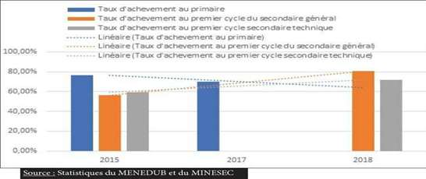Evolution du taux d’achèvement au cycle de l’enseignement primaire et au 1er cycle des enseignements secondaires technique et général au Cameroun entre 2015 et 2018
In addition to this unfavourable context, there are humanitarian and security crises that have a negative impact on the education system and aggravate the level of poverty among families. The dropout rate of pupils from pre-school to secondary education observed over the last two years is linked, among other things, to the instability in the Far North, Northwest and Southwest regions. At the national level, primary, general and technical secondary school enrolments declined by 3.6%, 4.7% and 8.5% between 2016-2017 and 2017-2018. Enrolments fell from 4,346,000, 1,548,782 and 358,862 respectively in 2016/2017 to 4,191,992, 1,476,216 and 328,382 in 2017/2018. In the Northwest and Southwest, pupil enrolments declined by 37% in primary, 49% in general secondary and 50% in technical and vocational education between the two academic years. A large number of schools closed during the same period. Between 2016-2017 and 2017-2018, nearly 300, 130 and 55 schools respectively stopped operating in these regions. However, it should be noted that several other regions also saw their number of schools decline, which contributed to the drop in enrolment.
A consequence of the decline in school enrolment is that limited access to education contributes to ignorance about women's rights, equity and socio-cultural traditional norms and practices hostile to gender equality. Barriers to the realisation of the right to education affect girls and indigenous peoples. Families are increasingly resorting to traditional practices, such as child marriage, as a survival strategy. There is a lack of cultural appropriateness of educational programmes and limited availability of education in aboriginal languages. Moreover, the relatively limited impact of the crisis on higher education is likely to exacerbate inequalities in the Cameroonian society in the long run, as the relatively well-off strata that dominate the terminal levels of the system are preserved, while the most vulnerable suffer in the early years of education at primary and secondary level. The vocational training system is still poorly developed and dominated mainly by the private sector (3 out of 4 learners are enrolled in private centres). Most students in higher education (81%) are oriented towards courses associated with the humanities and social sciences. The contribution of volunteers has strengthened the education component in the improvement of pedagogical approaches and educational themes with an emphasis on inclusive and learner-centred education. The volunteers' contribution focused on pupils, students, unemployed young people and children in difficulty, women and people living with e by the creation of a specialised corps of volunteers for popular education.
The high level political commitment to mainstream Comprehensive Sexuality Education (CSE), based on international standards, both in and out of school settings, marked by its integration in primary and secondary school curricula, as well as the development of a community programme, will foster adolescents and youth health and wellbeing, which are critical for their development, transition to adulthood, self-management and the realisation of their potential.

Impact of COVID-19 on continuous teaching and learning in Cameroon
On 18 March 2020, in an attempt to contain COVID-19 pandemic, the Government of Cameroon enforced restrictive measures including, among others, the closure of all public and private laid educational institutions in the country. The entry into force of this important government decision affected the schooling of 7.2 million students enrolled in public and private institutions on the national territory, including about 4.5 million children in primary education, with 47% girls; 1.8 million children in general and technical secondary education. 40,000 vocational training learners were also affected. Higher education is not an exception, with more than 347,000 students. Overall, 48% of them live in rural areas. More than one million students enrolled in the examination classes are confronted with serious concerns and the uncertainty of successfully completing the current school year and on how to approach the upcoming school year if the pandemic is not fought. The disruption of in-class tuition has serious consequences on children’s learning skills, access to, and the quality of education. Children from the poorest families are much more likely to be out of school than those from the wealthiest households. The longer the closure of schools, the more it has an impact on children in general, but in particular on the most vulnerable who will see their chances of returning to the education system diminish considerably. The impact of school closures goes far beyond the school spectrum and exposes children and adolescents to multiple risks linked to child labour, early marriage, early pregnancies, sexual exploitation, violence, the recruitment of children by armed groups, among others. Girls and young women, as well as forcibly displaced children and children with disabilities, are particularly at risk of no longer being able to access school and of further marginalisation.
The Government has set a partial reopening of schools and universities for 1 June 2020. Thus, the continuation of learning in a safe protective environment through distance learning platforms, the completion of the school year curricula in view of the final exams, the provision of psychosocial support, as well as the planning for the reopening of schools are among the current challenges and priorities of the education system.

Gender Equality and Women’s Empowerment
Despite women representing 51% of the total population in Cameroon, gender equality and women’s empowerment remain an unresolved issue (National Human Development Report, 2019). The National Gender Policy (NGP) highlights some areas of gender inequality in Cameroon, such as education. The number of women without an education is more than 1.7 times that of men in a similar situation. There is also a growing inequality between girls and boys as we move up the educational ladder (91 women at primary level, 79 at secondary level and 44 at tertiary level respectively per 100 men). Regarding literacy, women are also lagging behind men with a gap ranging from 31 points to 27 points in nearly 20 years as shown by the parity indexes. In vocational training, girls made up 45.4% of the total enrolment against 54.6% of boys in the 2008/2009 academic year, and the dropout rate was 14.2% for girls and 10.6% for boys.
Gender-based violence is common. 52.0% of women have experienced domestic violence at least once, and 53.0% of women have experienced violence since the age of 15. In the age group of 15 to 49 years, 1.4% of women have undergone female genital mutilation (National Gender Policy, 2011-2020). Child marriages are also still common, with dire consequences for physical and mental health, wellbeing, education, and agency of women and girls. In 2014, in the age group of 20-24-year-old women, 31% had got married before the age of 18.
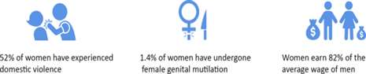
According to the 2019 National Human Development Report, the persistence of gender inequalities has led to strong disparity between men and women in the political, economic, social and cultural spheres. According to the latest development policy review of 2010-2018, as mentioned in the 2019 NHDR, this wide disparity is caused by:
- Poor integration of gender issues into development policies
- Insufficient material and financial capacities of the ministries concerned
- Insufficient mobilisation of the gender budget
- Insufficient disaggregated data by sex
- Poor coverage of women in social protection
While gender disparities are slowly narrowing, they are rooted in social norms and long-standing patterns of exclusion from family and community decision-making that limit women’s opportunities. Some measures taken have not yielded expected results despite the resources mobilised (National Human Development Report, 2019). The 2011-2020 National Gender Policy, based on SDG 5 on gender equality and empowerment of women and girls, aims to create an environment that protects women and ensures their equal access to social services, as well as their equal rights and opportunities. However, it has not been effective due to weak institutional capacity to lead the NGP (National Human Development Report, 2019).
Based on the 2014 tax declarations analysed in the report assessing the situation of decent work related SDGs in Cameroon￼, women earn 82% of the average wage of men. Disparities are greater at the senior management level (60%), than at the middle manager level (75%) and technical level (95%). This means that the disparities become more pronounced in areas of work that require higher skill-levels. ILO supervisory bodies have emphasised on numerous occasions the need to review national legislation in order to reflect the principle of “equal remuneration for work of equal value”,including the removal of discriminatory clauses in existing collective bargaining agreements.Furthermore, there is a need to gather statistical data to evaluate gender pay gaps and their development over time, and to remove from the statute book any provision that has the effect of nullifying or impairing equal treatment of women in employment and occupation.

Effect of COVID-19 on gender equality
The COVID-19 pandemic is disrupting access to life-saving sexual and reproductive health services. It is also compounding existing gender and social inequalities. The COVID-19 pandemic will have a negative effect on ending preventable maternal deaths, ending unmet needs for family planning, and ending gender-based violence.
The COVID-19 pandemic itself, but also the strategies to reduce transmission, such as social distancing, are anticipated to impact the ability of women to access and use contraception. The closure of health facilities, the unavailability of medical staff to provide family planning services, and women themselves being hesitant to visit health facilities due to concerns about COVID-19 exposure are also expected to impact women's access to and continued use of contraception.
The COVID-19 pandemic is likely to increase levels of violence. In the immediate term, the largest contributor is likely to come from the effects of movement restrictions, which could increase women's exposure to violent partners. Mounting household tensions and economic stresses could also play a role. There are already indications that violence incidence is growing, including increases in calls to violence prevention hotlines and media reports of rising domestic abuse and homicide.
COVID-19 is likely to have a significant impact on the implementation of the interventions to reduce child marriage, in particular as a result of the social distancing requirements implemented in many countries. The economic downturn is therefore likely to have a large impact on poverty levels. Because poverty is a key driver of child marriage, representing one of the ways poor families lighten the perceived burden of maintaining dependent daughters, the pandemic is projected to have a significant impact on the prevalence of child marriage. (UNFPA: Impact of the COVID-19 Pandemic on Family Planning and Ending Gender-based Violence, Female Genital Mutilation and Child Marriage, 27 April 2020)

Social effects of COVID-19 on individuals, households and communities
It is essential to contain the spread of COVID-19 to decrease the deterioration of human assets and rights, social cohesion and livelihoods. The pandemic will have immediate, medium and long-term social effects. Vulnerabilities are expected to be induced, risking to compromise the progress made in UCU, FP, the empowerment of adolescent girls and women, maternal and neonatal morbidity and mortality, among others.
Very young mothers are already more likely to die in childbirth, but the situation is expected to deteriorate. Their children are also more likely to be stunted, get sick and die before the age of five. High levels of fertility and GBV weaken efforts to improve human capital, as high numbers of children are associated with less investment in human capital (public or household). These situations are particularly dire in humanitarian settings.
It is important to protect, assist and advocate for refugees, IDPs, migrants and host communities particularly vulnerable to the pandemic, preserving the social development gains. The most heavily affected are the displaced persons in urban environments where the infection rates are higher and the confinement measures more rigorous. Already before the onset of the pandemic, refugees in urban settings were living in precarious conditions. This situation worsens every day with the progressive reduction of the availability of aid that has become more difficult to mobilise, but could become catastrophic with the pandemic.
At the beginning of the pandemic, 73% of urban refugees had already lost their jobs and 23% had seen their livelihoods become interrupted (UNHCR, April 2020). Food prices have increased by 40%, which has put parents in difficulty to provide for their families. The pandemic has also had serious consequences on the access to basic social services, such as education, healthcare, water and sanitation.
Existing water infrastructure that was already very limited in the poor neighborhoods, has been overwhelmed due to the growth in demand as people are using more water to prevent the spread of the virus. Consequently, the refugees who used to drink water from the wells now to have to buy drinking water.
With the closure of schools, nearly all children and students have stayed at home. However, 44% of urban refugees do not respect the restrictions of movement, or even total confinement, as they say they would otherwise starve to death. 33% are spending their monetary savings and 5% are selling their assets to survive. 18% of refugees make their children work in the to earn money for the families.
The table below highlights some impacts of COVID-19 on households resulting from the government survey mentioned above, under "Economic Effects of COVID-19". Households are worried about the pandemic and a high percentage amongst them are already facing reductions in income and standard of living, and their way of life has been upset (56%). As a way of mitigating the impact of the crisis, households suggest some of the following forms of assistance by order of importance: the distribution of cleaning products, disinfectants, facemasks and basic food stuff; reduction in food prices; regular disinfection of public spaces, and financial assistance to very poor households.

Table: Impact of COVID-19 on households in Cameroon

Description | Households concerned (%)
- Worried and very worried | 78
- Reduction in standard of living | 62.7
- Fall of income | 65
- Slowdown of activities | 74
- Difficulties accessing food products/catering services | 43.3
- Way of life largely and totally upset | 56.1
Source: Government of Cameroon (May 2020) survey

Environmental challenges

Biodiversity
Cameroon has a remarkable biological diversity. Both the highland rainforests of the coastal regions of the Southwest and the Littoral, as well as the tropical rainforests of the South and East regions of Cameroon, have been described as some of the most biologically diverse forests. At the African level, Cameroon's rich natural heritage in terms of biodiversity ranks fourth in terms of floral diversity and fifth in terms of wildlife diversity. The forest areas of Cameroon cover 39,8￼ of the national territory and constitute an undeniable reservoir of genetic resources for science, food, various industries, traditional knowledge, livelihoods and development. The different ecosystems, representing 92% of Africa's ecosystems, make Cameroon an “Africa in miniature”. The environmental management of the biodiversity of the country is a national stake.
The forests of southern and eastern Cameroon are part of the Congo Basin forest, recognised as one of the lungs of planet Earth. These forests are an important carbon sink after the Amazon Basin Forest and the Borneo Mekong Forest Basin. Cameroon's forest components support many agricultural, fishery and forestry activities. The socioeconomic benefits generated by the forests of the East, South and Littoral, including those of protected areas are widely recognised. These forest ecosystems constitute a source of subsistence for communities that depend on them for food, income generation or even residence (access to land). About 80% of rural populations are involved in economic activities based on the benefits of biodiversity. The added value of the forest sector is an economic asset. Indeed, it has consistently represented 2.7% of overall value added (GDP) between 2008 and 2010. This contribution is greater than the contribution of the non-oil mining sector (0.18% of GDP in 2010).
Despite this, these forests are threatened because of anthropogenic deforestation and degradation. The rates of loss of plant cover increased from 0.34% to 0.57% to 0.90% for the periods 2000-2005, 2005-2010 and 2010-2014 respectively (Hansen et al., 2013). Deforestation projections indicate that this rate could triple in certain Agro-Ecological Zones (AEZ) by 2035. The main direct causes of deforestation and forest degradation are the extension of agriculture (itinerant and permanent), wood extraction (commercial, wood energy, charcoal), and the extension of infrastructure (transport, housing, private companies and public services). These causes vary within and between the different agro-ecological zones of the country. Deforestation and the degradation of forest ecosystems reduce the potential for carbon dioxide sequestration, thereby causing emissions into the atmosphere (greenhouse gases), posing a threat to biodiversity and the livelihoods of forest populations. Under these conditions, any initiative aimed at combating climate change must imperatively take forests into account.

Climate change and consumption, production model trends

Rainfall patterns and rising temperatures
The coastal agro-ecological zone is characterised by the highest rainfall in the country. The evolution of the average annual rainfall, however, shows a significant drop since 1978 and despite the presence of stations collecting more than 1000 mm of water per year, the curve has not returned to the level of the average annual rainfall since then. An overall decrease of 40.16% has been recorded, i.e. a decrease in average rainfall of 6.69% per decade over the last six decades.
Projections made on the basis of available rainfall data show that the national territory will be subject to a variation in precipitation of the order of -12 to +20 mm of rain per month (from -8 to +17%) in the 2090s. These projections announce an increasing pressure on the environment and in particular on biodiversity. Among the most affected regions, those of the North and the Far North, are already classified as semi-arid or arid zones. They will benefit from less rain in the future. The zones of bimodal rain forests and the high savannah zones will record a respective decrease in rainfall by around -7.8% to -19% by 2100. The observed variability will be relatively greater in the Southeast of the country.

Greenhouse gas emissions
An analysis of Cameroon's overall situation in terms of greenhouse gas (GHG) emissions shows that the country has not succeeded in decoupling economic growth and the increase in GHG emissions. Between 1995 and 2014, the country achieved an average annual growth in GDP of 1.33%, while the average annual GHG emissions increased by 1.37% in addition to rising global emissions. These emissions are expected to increase over the next years. It therefore appears that without strategic and effective actions, Cameroon's efforts to achieve emergence by 2035 will be severely limited.

The national REDD+ strategy adopted in 2018 highlights the fact that forests are threatened by anthropogenic deforestation and degradation. Intensive deforestation and the degradation of forest ecosystems cause emissions of carbon dioxide into the atmosphere (greenhouse gases) and at the same time reduce the sequestration potential of forests, making the change of plant cover the second cause of global warming. Consumption, production model trends
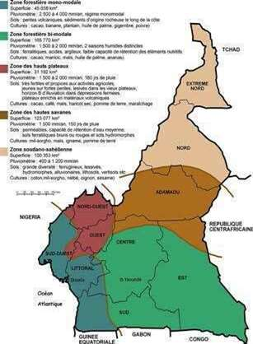
With reference to the above-mentioned future climatic conditions, in the absence of a coordinated and strategic response, the impacts of the changes on the economy will be critical and considerable. In fact, drought losses could reach 24% of the GDP, which could reach USD7.4 billion per year. While for the floods, the potentially affected GDP will reach nearly USD3 billion per year (UNISDR, 2018). This will have negative consequences for agricultural production. In the Far North region, for example, thousands of tonnes of grain lost each year are the source of food shortages for several families.

A study carried out in 2017 to establish a methodological guide for the integration of adaptation to climate change (ACC) and disaster risk management (GRC) in the strategies, programs, and development projects of the country, identified four main strategic sectors of the economy that are highly vulnerable to the effects of climate change: (1) Agro-forestry, (2) Transport, (3) Energy, and (4) Urban Development. The actions to be taken will be integrated into the implementation of the Sendai framework through the main coordinating bodies, which are the National Council for Civil Protection (CNPC), the National Risk Observatory (ONR) and the National Platform for Disaster Risk Reduction (PN2RC) and support from the 'National Observatory on Climate Change (ONACC).

Urbanisation
The number of cities with more than 100,000 inhabitants increased from 6 to 9 between 1987 and 2005. Two cities, Douala and Yaoundé, are approaching 2 million inhabitants. 42% of Cameroon´s population live in rural areas. However, migration to the cities is significant, especially to Yaoundé, the administrative capital, and to Douala, the economic capital. As a result, the urbanisation rate rose from 37.9% to 48.8% between 1987 and 2005. These cities, whose population has grown very rapidly since the late 1970s, are experiencing anarchic development and chronic insalubrity. According to the "National Report on the State of the Population of Cameroon" (2011 edition), 53.2% of the country's population now live in cities. By 2035, and on the basis of current trends, it is estimated that the proportion of the urban population in Cameroon could reach 63.2%. This situation causes growing pressure on the environment that has experienced accelerated degradation over the past 20 years. The degradation results from accelerated deforestation, uncontrolled peri-urban agriculture, the uncontrolled expansion of human and industrial settlements, uncontrolled exploitation of lowlands, growing demand for firewood, the increase in various forms of air/water/soil pollution by various types of waste, and the development of unhealthy and overcrowded conditions. The lack of data limits the feasibility of an accurate description.

Dependency on fossil fuel
The contribution of the wood energy sector to government revenues remains marginal. Less than 40% of the population has access to electricity, and this rate is barely 10% in rural areas. More than 7.4 million people living in rural areas do not have access to modern energy services, and barely 3% of rural households have access to gas for domestic use (Bikidik, 2010). 65% of final energy consumption in the country is based on traditional energy sources (wood, charcoal, etc.), which meet at least 95% of the cooking needs of the poorest households, especially in rural areas (EIS, 2010). In coastal areas, the demand for mangrove wood for its calorific properties has contributed to the loss of 40% of the area covered by mangroves in the country. Mangrove wood is mainly used in smokehouses for fish drying by fishermen along the coasts and deltas.
The increasing population growth coupled with the lack of alternative sources of income for local communities, as well as the growing demand for fuelwood and non-wood forest products from the cities represent a serious threat to forests. The rural populations of Cameroon depend entirely on wood energy for cooking. It is estimated that rural populations self-consume annually about 4 million tons of fuelwood that they collect directly from their surroundings. The value (XAF77.8 billion), however, is lower in monetary terms as the various costs related to transport and marketing do not incur.

Generation of waste and other residuals (emissions, waste, chemical, water and air pollution)
In the largest agglomerations, waste management is one of the priority environmental problems. In Yaoundé, waste considered special (expired medicines, chemical laboratory waste, certain radioactive substances from the Pasteur Centre of hospitals), produced in small quantities, is collected, without precaution, by informal sector operators for treatment or recycling. The volume of non-household special waste - especially packaging and bulky items - is estimated at 668 t/month, 94% of which comes from enterprises and 3.5% (15.4 t/month) from the informal sector. This is mainly soiled packaging (paint cans, detergent bottles, packaging for hair products, etc.) Every month 21t of old batteries are discarded. However, 69% of business waste is recovered by the informal sector and households. Half of the 2,823 t/year of special household waste follows the household waste circuit. The rest is dumped in uncontrolled dumps in inaccessible neighbourhoods or in watercourses. This congestion (physical pollution) sometimes increases the risk of flooding during the rainy season. Under the current conditions, it has become urgent to "adjust" the practice to the polluter-pays principle particularly in urban areas, in accordance with the terms of the Framework Law on the Environment. A study conducted by the Cameroonian Ministry of Scientific Research and Innovation and made public on 2 August 2018 in Yaoundé reveals that the presence of carcinogenic pollutants in the two major Cameroonian cities of Yaoundé and Douala. This is due to industrial activities and the presence of an ever-increasing number of cars without any real condition check of the vehicles. The results also indicate that due to the illegal exploitation of gold, bauxite and uranium in the region of East Cameroon and particularly in the localities of Betaré Oya and Kambele, the area is currently facing pollution by metals such as arsenic, mercury, lead and radioactive substances. These substances are present in particular in the wastewater that flows into the rivers and artificial lakes therein. In this region, the level of radiation exposure of the population is higher than the world average.

Natural disaster risk
Nationally floods are the second leading cause of death (4%) related to natural hazards. Ground movements (7%) and volcanic eruptions (9%) form other significant causes of death. (Tchindjang, 2013). Over the past 20 years, floods have affected more than 90,000 people in Cameroon. Between 2011 and 2012, they claimed the lives of around 150 people in the North and Far North regions, who also account for almost 98% of the total number of victims (deaths, injured, displaced) recorded in the whole of the national territory. The floods also have indirect consequences on the lives of the populations. They encourage, beyond the movements of the land, mudslides, caused by the runoff of rainwater following heavy precipitation. They are also a trigger for cholera, favored by insufficient latrines and potable water as well as poor hygiene practices. On average, the floods caused an upsurge of cholera in six regions of the country (Center, Far North, Coastline, North, West, Southwest). A total of 7,869 cases and 515 deaths have been recorded, of which almost 97% were in the Far North region.

Urban context
The rapid growth of urban centres is linked to an increasing need for housing, water, energy, sanitation, education, health, leisure, consumer goods, mobility, employment and security. Faced with this demand, the response provided by the public authorities has so far had little effect on the living conditions and general wellbeing of the population. In urban areas, the insufficient provision of housing has resulted in informal construction and an extensive consumption of natural areas. These illegal developments built on hillsides and swampy lowlands not only expose people to risks of floods and landslides but also lack security of tenure.
The lack of urban planning and uncontrolled peripheral urban extensions, limit the access of the majority of the urban population to basic urban services. In central and periurban districts the quality of life is reduced due to decaying buildings, the advanced deterioration of urban infrastructure networks, frequent cuts to the water and electricity supply and, in many areas, an absence of sanitation services. Waste management has serious shortcomings and leads to worsening levels of pollution.
The number of urban households, estimated at 1.78 million in 2005, could reach 5.01 million in 2035. This means that 2.57 million new urban households will have to be welcomed by 2035, in addition to meeting the needs of the current population. So far, the impact of public interventions has remained marginal (less than 1% for housing). To achieve SDG 11, a dramatic scaling up is required for public interventions.
The housing is of poor structural and architectural quality. The generally insufficient size of the units has led to overcrowding. The dwellings are not built in areas designated and planned for housing, and the urban fabric meets practically no urban quality criteria. Housing is located far from jobs, generating expensive daily commutes to urban centres as public transport is rarely available. Cameroon's medium-sized cities and metropolitan areas suffer from daily congestion with detrimental consequences to air quality.
- According to UN-Habitat, an urban area can be defined as a slum if the households lack at least one of the following criteria:Durable housing of a permanent nature that protects against extreme climate conditions.
- Sufficient living space, which means not more than three people sharing the same room.
- Easy access to safe water in sufficient amounts at an affordable price.
- Access to adequate sanitation in the form of a private or public toilet shared by a reasonable number of people.
- Security of tenure that prevents forced evictions.
It is estimated that nearly two thirds of the population of Cameroonian cities live in slums.

COVID-19 effects on housing and urban planning
UN-Habitat estimates that the COVID-19 crisis will most significantly impact slums and informal settlements in urban areas of Sub-Saharan Africa where the poorest and most vulnerable live, thereby amplifying the already challenging conditions of overcrowding, limited access to water, sanitation and health facilities, overall lack of hygiene, poor access to reliable electricity, and high dependency on a daily income with no or very limited savings capacity. The known measures to prevent and to slow the transmission of the virus (self-isolation, quarantine, physical distancing, contact tracing, etc.) are hard to apply in these settings especially when community engagement and local authorities' contribution to the containment are weak.
In the face of this pandemic, the lack of adequate housing has repercussions for the society as a whole and it is a direct threat to everyone’s health and safety. Ensuring decent and secure housing for all and the provision of essential services are crucial components of national efforts to contain the spread of the pandemic and prevent the loss of life. In addition to the right to housing, access to water is very important.
The COVID-19 pandemic has demonstrated the unavoidable interdependence of the different aspect of living in cities. This includes need for safe mobility to move essential workers and to access livelihoods, as working from home is in most cases not an option for those in the informal economy.
COVID-19 has also brought to light a new form of urban divide, the unequitable access to internet and television. This digital divide has affected the access to and quality of education, putting those children who cannot attend online lessons at a disadvantage. Adults without a television or internet connection are also more susceptible to disinformation. City management should capture all aspects of life and increase the access of households to the digital technology and telecommunication tools.
Another lesson from the COVID-19 pandemic is the importance of curbing urban sprawl as protecting the space left for biodiversity has been identified and an important factor in limiting the spread of zoonotic diseases from wildlife to people. Parks and other public spaces are not "nice-to-haves", but part of the minimum conditions of urban life.
An understanding of the nature and complexity of urban systems is necessary to tailor the COVID-19 response to urban areas, support recovery, and build resilience of Cameroon's cities. A more integrated multi-sectoral approach is needed with a clear spatial dimension coordinated locally by mayors. (UN-Habitat, Key messages COVID-19 and informal settlements, 2020)

Reflections on the interlinkages among the three dimensions of sustainable development

Key pillars of sustainable development and major trends observed in the past
The 2030 development agenda enjoins the international community to achieve sustainable development to the benefit of the earth's population. The three dimensions include (i) economic, (ii) social, and (iii) environmental. Past trends in international development have shown that economic development has not only failed to generate the expected progress in the social dimension, but it has also caused environmental damage.
As many unindustrialised nations, Cameroon's economy has been depending and will still depend on the exploitation of natural resources most often sold to the world market with very limited level of transformation. Both on and offshore, exploitation of natural resources has generated significant and/or irreversible damage to the natural environment. The most visible consequences are deforestation, coastal sea pollution, soil erosion, water pollution and inadequately managed waste.
The social dimension considers how well development policies are generating a positive transformation in people’s lives and livelihoods in an equitable manner. For the past two decades, Cameroon's GDP has grown at an average of 3% annually. This growth has failed to generate the expected social progress measured in poverty reduction. According to the Human Development Index, Cameroon has remained in the lower ranks of countries on the medium level of HDI. Poverty has significantly increased in rural areas.
Over the past two decades, Cameroon's socioeconomic indicators have revealed strong multidimensional correlations between the situation of the natural environment and the development indicators. Maps of environmental stress and the prevalence of monetary poverty are perfectly overlaid. The northern semi-arid and arid regions have the lowest level of socioeconomic indicators. Poverty is rampant, and youth accomplishments are the worst in the country. This also applies to health, education, food accessibility and affordability, socioeconomic infrastructures and other development indicators. Difficult access to water makes the economic activities of farmers both difficult and not productive enough. The overall result is the incapacity to develop a stronger human capital capable to innovate and seize emerging opportunities.
Tree-planting and other reforestation initiatives are jeopardised by the survival strategies households have adopted. Despite the ecological constraints, firewood is the major source of power used for cooking.
In national, sectoral and regional development policies, addressing the three pillars of sustainable development has not been effective. Though strategic documents, such as the Growth and Employment Strategic Paper (GESP), mention sustainable development and social integration as a core concern of the country, the ambition has neither been followed by the allocation of resources, nor concrete actions. The renewed focus on human capital development, under the new NDS, will contribute to boost sustainable development.

Interlinkages among the three dimensions: the state of the art
At institutional level, economic, environmental and social development are managed by different ministries. This makes it difficult to implement a structured approach to sustainable development in Cameroon. A thorough analysis of the 2010 – 2019 GESP reveals that none of the three dimensions of sustainable development is clearly mentioned in the priority objectives. Socioeconomic development is a broad goal planned to be achieved by the contributions of the line ministries with no significant capacity to influence resource allocation at the national level. It is, therefore, not easy to track how well the Government is implementing its commitment to the global agenda.
By assigning roles and responsibilities to many ministries without a strong coordination and coercive accountability framework, an effective integration of all three dimensions is not easy to implement. The necessary concertation among actors needs to be ensured at the key stages (design – prioritisation – financial allocations) of development policies cycles. Otherwise, the opportunities to generate beneficial and productive synergies will continue to be missed and policies end up remaining at the stage of documents. The legislation in force recommends an environmental impact assessment before authorising any large-scale development projects such as roads, seaports and power dams to be implemented. However, assessments most often minimise the impact on the environment, people and human settlements. There is no clear platform of action that would gather government decision-makers, the private sector and local populations. As a result, the effectiveness of the law on environmental protection is undermined. Though mentioned in the national constitution, social justice has hardly been monitored as a clear development priority. This could explain continued challenges with the resorption of social inequalities.
Concerning the national policies that govern rural development, the impact of manmade activities on the natural environment is mentioned but lacks the key elements of an enabling environment (resource allocation – accountability framework/mechanisms – participatory framework). Large-scale interventions that translate policies into actions are not systematically monitored. Finally, the collaboration between the public sector, domestic private sector and business stakeholders is not effective. Violations of the existing legal framework are not systemically sanctioned. Therefore, urban areas are facing significant challenges with waste management and the resulting pollution that ultimately affects the wellbeing of the population.
The high natural diversity in Cameroon is not adequately taken into account in the national, sectoral and local development policies. A documentary analysis of existing development policies found that the needs of environmentally stressed and poverty-stricken areas/communities to be strongly or specifically addressed. For example, the Ministry of Basic Education recommends the same model of classrooms to all the regions of the country. This is not effective from a budgetary or environmental point of view.
According to the National Development Strategic Paper, the performance of national development policies is measured through household surveys, the major one being “Enquête Camerounaise auprès des Ménages (ECAM)”. These surveys are organised once every five years but the data they collect is not disaggregated enough. An important example is the gender gap, as the data is not disaggregated enough to highlight many existing gender issues. To date, the most followed indicator is the prevalence of monetary poverty. This indicator is used to measure the effectiveness and impact of economic and social development policies. The amount of money spent on data collection is not productive enough as in-depth analysis is not done. No measure or evidence is provided to monitor how development policies influenced/impacted issues such as equity and the socio-environmental sustainability of policies.
The following examples from the timber and oil industries illustrate the limited concerns for the integration of the three pillars of sustainable development:
Timber industry: Timber exploited from a green natural forest is taking place in remote rural areas. Here, economic development (contribution to foreign trade) is seldom accompanied by a structured approach to social development and ecological sustainability. Even though a clear framework and guidelines for societal responsibility exist, there is no evidence of a meaningful contribution of the timber industry to the social development of the communities living in the areas where trees are cut. This exploitation has not been able to reduce poverty in the East region. Additionally, tree replantation is not systematic and environmental sustainability is not ensured.
Oil industry: Oil production in Cameroon started almost four decades ago. This activity has gained momentum since the pipeline linking Chad and Cameroon went operational. To date, oil exploitation has resulted in the pollution of seashores where sand is gradually darkening. The reinvestment of oil revenues and other remnants in seashore protection is not effective. Oil income has so far been used to fund development projects and government running costs.
In conclusion, Cameroon’s context provides numerous examples of strong linkages between the economic, social and environmental dimensions. These three dimensions are strongly intertwined as portrayed by the geographical distribution of poverty and the low social development indicators. Examples analysed above also showed an insufficient balance between the three dimensions of sustainable development. In public policies, economic growth is given a prominent role to the detriment of the two other dimensions. Expected positive impacts are not the result of structured and thought-through mechanisms.
Improved functional linkages between the three dimensions of sustainable development can have a boosting effect on national development. This would require a radical change of mindset of the development policy makers. Systemic thinking and thinking out of the box are an imperative if Cameroon wants to take full advantage of the opportunities offered by the global transformative development agenda.

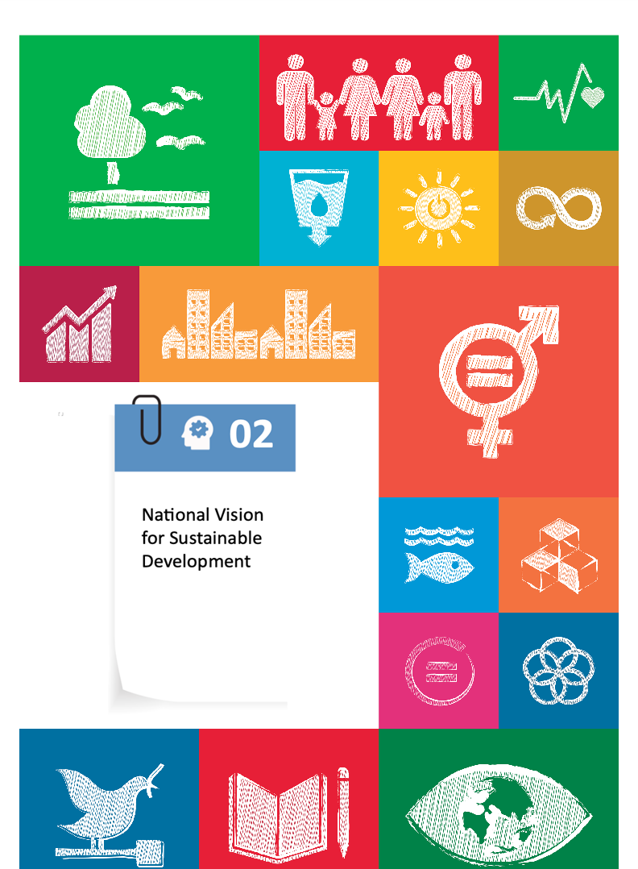

National vision for sustainable development

National Development Vision
Since 2009, Cameroon has drawn up its development guidelines underscored in the Vision 2035 document. The aim of this vision is to make Cameroon a Newly Industrialised Country (NIC) via the consolidation of growth, the widening of the distribution of wealth, the intensification of the mechanisation of agriculture, industrial transformation and the improvement of governance. The vision is composed of strategic objectives with targets related to the achievement of the SDGs. These include:
- Establish favourable conditions for the accumulation of national wealth and ensure a structural transformation essential for industrialisation with as set target, amongst others, the achievement of SDGs 8 to 12.
- Improve the living conditions of the populations and their access to basic social services by ensuring a significant reduction in poverty and underemployment. This would achieve SDGs 1 to 8 and SDG 10.
- Strengthen adaptation and climate mitigation measures and environmental management to guarantee economic growth and sustainable and inclusive social development, with SDGs 13, 14 and 15 in mind.
- Improve governance to strengthen the performance of public action with a view to achieving development objectives linked to SDGs 16 and 17.
As part of the second phase of the implementation of the 2035 vision, the Government has developed the new strategy aligned with the SDGs for the period 2020-2030 (SNDC 2020-2030). It revolves around four pillars:
- Structural transformation (industrial development and services; productive infrastructure)
- Human development (education, training and employability; health and nutrition; social protection)
- Employment policy (promotion of employment in public investment projects; development of very small enterprises (VSEs), small and medium sized enterprises (SMEs) and entrepreneurship; strengthening of labour market governance)
- Governance and strategic management of the state (political, administrative, economic and financial; social and cultural)
The development of the new vision would benefit from a systematic assessment of gender gaps and the identification of actions to close them, with the ultimate objective to achieve inclusion and sustainable development. Gender must be mainstreamed in all sectors.

Rule of Law and Accountability
The Constitution enshrines the respect for the principles, rights and freedoms contained in the human rights instruments ratified by Cameroon. These include the promotion of the rule of law, the effectiveness of the judicial system, respect for human rights, the maintenance of order and security, the participation of citizens, and the accountability of government officials. Cameroon has ratified the Protocol to the Convention against Torture, and the National Human Rights Commission has been designated as the national preventive mechanism. Furthermore, the National Governance Strategy explicitly refers to rule of law and accountability as overarching objectives.
Since the early 2000s, the Government of Cameroon has carried out a series of initiatives aimed at curbing corruption and promoting accountability. These initiatives are of institutional, legal, judicial and strategic nature.
At the institutional level, several anti-corruption institutions have been established, namely the Anti-Corruption Units (2000), the National Anti-Corruption Commission of Cameroon (2006), the National Financial Investigation Agency (2007), the Ministry of Superior State Control (1982), the Audit Chamber of the Supreme Court (2003) and the Special Criminal Court (TCS) (2011).
At the strategic level, the government has developed and is implementing a National Anti-Corruption Strategy in a participatory manner. Despite this approach, it must be noted that corruption does not seem to be regressing. While the actions taken to combat corruption are visible at the judicial level, petty corruption, which mainly affects the poorest, remains rampant and insidious. In 2019, Cameroon ranked 153rd out of 180 in the Transparency International Corruption Perception Index, and 166th out of 190 in the Ease ofDoing Business Index . These two rankings are quite eloquent and express a decline in the country's ranking compared to its previous rankings despite the government's declared willingness to fight corruption.

Civic Participation and Social Cohesion
Cameroon has not adopted a peacebuilding strategy. However, to resolve and mitigate conflicts, the Government has taken several measures, including the creation of the National Commission for the Promotion of Bilingualism and Multiculturalism and the creation of the National Disarmament, Demobilisation and Reintegration Committee (NDDRC) in 2018. The NDDRC has got three centres (in the Northwest, Southwest and Far North) to respond to requests for the reintegration of combatants who surrender. Other measures have been the Major National Dialogue organised in 2019, the amendment of the Penal Code to criminalise hate speech targeting tribal groups, the creation of a ministry dedicated to decentralisation to speed up the process with the allocation of significant budgetary resources to support local authorities, the establishment of a Humanitarian Emergency Plan in the Northwest and Southwest regions, and a Coordination Center for Humanitarian Assistance in the Northwest and Southwest regions.
The Government has elevated youth issues to a national priority, but the focus has shifted to economic empowerment to reduce the poverty rate on the one hand, and civic education on the other. The Government has committed to promote youth participation in the emergence under the DSCE, MINJEC, through Decision N°009/2010/D/MINJEC/CAB of 23 February 2017, and thus created and organised the project for the implementation of a National Youth Observatory (NYO) within the Multipurpose Youth Centres. The main mission of the NYO is to ensure that governmental and non-governmental programmes address the demands of young people in terms of civic education, social integration and economic promotion.
These include, inter alia, initiatives geared by the Ministry of Youth and Civic Education:
- National Civic Agency for Participation in Development (ACNPD) and the National Committee for Youth and Popular Education (CONAJEP) for the moral rearmament of young people and the promotion of voluntary work, the values of peace, work, democracy and solidarity
- The National Literacy Programme (PNA), which aims to provide the population, particularly young people, with the skills essential for the exercise of citizenship and the improvement of their well-being
- The National Youth Council of Cameroon (CNJC), a framework for dialogue, expression, consultation and action by young people and an interface between them, the public authorities and development partners
- Multipurpose Youth Centres (CMPJ), structures for the supervision and extra-curricular accompaniment of young people with a view to their development; the National Youth Employment Pact (PANEJ)
- Numerous Integrated Projects to Support Youth Entrepreneurship and Socio-Economic Integration such as the (PIAASI), Programme of Support for Rural and Urban Youth (PAJER-U), Project for the Socio-Economic Insertion of Young People through the Creation of Microenterprises for the Manufacture of Sports Equipment (PIFMAS); the Programme of Support for the Technological and Professional Component of Higher Education (PRO-ACTP), Programme d’Aide au Retour et à l’insertion Des Jeunes De La Diaspora (PARI-JEDI), FONIJ -Fonds National d’Insertion des Jeunes
- The Department of Youth Social Integration and Volunteerism (DISJEV) has been established in 2012 by Decree N°2012/565 by the Ministry of Youth and Civic Education
- The National Volunteer Programme of Cameroon is being implemented since January 2019 with the support of the UN System as a means to support youth contribution to the country's development, with national volunteers being deployed in education, health and agro-pastoral areas
- U-Report Cameroun
- Youth Connekt Cameroon Initiative
- Popular Education Programme for National Integration (PEPSIN)
Some other projects initiated by other ministries on behalf of the youth are: Programme d’Appui à la Rénovation et au Développement de la Formation Professionnelle dans les secteurs de l’Agriculture, de l’Elevage et des Pêches, Phase de Consolidation et de Pérennisation (PCP-AFOP); Programme pour l’entreprenariat agro-pastoral des jeunes (PEA-Jeunes), both initiated by MINEFOP.
In 2015, the PPJC Platform for the Promotion of Cameroonian Youth was established. It was selected as a youth transversal group within the Multipartner Committee and as a joint platform (government - UN system) for monitoring the implementation of the "Special Youth" Triennial Plan, a mechanism through which joint initiatives are carried out and which could lead to closing the gap in the achievement of the SDGs by 2030.
In November 2017, Cameroon adopted its first ever National Action Plan for women, peace and security (NAP 1325). The vision of the plan of action is aligned with that of the country: “Cameroon, an emerging, democratic country which is united in its diversity”. The strategic objectives of the plan are: “By 2020, the commitments and indebtedness of Cameroon towards women, peace and security are realised through":
(a) The leadership and participation of women in the process of prevention and management of conflict and post-conflict situations, to construct peace and social cohesion;
(b) The scrupulous observation of international humanitarian law and legal instruments for the protection of the rights of women and girls against sexual violence and gender-based violence during periods of armed conflict;
(c) A better integration of the gender dimension in emergency aid, during reconstruction in the course of, and after, armed conflicts, as well as in the management of grievances;
d) The strengthening of institutional mechanisms and the collection of quantitative and qualitative data on the consideration of gender in the domains of peace, security, prevention and resolution of conflicts.

Decentralisation and governance
The General Code of Regional and Local Authorities brings together all the legislation concerning decentralised territorial collectivities in a single document. It also embodies the willingness of the public authorities to accelerate and deepen the decentralisation process, as confirmed by the recommendations of the General Assembly of the Communes and those of the Major National Dialogue.
Beyond the political will to decentralise the country, which is often expressed in official speeches, the implementation of Vision 2035 has contributed to the deepening and acceleration of decentralisation and local development, strengthening the democratic process and local governance.

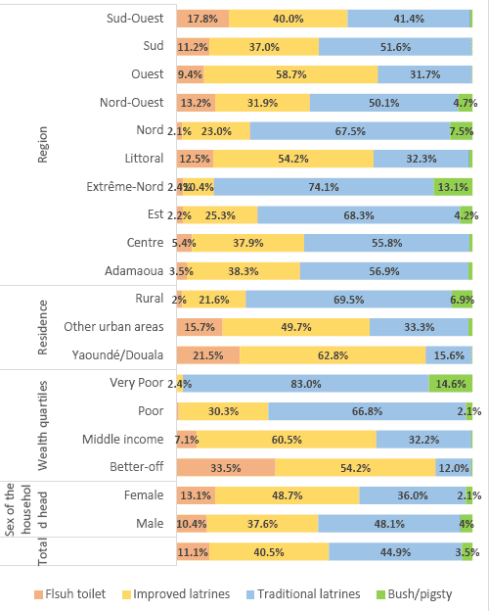
Water Sanitation and Hygiene
The country has, on the one hand, initiated vast programmes aimed at ensuring the sustainable and equitable access of the population to drinking water, basic hygiene and sanitation services, and on the other, strengthened the governance framework of the sector through the development of policies and strategies and the establishment of an integrated system for the collection and management of data and information on access to services.
At the institutional level, the state, focusing on its sovereign mission and national objectives, guarantees, through the ministry in charge of water, sustainable management of water resources for the common good. The main ministerial departments concerned with access to WASH services in Cameroon are the Ministry of Public Health, the Ministry of Environment, the Ministry of Economy, Planning and Regional Development, the Ministry of Agriculture and Rural Development, the Ministry of Education, the Ministry of Finance and the Ministry of Territorial Administration. The local authorities, to which decentralisation transfers competencies in terms of planning, supply and management of drinking water, hygiene and basic sanitation services, constitute an important group of stakeholders in the sector. The other key stakeholders are research and training institutes, the private sector (all individual or corporate companies), civil society organisations, international institutions, regional institutions, transboundary basin organisations and technical and financial partners.
Proportion of households by type of toilet facility (Source: CFSVA 2017)
The main bodies for coordinating interventions in the sector are: the WASH sectoral group set up by a decree of the Prime Minister, the WASH emergency response sectoral group with its regional and departmental branches, the group of technical and financial partners of the WASH sector. These different groups operate on the basis of tools prepared and adopted by all stakeholders. The functioning of the WASH sector is governed by the policy and strategy documents and the legal and institutional framework.
Among the policy and strategy instruments are: the law governing the water regime (Law No. 98/005 of 14 April 1998), the rural drinking water supply and sanitation policy, the urban hydraulics sector policy letter, the health sector strategy, the National Strategy for Liquid Sanitation, the National Strategy for WASH, the WASH Strategy in schools. The National Water Policy and the National Hygiene and Sanitation Policy were also technically validated. These policy and strategy documents are based on the Government's Vision 2035. This Vision is implemented through the Growth and Employment Strategy Paper, the economic compass of the country. The realisation of this vision should enable the country to honor its commitments to achieve the Sustainable Development Goals (SDGs) and particularly SDG 6.
With a view to achieving the objectives of SDG 6, the national vision of the sector as defined in the national water policy is as follows: "By 2035, Cameroon's water resources are known and sustainably managed to contribute to the country's socioeconomic development and environmental preservation". The implications of this vision are that the country's water resources are known, mobilised, exploited and managed while guaranteeing equity, social peace, environmental sustainability and economic efficiency, and this in compliance with Cameroon's international, regional and subregional commitments.
Taking into account the overall development objectives, vision and management principles of the water, hygiene and basic sanitation sector and, on the basis of the priorities identified during the formulation of the various policy and strategy documents, the Government of Cameroon has made the following commitments:
- Ensure the right of universal access to water and sanitation by 2030
- Increase the access of urban and rural populations to improved sanitation facilities by increasing the national coverage rate from 34% in 2010 to 57% in 2020
- End open defecation by 2035
- Promote good governance of the water sector through the development, updating and implementation of policies and strategies, the development of financing mechanisms for the sector and the updating of its legal and institutional framework

Social Protection
Technically validated in December 2017, the National Social Protection Policy (PNPS) aims to bring together all initiatives underway in the various sectoral strategies likely to directly address risks, vulnerability, capacity gaps and chronic poverty, taking into account regional and local specificities. The PNPS is structured around four strategic development lines whose objectives correspond with the strategic objectives of the policy as a whole.
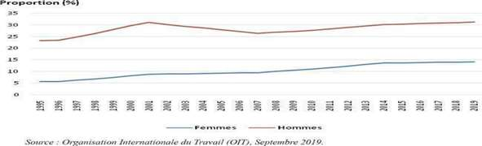
Change in the proportion (%) of employees by sex

The first priority concerns social transfers, the common thread of which is the strengthening of non-contributory systems. The aim of this priority is to strengthen the human capital of vulnerable populations by improving their access to basic social services and meeting their basic needs. In the context of social protection policy, improving access to basic services means reducing costs. The priority targets are orphans and vulnerable children, women in difficult circumstances, the elderly, chronically poor households, small farmers, victims of accidents and disasters, the chronically ill, internally displaced persons and refugees.
The second priority refers to social security, the objective of which is to guarantee social and health coverage for the whole population but particularly the most vulnerable.
The third priority relates to social action services through the protection and promotion of groups with specific and cyclical vulnerabilities. It aims to improve the access of groups with specific and cyclical vulnerabilities to social action services by reducing exclusion and implementing support and guidance initiatives.
The fourth priority is to promote the economic integration of vulnerable people. As a major lever for poverty reduction, inclusion and social justice, employment has since 2010 been the focus of the development strategy of the public authorities. The aim is to improve the access of vulnerable populations to economic activities.

Health
Cameroon's vision of sustainable development is contained in the country's Vision 2035, and successive strategic development documents (PRSP, 2003), (ECDP, 2010) and soon (SNDC 2030). For health, this vision is formulated as follows: "Cameroon, a country where universal access to quality health services is ensured for all social strata by 2035, with the full participation of communities". The Health Sector Strategy 2016-2027 (HSS) develops this vision, with the overall objective of "Contributing to the development of a healthy, productive human capital capable of generating strong, inclusive and sustainable growth". The HSS has identified 4 priority SDGs, namely SDGs 2, 3, 6 and 13, to which the objectives of the health sector strategy have been anchored and targets for 2027 have been defined. Maternal and infant mortality have been reduced. An acceleration strategy is essential to progress towards the SDGs. Emphasis must be placed on reducing disparities and inequalities, which are still high in some regions and departments. This is all the more so as the security and humanitarian crises that Cameroon is going through are having an impact on social budgets. Multi-partner and multi-sectoral action, through the social determinants of health, could play an accelerating role.

Education
The Government has chosen to develop education and vocational training by (i) an extension of the universality of education to the first two years of secondary education in order to guarantee eight years of compulsory education to all young Cameroonians; (ii) an increase in resources to support the quality, relevance and resilience of the education and vocational training system; and (iii) a significant strengthening of the overall budget allocation and the relative share allocated to primary education.

Gender and Women's Empowerment
In line with the 2035 vision slogan “Cameroon: an emerging, democratic and united country in diversity", Cameroon aspires to become a nation that promotes gender parity in electoral processes, equality in elective positions and equality in professional settings. Other goals comprise the notion of a socially and economically empowered woman, a stable and harmonious family, the access to basic and quality social services to all, the independence and accessibility of the judiciary, as well as minimal illiteracy and social exclusion rates, and well-trained youth gaining merit and deepening the country’s expertise. Within the vision, promoting the management, social inclusion and integration of women, the youths and the vulnerable in economic channels is primordial (2035 National Vision 2009).

Environmental and Climate Change Initiatives
Cameroon has signed and ratified almost all the international conventions relating to the protection of the environment, the Convention on Biological Diversity (1992), the United Nations Framework Convention to Combat Desertification in Countries Experiencing Serious Drought and/or Desertification (1997), the Stockholm Convention on Persistent Organic Pollutants (2001) and the United Nations Framework Convention on Climate Change (1994). Cameroon has a National Action Plan to Combat Desertification. Within this framework, the "Sahel-Vert" project, implemented by the government since 2008, has contributed to the restoration and defence of nearly 22,000 ha of degraded land. In addition, the CTD and FEICOM are working to develop lowlands and practice reforestation as a climate change mitigation measure. Furthermore, within the framework of Law No. 94-01 of 20 January 1994, the Ministry of Forestry and Wildlife is ensuring sustainable forest management in the area of decentralisation of forest management, delegation of forest management responsibilities to local municipalities (communal forest) and to local communities (community forest). The final aims are local ownership, local development, livelihood improvement, poverty reduction, biodiversity conservation, sustainable forest resource management, and the associated challenges brought by the lack of financial resources and technical skills.
At the institutional level, the Ministry of Environment, Nature Protection and Sustainable Development (MINEPDED) has the mandate to address environment and climate change issues. It was established by Presidential Decree No. 2004/320 of 14 April 2005 with the following responsibilities:
- Coordinating national, regional and international cooperation institutions working in the field of the environment
- Designing measures for the sustainable management of natural resources, policies that take into account all sectors of the economy in collaboration with other ministries, technical partners and scientific research centres
- Negotiating, monitoring and implementing international treaties and conventions
In order to deal competently with climate change issues, the MINEPDED has established a climate change unit that coordinates and monitors multi-institutional CC projects, a national focal point (UNFCCC, IPCC focal points) and respective focal points in the departments of various ministries. Following the 13th Conference of the Parties to the United Nations Conference on Climate Change in 2007, the Government has set up the National Observatory on Climate Change (ONACC).
The country has also adapted its institutional framework to meet these objectives. The Ministry in charge of Environment and Forestry was created in 1992 and split in 2004 into two Ministerial Departments, namely, the Ministry of Environment and Nature Protection and the Ministry of Forestry and Wildlife. Aware of the absence of reliable environmental data, which constitutes the main factor limiting decision-making in terms of rational environmental management and conservation of natural resources, and to evaluate the various programmes and strategies implemented by these ministerial departments, the Government created in 2009 an Environmental Cartography and Statistics Unit in the new organisational chart of the National Institute of Statistics.
The country adopted a National Climate Change Adaptation Plan for Cameroon (NCCAPC) in 2015. An inter-ministerial committee in charge of monitoring the implementation of the recommendations of the Paris Agreement (COP 21) has also been set up by the Prime Minister, Head of Government.
A methodology for integrating climate change is being developed in the Planning, Programming, Budgeting and Monitoring (PPBS) framework set up by MINEPAT with the support of the ICZM in May 2014. In addition, a methodological guide for taking into account climate change and disaster risk management in strategy documents, programmes and projects has been developed with the support of the World Bank. This guide will be tested in the agriculture and urban development sectors.
At the national level, Disaster Risk Management has been entrusted to the Ministry of Territorial Administration (MINAT) through the Directorate of Civil Protection (DPC) according to Decree No. 103/2005 of 13/4/2005. The objective of this Directorate is to improve the protection of property and the environment against risks and disasters and their effects and overall in charge of to coordinate the implementation of the Sendaï framework. Thus, the major civil protection projects at the national level mainly concern the National Programme for Disaster Prevention and Management (PNGC) and the National Risk Observatory (ONR).
Cameroon has focused its green economy model on six main sectors, namely: renewable energy, means of transport, water management, waste management, green construction and land use planning.
The first Green Economy Forum: This consultation framework enabled participants to reflect on the development of an equitable model that will meet urgent development needs (poverty alleviation and environmental protection). The areas of reflection submitted included the following: the establishment of a regulatory framework, which will make it possible to direct investments towards activities that are environmentally and socially inclusive, and the orientation of public expenditure to give pride of place to initiatives that will help to boost the choice of populations towards healthier consumption. The Government of Cameroon has elaborated a national green job promotion programme (PPEV2019-2022, MINEFOP, ILO 2018) in order to facilitate the preservation of aquatic and terrestrial ecosystems by supporting the development of sustainable enterprises and activities conducive to the sustainable mode of production.

Urban Development Initiatives
The 2035 vision has the following objectives for urban policies: to reduce poverty to a socially acceptable level, to become a middle-income country, including by increasing the productivity of the economy, to reach the stage of a New Industrialised Country, and to consolidate democracy, in particular by promoting decentralisation.
In terms of urban development, the main objective is to control urban expansion and improve the environment and living conditions of urban populations in order to increase the competitiveness and the economic, social and environmental efficiency of Cameroon's cities.
These gains can be achieved by (i) rationalising the use of urban space and human settlements in urban extensions and newly urbanising areas; (ii) improving housing and living conditions, particularly access to basic services and public transport; (iii) increasing intra-urban mobility at a lower cost for transport companies and users; (iv) increasing the quality and quantity of private sector supply of urban services, particularly construction, transport and sanitation; (v) improving city management through a better allocation of responsibilities and resources, including tax resources, between the state, decentralised territorial authorities and civil society.
The Cameroonian Government has opened three major projects whose conclusion should make it possible to rebuild the human settlements fabric in Cameroon: The Land and State Reform, the National Housing Policy and the National Urban Policy.
The Land and State Reform amended legislation regarding the housing sector, such as the implementation of the technical and legal infrastructure concerning the regulation of the land market, the security of registers and the reliability of information on the land object, the diversification of land intervention tools, and better management of urban land reserves.
The National Housing Policy (NHP), whose development process was launched in 2015, aims to "diversify the supply of suitable housing for all and improve the living conditions of all segments of the population in both urban and rural areas" in order to promote the right to adequate housing in Cameroon. This process, which has benefited from UN-Habitat inputs, is well advanced and the policy document has been technically validated. The process of developing the National Urban Policy (NUP) is in the process of final adjustment.

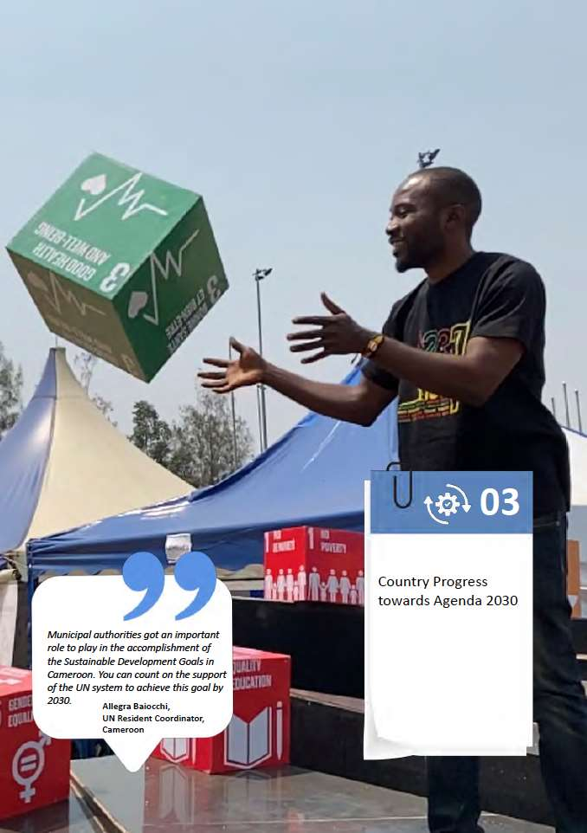

Country Progress Towards the 2030 Agenda

National trends in SDG indicators
Cameroon was ranked 28th out of 52 countries analysed in 2019. Out of 17 SDGs, nine are posing major challenges as illustrated in red in the table below.According to the Africa SDGs Index and Dashboard report, Cameroon belongs to a group of countries, which “must ensure that they leverage their growth in a way that reduces poverty and promotes human welfare, without compromising environmental sustainability”.
SDGs | SDG Index | Trend
- No Poverty | 43.2 | Stagnating | Major challenges remain
- Zero Hunger | 48.0 | Stagnating | Significant challenges remain
- Good health and Well-being | 42.7 | Stagnating | Major challenges remain
- Quality Education | 58.0 | Moderately improving | Significant challenges remain
- Gender Equality | 55.4 | Stagnating | Significant challenges remain
- Clean Water and Sanitation | 52.5 | Stagnating | Major challenges remain
- Affordable and Clean Energy | 64.9 | Moderately improving | Major challenges remain
- Decent work and Economic Growth | 67.1 | Moderately improving | Significant challenges remain
- Industry, Innovation and Infrastructure | 24.7 | Stagnating | Major challenges remain
- Reducing Inequality | 21.6 | Information unavailable | Significant challenges remain
- Sustainable Cities and Communities | 29.8 | Stagnating | Major challenges remain
- Responsible Consumption and Production | 86.0 | Information unavailable | Challenges remain
- Climate Action | 97.9 | On track or maintaining SDG achievement | Challenges remain
- Life Below Water | 35.6 | Information unavailable | Major challenges remain
- Life on Land | 69.8 | Decreasing | Challenges remain
- Peace, Justice and Strong Institutions | 45.4 | Decreasing | Major Challenges remain
- Partnerships for the Goals | 34.2 | Decreasing | Major challenges remain
SDG Index Score for Cameroon | 51.57
Source: Africa SDG Index and Dashboards Report 2019 - Cameroon

Analysis of trends
Cameroon carried out a consultative process to contextualise and prioritise the SGDs starting in 2015, with the technical support of the UN System in Cameroon. This exercise as outlined in the Prime Minister’s preface to the Contextualisation/Prioritisation Document, aimed at “strengthening national ownership and at domesticating the SDGs in a view to determining which of the targets are aligned with national development policies, including the 2035 Development Vision, and which ones respond to new development challenges”. Out of the 169 SDG targets , 152 were selected as relevant for Cameroon. Considering that the contextualised targets could not all be implemented simultaneously, the decision was taken to prioritise some of them. Out of the 152 contextualised SDGs targets, 46 were identified as priorities by the country. The trend analysis in this section takes into consideration the targets as contextualised by Cameroon.
An analysis of the country's progress towards achieving the SDGs by 2030 reveals a mixed picture. The only goal toward which Cameroon has made significant progress is SDG 13, relating to measures to combat climate change. Moderate improvement has also been observed on SDGs 4, 7 and 8, (relating respectively to Quality Education; Affordable and Clean Energy; and Decent Work and Economic Growth).
The trend that stands out the most is that of stagnation. Indeed, this concerns 7 out of 17 SDGs, notably SDGs 1, 2, 3, 5, 6, 9, and 11. The downward trends are to be attributed to SDGs 15, 16, and 17 (respectively relating to Life on Land; Peace, Justice and Strong Institutions; and Partnerships for the Goals).
However, the lack of data for some SDGs makes it difficult to analyse trends. These include SDGs 10, 12 and 14, respectively relating to Reducing Inequality; Responsible Consumption and Production; and Life Below Water.

People
Regarding the objectives linked to the "people" component, it appears from the analysis of the different sources, how difficult it is to obtain updated socio-economic statistical data, especially related to refugees and IDPs, groups often forgotten in National Statistics. However, the March 2020 Cadre Harmonisé covers all the 10 regions of Cameroon. It shows that the number of food insecure populations represents 11% (2.66 million persons) of Cameroon´s total population in crisis and emergency phases, while 7.5 million people are under the pressure phase of food insecurity. The poverty rate was at 37.5% in 2014, while the number of poor peaked at 8.1 million in the same year.
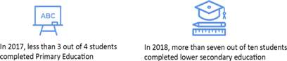In terms of education, in 2017, less than three out of four students (73%) completed primary education, compared to 78% at the end of the 2015-2016 school year, notably due to sociopolitical unrest in the Northwest and the Southwest, as well as in the Far North. In 2018, more than seven out of ten students completed lower secondary education, both in general and technical education.
The Government was committed to reducing poverty among migrant families by encouraging investment. The beneficiaries of funds from the Cameroonian diaspora were enrolled on small business initiatives and trainings on how to manage funds to improve their living conditions. Many discussions were held to find how to improve the services of transfer and minimise the cost of transfer to increase local development.
It should be noted that progress has been uneven across the regions and population groups, and in the event of a shock, the disparities could widen further, which would make it difficult to reach the SDGs.

Planet
Within the framework of the objectives of the "planet" component, access to water and sanitation and environmental issues remain problematic. If the lack of data makes it difficult to measure the progress made towards achieving SDGs 12 (Responsible Consumption and Production) and SDG 14 (Life Below Water), the country is, however, credited with a good performance according to the SDG Index and Country Profile Dashboard with regard to SDG 13. This progress has notably been made on the resilience and adaptation component to the effects of climate change (signature of international conventions on the environment, development of a National Action Plan to combat desertification, development of lowlands and reforestation as a mitigation measure for climate change, National Plan for Adaptation to Climate Change in Cameroon (PNACC), etc.) However, according to the VNR, the absence of updated statistics has not made it possible to measure progress on the other aspects of SDG 13, notably the mobilisation of resources for the operationalisation of the green climate fund, and the strengthening of the capacities of populations to cope with climate change. This situation is the same for SDG 15, in particular concerning data on the preservation and restoration of ecosystems, the exploitation and sustainable management of ecosystems, as well as the fight against desertification, land degradation and impoverishment of biodiversity.

Prosperity
As part of the objectives linked to the “prosperity” component, Cameroon promotes sustained, inclusive and sustainable economic growth. Cameroon's growth remains below the forecasts made in its strategy for growth and employment as since 2016 it has been less than 7%, i.e. 3.5% in 2017 and 4.5% in 2016. The annual growth rate in real GDP per capita was 3.3% in 2016 and stood at 2.7% in 2017 to rise to 2.9% in 2018.
Regarding the annual growth rate of real GDP per person with a job, the rate was 1.4% in 2016, fell to 0.8% in 2017 and rose to 1.15% in 2018 (Source VNR). The indicators used to measure the progress made in terms of full employment, decent work and youth employment are mainly provided by the Cameroonian Household Survey (ECAM). However, the most recent ECAM survey was carried out in 2014. This is a vivid reminder of the problem of updating statistical production. Regarding the average hourly earnings of men and women workers and the unemployment rate, there are no updated statistics for the period under review, the most recent data being from 2010.
Given the absence of disaggregated data on the tourism sector in Cameroon, the selected indicators could not be provided.

Peace
In line with Cameroon's Development Vision for 2035, SDG 16 aims to build peaceful and inclusive societies based on respect for human rights, the rule of law, good governance in all sectors of national life, and transparent, efficient and accountable institutions. In order to achieve this objective, the Government has focused on five of the twelve targets grouped around four measurable priorities. With regard to the reduction of all forms of violence and the death rates associated with it in general (SDG 16.1), INS statistics (2015) show that one in four adults (27%) say they feel generally safe. Furthermore, lingering political and security crises have resulted in significant conflict-related casualty rates and population movements. According to the Afrobarometer 2016-2018 (round 7) 42.3% of the population feel that their personal security has improved; 33% of Francophone and 7% of Anglophone are satisfied with the functioning of democracy; 59% think that municipal council members are involved in corruption; and 71% think that corruption has increased over the last year.

Partnerships
The various partnerships that exist at both national and international levels in the context of volunteerism make volunteerism the crosscutting framework par excellence for the implementation of the SDGs. As an illustration, more than 1500 international volunteers are currently deployed in Cameroon in various organisations to contribute to the achievement of the SDGs. On the other hand, more than 250 Cameroonians are deployed abroad as volunteers and also contribute to the realisation of the SDGs.
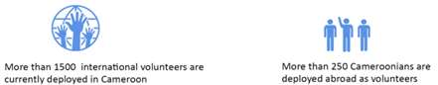

The National Volunteering Strategy, the network of Volunteer-Involving Organisations (VIO), and the Platform of Actors Working in Volunteerism in Cameroon (PLAVOLCAM), have benefited from the support of various national and international partners for their implementation. Especially the National Volunteerism Programme, as an output of the UNDAF 2018-2020, has benefited from the support of the United Nations agencies (UNDP, UNFPA and UNV), which demonstrates the importance of partnerships for the achievement of the SDGs in Cameroon through volunteerism.
SDG 17, for strengthening the means of implementation of the global partnership for sustainable development, contains 19 targets that are grouped into eight thematic areas: Finance, Economy, Technology, Capacity Building, Trade, Policy Coherence and Institutional Structures, Multi-stakeholder Partnerships, and Data, Monitoring and Accountability.
For Data, Monitoring and Accountability, which is of particular concern to M&E, the downward trend of SDG 17 (according to the National Strategy for the Development of Statistics and the NRV 2019) could be attributed to a number of factors linked to challenges with the National Statistical Information System (SNIS), including limited coordination and governance of the SNIS, the inadequacy of qualified human resources and their low motivation, the obsolescence of infrastructure, equipment and technological and statistical supports, the vulnerability of the financing mechanism, as well as the inadequacy and irregularity of statistical production. The limited funding has affected the conduct of major national statistical surveys (RGPH, ECAM, EESI, EDS-MICS, RGE, among others), thereby accentuating the difficulties related to the availability and updating of national statistics.
However, this weakness hinted at the prospect for Cameroon of exploring new sources of data to measure progress towards achieving the SDGs. Examples of the new sources of data are big data (human-sourced information, such as social networks), process-mediated data (search engines, commercial transactions), and machine-generated data (such as mobile phone location).
Indeed, the United Nations Global Working Group on the Use of Big Data in Official Statistics is working, in collaboration with countries and with their private sector partners, to demonstrate that unconventional data sources can be used in complement to official statistics. Even though many projects are still in the pilot phase, they already show that information can be obtained by combining data from traditional sources - censuses, surveys or administrative data - with other data from new big data sources. Cameroon intends to be part of this dynamic, through the imminent signing of a cooperation framework between the UN and the INS, which will aim among other objectives to propose local recommendations for how new sources of data could complement conventional data sources, especially concerning the leave no one behind agenda and gender data disaggregation.

Cities and Human Settlements
The creation of safe, resilient, inclusive and sustainable communities remains one of the biggest challenges of Cameroon. Progress on SDG 11 is stagnant, but the number of unplanned neighbourhoods with poor living conditions increase. Furthermore, there is limited data to monitor the situation and to generate informed decision-making from the national to the local level. Decent shelter and adequate housing meeting international and national standards are key to the reduction of inequality, insecurity, the prevalence of diseases, mental health problems and sources of discontent. In Cameroon “the rate of homelessness is therefore 19.1%, a demand for housing caused by an estimated 903,779 housing problems. Thus, the demand due to the housing deficit, which is the sum of the deficit caused by overcrowding and poor housing, amounts to 1,389,342 housing units”.
In sum, in order to achieve the SDGs in Cameroon, it is critical to put in place an integrated financing framework that combines an SDG oriented public finance system and other blended finance mechanisms. The Development Finance Assessment (DFA), conducted by UNDP in 2019, provides a comprehensive review of the development financing landscape for the period 2009–2017 and offers recommendations and proposals to strengthen the use, effectiveness and complementarity of various types of financial resources. Building on this evidence, the implementation of the new National Development Strategy (2020-2030), fully aligned to SDGs, requires an integrated financing framework which ensures coherence between the planning and financing systems, and engenders the mobilisation of public and private stakeholders around the national development strategy, and consequently the SDGs.
Domestic resources are important in Cameroon’s financing landscape: domestic tax revenue and domestic loans accounted for 76% of public sector funding in 2017. While government revenue has increased in volume since 2009 (driving the trend in overall public resources), it remains low in comparison to other countries and the minimum targets required for achieving SDGs. From 2013 to 2017, tax revenue accounted for 12,3% of GDP in Cameroon as compared to 20% in Senegal and 18% in Ghana. Cameroon needs to reach at least a tax-to-GDP ratio of 23% to achieve the SDGs.
Despite this weakness, the mapping of the funding sources in Cameroon reveals that there is potential for mobilising additional public, private, domestic and international resources to fill the gap and achieve the SDGs by 2030. The various sources of financing that could be exploited, and the elaboration of an integrated financing framework that combines an SDG-oriented public finance system and other blended finance mechanisms is essential.

The Nexus: Synergies Across the Humanitarian, Development and Peace Dimensions
There is a wide recognition in Cameroon that humanitarian, development and peacebuilding efforts are complementary and should reinforce each other. The roll out of the humanitarian-development-peace nexus in crisis-affected regions aims to achieve greater impact by responding to immediate needs, whilst building the resilience of the most vulnerable communities and people. The focus will be on enhancing food security, preventing conflict and disasters, reducing poverty, increasing access to adequate living conditions and public services, , promoting shared prosperity, and sustaining peace in situations of ongoing violent conflict, post-crisis situations and in disaster-prone areas. Cameroon is a pilot country of the UN Joint Steering Committee to Advance Humanitarian-Development Collaboration. Several initiatives have been taken to strengthen coherence, coordination and work in complementarity between humanitarian, development and government planning frameworks. The humanitarian-development-peace nexus approach has been integrated into the Humanitarian Needs Overview and the Humanitarian Response Plan, into the mid-term review of the UNDAF and the strategic positioning for the UNSDCF. It has also been discussed at the post-DSCE retreat in preparation of the new National Development Plan and during the following sectorial consultations. The objective is to integrate the approach into most humanitarian, development and peacebuilding frameworks, strategies and plans addressing needs, risks and vulnerabilities in crisis-affected areas.
The COVID-19 pandemic has become a global crisis with major and long-lasting impacts on social, economic, human rights, security and political sectors. COVID-19 has brought to light the gaps and inequalities in service provision, access to basic services and access to information, specifically for people in vulnerable situations, such as IDPs, refugees and urban poor, who cannot take adequate hygiene measures or practice physical distancing. If not properly addressed, the trade-off between saving lives and saving livelihoods will be excruciating and could increase social unrest. More than ever the humanitarian-development-peace nexus approach must be rolled out specifically in the crisis-affected regions with inequity being a driver of worst cases, and where the populations affected by forced displacement will bear the heaviest cost.
In order to address the long-term impact of the pandemic, the nexus strategic framework outlined below will strengthen the following courses of action:
1. Ensuring that health systems, essential primary health services and COVID 19 integrated preventive measures in open and closed public places are reinforced (pillar 1);
2. Helping people cope with adversity, through social protection, basic services and improved living conditions in houses and public spaces (pillar 1);
3. Protecting and creating jobs, supporting small and medium-sized enterprises, and including informal sector workers and the construction domain through economic response and recovery programmes (pillar 2);
4. Promoting social cohesion and investing in community-led resilience and response systems (pillar 2 and 3):
5. Strengthening multilateral and regional responses (programmatic and operational framework).

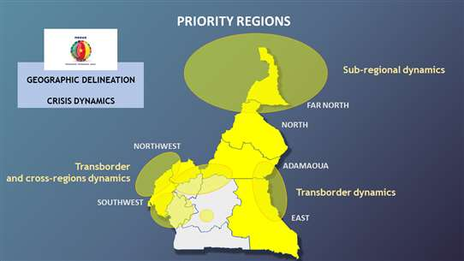
HDP nexus priority regions in Cameroon (HDP Nexus Task Force, 2019)

Analytical Framework

Far North, North, Adamawa and East regions
The Government requested the assistance of the World Bank, the United Nations and the European Union to develop a Recovery and Peace Consolidation Strategy (RPC) for the Northern and East regions of Cameroon for the period 2018-2022, combining recovery and development interventions and promoting a more efficient national and international engagement in response to the subnational crises. The OECD-DAC has agreed to support joint analysis efforts by leading a joint analysis exercise to enrich the RPBA conducted previously for the Northern and East regions. This analysis will also help to measure the impact of the COVID-19 pandemic in these regions.

Northwest and Southwest regions (NW/SW)
The OECD-DAC has also agreed to conduct a joint analysis based on the Resilience System Analysis tool in Northwest and Southwest regions as soon as the situation allows.
Meanwhile, the World Bank has started an Environment and Social Impact Assessment (ESIA) by generating an up to date, integrated, and multi-sector analysis of the scale and composition of the economic and social impact of the NW/SW crisis in the two directly affected regions, in the regions directly bordering these two regions, and at the national level. A comprehensive understanding of the drivers of and trends in conflict and fragility in NW/SW is being developed as a starting point for the ESIA. This will provide an evidence-based analysis on the dynamics of the crisis, its nature, and links between the regional and national level that might reinforce conflict dynamics and hamper development, and emerging key risks and opportunities. A better understanding of displacement dynamics and trends will be developed to inform the ESIA. The analysis would extend the work done in the Far North and East regions, focusing on mapping those displaced across geographic areas and population groups, understanding their living conditions and levels of access to basic services, adequate living environment and economic opportunities as well as possible discrimination they are facing, and the impact of displacement on host communities and cities in Cameroon.

Strategic framework
The humanitarian-development-peace nexus in Cameroon is based on coherent strategic planning encompassing one collective outcome and three pillars as outlined below.

Collective outcome
By the end of 2024/5, the populations living in areas of convergence in the Far North, North, Adamaoua, East, Northwest and Southwest regions (returned internally displaced persons, repatriated or locally integrated refugees and their host and/or communities of origin) recover indiscriminately their fundamental rights and improve their physical wellbeing and social welfare.
Pillar 1: Basic social services and adequate housing
By the end of 2024/5, the populations living in areas of convergence have an increased equitable and sustainable access to basic and social services.
Pillar 2: Sustainable livelihoods and economic opportunities
By the end of 2024/5, the vulnerable people living in areas of convergence have equitable and sustainable access to livelihoods and economic opportunities.
Pillar 3: Protection, social cohesion and local governance
By the end of 2024/5, good local governance and the consolidation of peace protect the fundamental rights of the populations living in the areas of convergence.

Programmatic framework
Different actors across the humanitarian, development and peace dimensions within and beyond the UN system will provide packages of intervention and contribute programmatically towards the achievement of the collective outcome, through their complementary but distinct actions and planning tools.
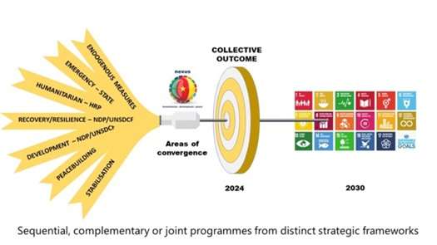
Humanitarian, development and peace nexus programmatic framework in Cameroon (HDPN Task Force, 2019)

Common principles of action
- Leave no one behind
- Build back better and safer
- Equitable and inclusive access to services
- Do no harm
- Accountability to affected populations
- Agro-ecological and agro-pastoral areas and livelihoods
- Appropriation of HDP nexus approach by local authorities and communities / Localisation
- Multi-sector approach
- Comparative advantage
- Partnership

Crosscutting issues
- Social protection: social safety nets; sustainable and free access to adequate housing and basic social services for most vulnerable people
- Gender, age, diversity
- Capacity building
- Prevention and management of social, economic and environmental risks
- Access to quality information and use of communication tools
- Access to communication for development
- Inclusion of the most vulnerable people in COVID-19 preparedness, response and recovery strategies;
- Area based integrated data collection

Operational framework
The humanitarian, development and peace actors will converge, coordinate and synchronise their data collection and priorities for interventions at municipality level in selected areas, based on specific criteria and crisis dynamics, and on a sequential approach taking into account the ability and potential to achieve collective results. Joint action plans will be developed for each of the selected areas of convergence to enhance coordination and strengthen coherence and complementarity.

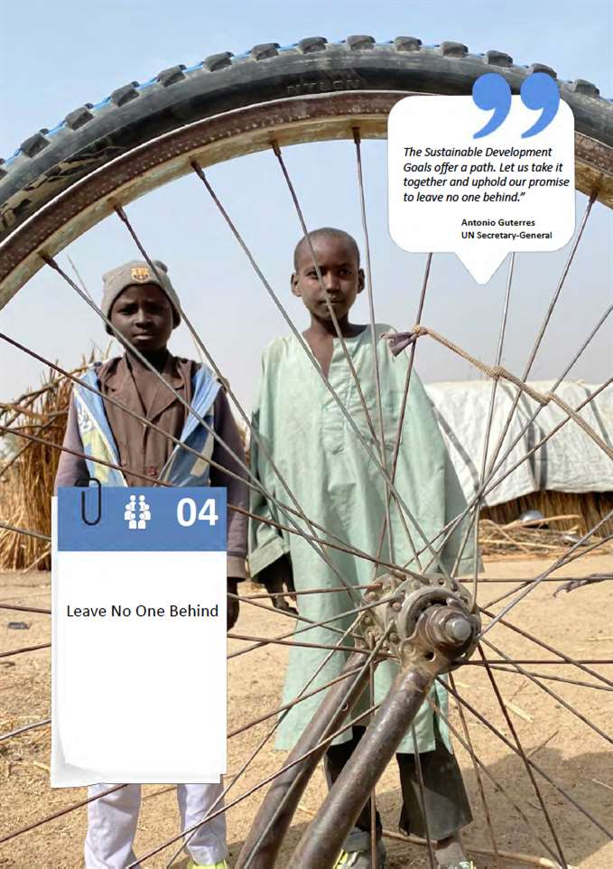

Leave No One Behind

Reducing inequality
Within the framework of the 2030 Agenda, UN Member States, including Cameroon, have pledged to “leave no one behind” in achieving the Sustainable Development Goals (SDGs) and focus on all forms of inclusion in 6 of the 17 goals. The economic dimension of exclusion refers to a lack of access to economic opportunities mainly related to the issues of monetary poverty, employment, access to production factors, new technologies and products/services delivered by formal financial institutions such as banks, cooperatives, microfinance institutions, etc. (Frota, 2007). In Cameroon, income disparities including high levels of vertical and horizontal inequality pose a serious problem, and people living in extreme poverty are left behind. Out of the total consumer expenditure in 2014, the poorest 20% of households shared 4.7% compared to 50.6% for 20% of the richest (UNDP, 2019).
The risk of exclusion due to location is considered a major fraction of total exclusion. The improvement in access to information for people living in remote areas through the development of community radio stations and the use of national languages is an illustration of the commitment to leave no one behind. In 2019, 4.3 million people were identified as people in need of humanitarian assistance (UNOCHA, 2019), most of them are affected by forced displacement (IDPs, refugees, and host communities). The vast majority, 1.9 million, live in the Far North region. In the conflict-affected areas in the Northwest and Southwest regions, respectively 0.35 and 0.54 million people need humanitarian assistance. These food insecure people are mostly located Bui, Menchum, Momo Division and Ngoketunjia in the Northwest, and Kupe Manenguba, Meme, Manyu and Lebialem in the Southwest.
The figure below shows the summary description of the different population groups concerned in 2020 (UNHCR, 2020).

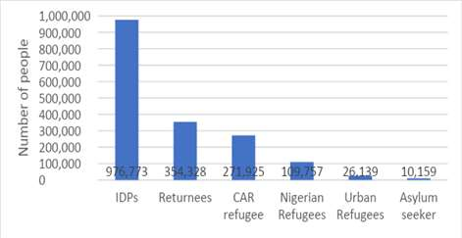
Number of people of concern in Cameroon
Source: https://data2.unhcr.org/en/documents/download/73909, Jan 2020

Even though food security experts are anticipating a slight improvement in food availability and access, the specific vulnerable groups in different geographical regions (Far North, Northwest and Southwest) require attention, also in order to achieve the economic development of the country. (Ministry of Agriculture, 2019).
People living with HIV are particularly vulnerable due to persisting stigma and discrimination affecting marginalised populations at high risk of HIV infection, including sex workers, injecting drug users and men who have sex with men. Only 81% of the 450,000 people living with HIV in Cameroon had access to life-saving antiretroviral therapy (ART) in 2019. Treatment adherence, which is necessary to achieve viral load suppression and stop the transmission of the virus, remains a major challenge. Access to services is limited for various reasons: distance to health care facilities, lack of financial resources to pay for transport, user fees charged for services, stigma, discrimination, insecurity, COVID-19 containment measures, etc. Malnutrition is also another factor contributing to the lack of adherence to ART. The introduction of a new policy by the government in January 2020 suppresses formal and informal HIV user fees and is expected to increase access to services and boost progress toward HIV targets.
The risk of exclusion due to existing gender disparities are also considered to be significant. The national gender inequality index of 0.879 places Cameroon 132nd of 188 countries in the Human Development Report. Women are also predominantly employed in unprotected jobs in the informal economy. They may not benefit from decent working conditions or social security, and have lower incomes than male workers (UNDP, 2019). Finally, migrant populations, from within the country or outside the country (including IDPs and returnees, who are extremely numerous in several parts of the country and particularly vulnerable, as well as Cameroonian migrants coming back from neighbouring countries, refugees and out of camp refugees) are at major risk of exclusion and need to be addressed through integration measures.
The risk of exclusion resulting from disabilities needs to be considered. WHO estimates that 15% of the world’s population has a disability and 75% of persons with disabilities living in emergency contexts are reported to lack adequate access to essential basic services such as water, shelter, food or healthcare. A 2016 study by Sight Savers International indicates that disability prevalence in Cameroon was about 10.5%. Women with disabilities face double discrimination, and, compared to men and boys, women and girls with disabilities are more likely not to receive education, to be victims of gender based violence, and to remain single, amongst others. With limited education, persons with disabilities will consequently have limited opportunities for employment, and even when educated, the lack of access to information, the stigma/bias of employers and the cost of accommodation or work places might reduce their chances of employment. In the Strategic Vision for Gender Equality of the Department for International Development (DFID), launched 7 March 2018, it is mentioned that “A disproportionate number of girls and women living in poverty experience additional discrimination because of their disability, ethnicity, religion or belief, sexuality, location or other characteristic, which further limits their prospects and opportunities.
Indigenous peoples are at risk of exclusion. Some 10% of the population of Cameroon have been identified as indigenous peoples. These peoples are divided into two major groups — the forest peoples commonly known as Pygmies and comprised of the Baka, Bakola or Bagyéli and the Bedzang in the east of Cameroon and the Mbororos (Nomadic herders) found in the West, East, and Northwest regions, and in the northern part of the country. They often live in inaccessible and geographically isolated areas, and suffer discrimination, stigmatisation and marginalisation, leading to a low level of participation in decision-making processes at both the community and national levels. Their lands come under pressure because of forestry and mining interests, conservation activities and agribusiness, which can restrict their access to the natural resources (products of hunting, gathering and grazing) upon which they depend for their livelihoods. Their work is often exploited and they lack access to the labour market. A high infant mortality rate also prevails in the indigenous communities. Access to free education adapted to the indigenous cultures is limited and school curricula take no account of the specific characteristics of the population groups, nor are the communities involved in the planning of the curricula.
Populations affected by forced displacement – IDPs, refugees and their host community or community of origin - are vulnerable groups that must be empowered through efforts to implement the SDGs. Leaving communities affected by forced displacement behind in continued marginalisation without the prospect of durable solutions may become an obstacle to long-term peace stability, recovery and reconstruction in Cameroon. While there are no SDG targets or indicators specifically related to forced displacement, the 2030 Agenda presents an opportunity to build on existing efforts and ensure that the plight of these populations is addressed in both the short and long terms.
Other groups that run the risk of discrimination in Cameroon include LGBTI, and the Anglophone minority.

The immediate, underlying and root causes of exclusion in all areas
The immediate, underlying and root causes of exclusion have been identified as the following:
- Extreme poverty is one of the main underlying causes of risks. Between 2007 and 2014, the number of poor people in Cameroon increased by 12% as the total poor reached 8.1 million, and the poverty rate 39%. Poverty is concentrated in the Far North, North, Adamawa and Eastern regions, where 90% of people requiring humanitarian support reside.
- Prolonged issues stemming from insecurity and cross border conflicts are considered as root causes of risks. Conflicts in northern Nigeria and north-western Central African Republic exacerbate poverty by displacing refugees to Cameroon. Insecurity hampers humanitarian access in the Far North and along the border in the East. Further, the Far North has been the target of Boko Haram attacks since 2013. Joint military operations by Cameroon and Nigeria have dispersed many of the fighters, but small groups still carry out unpredictable attacks that result in the inaccessibility of many areas.
- As per the latest statistics, more than 400,000 people have been displaced due to the Boko Haram crisis (not counting refugees outside camps). Further, 112,228 Nigerian refugees in the Far North region and 272,273 refugees from the Central African Republic are currently under UNHCR competency.
- Although national commitments and plans are now in place to pursue the SDGs, communities affected by forced displacement are being left behind as refugees, IDPs and other people caught in crisis are not systematically included in the country's SDG progress reports, national surveys to determine socioeconomic status and needs, or national development and sectoral plans.
- Extreme climatic events (floods and prolonged dry periods) also cause food insecurity in the Far North, Adamawa and North regions and limit market functionalities. Climate change impacts will further exacerbate inequalities between the resilient and vulnerable farmers in the future.
- Gender inequality is also considered another underlying cause of risks. 65% of women are literate compared to 78% of men leading to poor economic and educational productivity among females. Excluding women and girls from discussions and from participative development processes (which still happens too often) means excluding 52% of the population from the development process.
- The lack of access to basic amenities, such as water and sanitation, causes huge problems to households and affects especially children, women and girls who have special hygiene needs. Limited access to clean water and sanitation, higher prevalence of diarrhoeal diseases, and poor access to health care and vitamin A treatment hamper the consumption of nutritious food by children (WFP, 2017).
- Gaps in educational services are another major underlying cause of exclusion. In 2015, primary and secondary school enrolment rates were reported as 90% and 50% respectively (UNDP, 2019). Under universal access to education, all people should access primary education. Unemployment and underemployment are also considered as immediate causes of risks of exclusion in Cameroon.
- Social exclusion also significantly affects people living with HIV and key populations at higher risk of HIV infection as they continue to suffer from high levels of stigma and discrimination. Laws that criminalise the behaviour of key populations fuel the HIV epidemic and must be suppressed.
- Poor governance is considered the main structural factor driving social exclusion. Inadequate public policies, corruption, increased misappropriation of public funds, nepotism and ethnic discrimination, risky management of public goods and a lack of accountability could create a significant distance between the elite and the citizens.
- Furthermore, the gaps and differences between urban and rural areas, regions and councils, and agro-ecological areas also create disparities and discrimination among people. Sometimes, the cultural values of community groups, marginalised groups such as youths, women and girls, people with disabilities, indigenous people and orphans, in lack of better social protection systems for economically or socially vulnerable groups (e.g., social insurance and various safety nets) will guarantee relief against misery, and establish acceptable minimum living standards for the marginalised. The Government of Cameroon has produced a National Strategy for the Extension of Social Protection (SNePS) in 2013, and a social protection policy was adopted in 2017. The SNePS aims to help reducing vulnerability among disadvantaged groups and in coping with significant risks in life, such as health related problems, and has four priorities: i) universal access to health care; ii) social assistance for vulnerable populations; iii) promotion of employment intensive programmes; and iv) expansion and modernisation of existing social security schemes.
A strategy for the better use of public investment to develop resilience, livelihoods and the economic inclusion of marginalised groups is a solution in the long run to move people out of a vicious circle by empowering their potential to generate an income. The UN and the development partners should strengthen institutional capacities and allocate initial resources for better public investment planning. It is recommended for Cameroon to establish a social registry to assist the most vulnerable and economically poor people while following a sustainable and transparent process that respects the principle of leave no one behind. The governance of the process, which includes the quality of coordination, the quality of spending and the quality of monitoring and evaluation is another important factor. Better sectoral planning taking advantage of cross-sectoral synergies, budgeting sensitive to the SDGs, transparency of the public financial management system and a duty of accountability are essential to have in place.
In addition to these challenges, also the limited availability of statistical information and the inclusion of vulnerable people in policies and strategies related to the implementation of the SDGs need to be addressed. The following is needed: (i) to plan during the process of integrating the SDGs into the strategies, an operational approach for their implementation so that we do not limit their integration only in the strategies but also in the MTEFs and budgets, (ii) mobilise resources for the production of the statistics necessary to monitor the implementation of the SDGs, (iii) define a strategy for mobilising resources to finance the implementation of the SDGs, (iv) take into account the level of contribution to the fight against poverty as a criterion for allocating resources to sectors, regions and decentralised local authorities.

Access to Education
In relation to access and the dropout rate in the Cameroonian education system, about 8% of Cameroonian children do not have the chance to access primary education. For those who access it, 72% do not complete primary education. At the lower general secondary education level, only 51% of children who complete primary education go on to lower secondary education and 43% of them complete it. The primary-college transition has deteriorated from 84% in 2011 to 72% in 2018. This trend indicates a weak performance of the system, particularly in primary and lower secondary education, showing that major challenges in terms of retention are still to be met in the perspective of universal primary education, which remains the main objective of the education development strategy. This low retention would depend on a high level of repetition and dropout, which contribute to generating significant wastage of public funds allocated to the system. In fact, in 2018, the repetition rates were 12% in primary and lower secondary and nearly 18% in upper secondary levels. In addition, 47.2% of the resources allocated to primary education are "wasted" due to repetition and dropout. At secondary level, the "wasted" resources are of the order of 20% and 37.9% respectively for lower and upper secondary education.
In terms of disparities, the chances of schooling are unfavourable for girls, rural people and the poorest 20%. Gender disparities to the disadvantage of girls appear at the beginning of primary school and narrow along the schooling path without completely disappearing. At the beginning of lower secondary education, only 44% of girls and 52% of boys of school age are enrolled. Data shows that while rural people account for nearly 52% of the total population aged 5-24, they represent 81% of young people who have never been to school. Nearly 77% of out-of-school children come from the first two quintiles of the poorest households. Out of 100% of children from rich families who expect to have access to school, the probability of access is estimated at only 76% for children from poor families. As a direct consequence of disparities in schooling, inequalities are observed in the appropriation of resources allocated to education. In fact, 10% of the most educated children appropriate nearly 33% of public education resources. Moreover, recalling that compulsory schooling is one of the most effective means of combating child labour, ILO supervisory bodies have urged the Government to take the necessary steps to make education compulsory up to the minimum age for admission to employment, namely 14 years.
The quality of learning also remains a major challenge for the Cameroonian education system. Indeed, 1 out of 2 pupils cannot read or calculate at the end of primary school and 2/3 of pupils are below the threshold of skills expected at the end of primary school. According to a World Bank study, 77% of children at the end of primary school cannot read and understand a short story (compared to 58% for the average of comparable countries in terms of income). Factors that hamper quality include the unfavourable school environment in which the children live, the unsuitable content of the curricula, and the shortage of trained teachers, which deteriorates pupil/teacher ratios.
At the primary levelthe allocation of teachers is not equitable. The pupil/teacher ratio in the public education is still relatively high compared to the indicative standard of 40 pupils per teacher. It is 80 without the parents' teachers and 50 with the parents' teachers, with very important regional differences, largely compensated by the parents' teachers. The question of the parents' teachers is still a real problem if we want to achieve free and fair access to them, since their care is almost entirely provided by the parents. They still represent more than 30% of the teaching staff.

Health Exclusions
The most vulnerable and systematically more disadvantaged groups in relation to access to health information and services are the following: (i) women and girls, including pregnant women facing multiple barriers in accessing obstetric care and girls exposed to various forms of violence; (ii) marginalised youths living in overcrowded areas and/or being exposed to violent extremism in insecure areas, often displaced or with refugee status; (iii) children facing barriers in accessing education; (iv) people living with disabilities; (v) indigenous peoples who prefer to adopt traditional health practices and live in remote areas and (vi) the elderly. In response to this situationthe efforts of policymakers and development partners need to be based on policies, strategies and interventions that address the structural factors of inequality/inequality in a sustainable manner.

Social Exclusion
Urbanisation has been one of the most striking demographic facts in Cameroon over the last four decades. The urban population is growing rapidly, driven by the migration of rural populations: 6.4% per year on average between 1976 and 1987, and 4.2% between 1987 and 2005. According to UN-Habitat (2019), more than half of the country's population, 56.3%, live in urban centres. According to the results of the Third General Census of Population and Housing (RGPH), the population in the 0-17 age group accounted for 50.6% of the total population in 2005, or 8,828,875 children in absolute numbers. In other words, slightly more than half of Cameroon's population is made up of children, which reflects the extreme youthfulness of the population and places a heavy burden on the state and on households.
Despite the progress at the national level, the socioeconomic situation in Cameroon is marked by deepening social gaps and difficulties in social inclusion. The most striking disparities are observed between urban and rural areas, between different regions, between poor and non-poor populations and to the disadvantage of specific groups including women, people with disabilities, children (especially orphans, children with disabilities and girl mothers), indigenous populations, persons without IDs, etc. An examination of the initiatives put in place in favour of equity reveals a non-inclusive system.
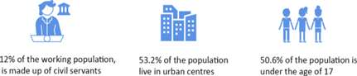
According to the results of the ECAM4, around 12% of the working population, consisting of civil servants and those in similar positions as well as private sector workers covered by the Labour Code, benefit from this security, while the vast majority (estimated at 88.6% according to ECAM4) are excluded and exposed to social risks not covered. Those who work in the informal sector are the ones who suffer the most (completely left to individual initiative), they are not protected, there is no insurance. They are not documented and therefore, remain vulnerable to corruption. Some categories of workers, such as artists and cultural service providers, do not benefit from a category protection scheme (status of the artist).

People living with a disability are among the physically, socially, politically and economically vulnerable populations and therefore deserve special attention in government development programmes and in cooperation programmes between the government and its bilateral and multilateral partners. As noted above, people living with disabilities represent 5.4% of the country's population. In other words, one person in twenty suffers from a disability, which is not negligible.

Gender and Exclusions
Rural dwellers, women and female-headed households, poor people, indigenous hunters and gatherers, persons with disabilities, girls, boys, LGBTI, the elderly, IDPs, refugees and host communities are the groups left behind in Cameroon (LNOB Cameroon report 2020, pg 5). Women in general are often left behind, with rural, poor, non-French speaking being the most disadvantaged (LNOB report, 2020 Pg 24). Women face educational, cultural and economic barriers. They face historic patterns of exclusion and gender-based violence, and they are subject to harmful practices such as child marriage, FGM and breast ironing. They are excluded from power structures and have lower participation in political processes. They face discrimination and mistreatment. Social, cultural and economic forces combine to create inequality. The Government will need to invest in the education and economic empowerment of women to reduce these inequalities.

LNOB Food and Nutrition Security Analysis
Rural communities are more vulnerable to food insecurity (22.2% food insecure and 1.4% severely food insecure) than households located in urban regions such as Yaoundé or Douala (10%) (WFP, 2017). Also, vulnerability to food insecurity is very high in households headed by females or households with elderly or chronically ill members.The Global Nutrition Report (GNR, 2018) showed that Cameroon is on course to meet the global nutrition target for infant breastfeeding and with some progress on under five stunting and wasting, and women of reproductive age. However, a lot of effort is needed for the low birthweight, adult obesity, diabetes, and under-five overweight.
Even though refugees in Cameroon enjoy many fundamental rights, such as the right to work and the right to education and healthcare, most Central African Republic (CAR) refugees nevertheless live in extreme poverty in the least developed regions of the country. Results from vulnerability analyses revealed alarming levels of extreme poverty amongst the refugee population, showing that over 80% are considered ‘extremely vulnerable’ and in need of assistance. More than 98% of CAR refugees are under the national poverty line and struggle to meet their basic needs in terms of food, non-food items and the financial costs related to health, education and shelter (UNHCR, 2019).
Agriculture plays a key role in food security with women producing 80% of food (UNDP, 2019). However, the asymmetries in ownership and access to vital livelihood assets (such as land, water, energy, credit, knowledge and labour) constrain women’s contributions to food production. This is because they are often constrained heavily by discriminatory policies and social norms deeply rooted in the culture limiting their access to productive inputs, assets and services (National Gender Policy (NGP) 2011-20). Consequently, one in five households tend to adopt coping mechanisms (stress (26.3%), crisis (18.1%) and emergency (2.9%)) that have a negative impact on their livelihoods (WFP, 2017).
There seems to be unanimity that eradicating hunger, food insecurity and malnutrition requires a common understanding of the root causes of these three scourges. A sound analysis can shape policies, investments and actions that understand the needs of the most vulnerable men, women and children. However, analysis can only add value when it is based on credible data, statistics and information. Therefore, it is crucial for Cameroon to generate reliable data, and to make it available and accessible in a timely manner. This will be especially important for measuring the progress of the implementation of the 2030 Agenda. Moreover, partnerships with the national systems, private sector, NGOs, research institutes, and also building the capacity of these partners, will offer long-term sustainability and improved food and nutrition security.

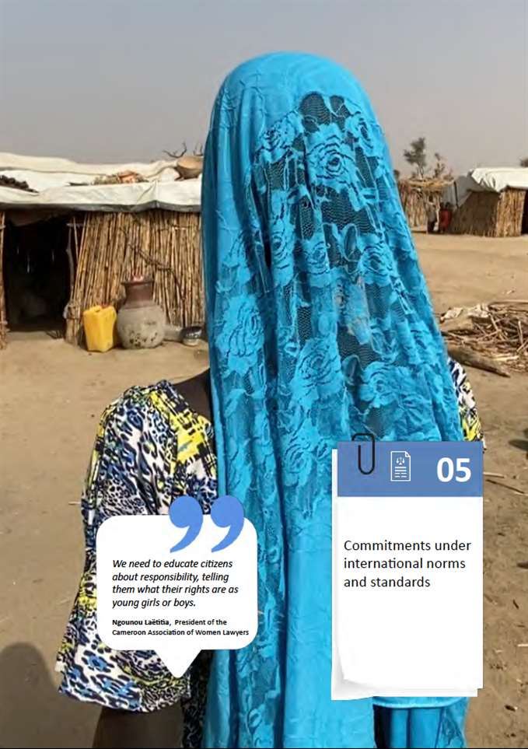

Commitments under international norms and standards

Regarding the national legal framework for decent work and productive employment in Cameroon, the labour code places emphasis on the protection of the employee, the requirements for employment and safeguarding business and jobs. This code responds to companies' need for flexibility and the promotion of employment and working conditions. . It is perceived as an instrument of quantitative employment policy, which delivers new hiring formulas (temporary, casual and seasonal contracts). The question of upscaling the minimum wage, currently at a low level, also constitutes an important challenge in the debate on the quality of work and the productivity of the workforce.
The law of 18 April 2013 that sets incentives for private investment in the Republic of Cameroon aims to promote productive investment in order to develop activities to promote strong, sustainable and shared economic growth, as well as employment. The law grants a certain number of tax exemptions and tax advantages during the investment and operating phases to companies investing in Cameroon, in exchange for certain obligations. The major bottleneck with this law is the inadequacy of incentives in terms of job creation by the private sector. In addition, more recently, by decree of June 20, 2018, the public procurement code supports the use of a labour-intensive approach in public investment programs. As part of the way forward, a national labour-based strategy should be developed and investment incentives for growth and productive employment effectively put into practice.
At the international level, the normative framework in the field of work is inscribed in over a hundred ILO conventions. As a signatory to the Universal Declaration of Human Rights, Cameroon undertakes to respect fundamental human rights and principles and to make so that no one is marginalised in their work for their origins, gender, race or opinions. The country is also committed to other normative instruments such as: (i) the African Charter on Human and Peoples' Rights; (ii) the resolutions of the 1995 Copenhagen World Summit on Social Development; (iii) the declaration of the African Union summit on employment and the fight against poverty. Cameroon has also subscribed to international commitments in the field of sustainable development (SDGs) and has adhered, for more than a decade, to the Recommendations of the Extraordinary Summit of Heads of State and Government of the African Union of Ouagadougou in 2004 on the employment and poverty reduction in Africa, which aim to make employment as much an inducer as a result of economic growth. These instruments (UDHR, ILS, SDG) indicate that to achieve diversification, labour market and employment/training policies cannot be designed without referring to other strategies in key areas such as industry, the digital economy, the environment and the green economy, agriculture, trade, tourism, crafts, education, local public services, infrastructure, energy.
In terms of ratifying International Labour Standards, Cameroon has ratified 50 ILO conventions, of which 41 are in force. The country is a State party to the eight ILO fundamental conventions, three governance conventions, and 39 technical conventions. Recently, Cameroon has had difficulties in complying with some of its standards-related obligations, namely submission and reporting. (Periodic) reports on the application of ratified conventions did not reach the ILO in 2019. ILO regular supervisory bodies were therefore unable to conduct a comprehensive examination of the application of the conventions concerned.
Cameroon has not yet ratified the Hygiene (Commerce and Offices) Convention, 1964 (No. 120), but is endeavouring to do so in compliance with a 1984 decree, which specifies the measures and provisions necessary to regulate the working environment and the physical and mental health of the worker. While it has yet to ratify the Employment Services Convention, 1948 (no. 88), Cameroon has an operational public employment service (The National Employment Fund) and is currently investing in a process of decentralising its services to the benefit of the labour force. Moreover, the country has not yet ratified the Human Resources Development Convention, 1975 (No. 142), Social Security (Minimum Standards) Convention, 1952 (No. 102), or the Domestic Workers Convention, 2011 (No. 189). However, since 2019, it has analysed the conditions for setting up 9 social security benefits in the country. Moreover, Cameroon has yet to ratify instruments concerning occupational safety and health (general provisions, specific risks and branches of activity), labour inspection, labour administration (labour statistics), and employment policy (employment services and private employment agencies) that have been considered as up-to-date by the ILO Standards Review Mechanism Tripartite Working Group (SRM TWG), and whose ratification is promoted. Such standards respond to the changing patterns of the world of work, for the purpose of the protection of workers and taking into account the needs of sustainable enterprises.
The implementation of international labour standards serves as a trigger for the adoption of policies and programs/reforms to accelerate the achievement of the related SDGs. For example, measures to give effect to the provisions of Employment Policy Convention, 1964 (No. 122) in Cameroon have made a real contribution to improving the mainstreaming of employment in development strategies. This places the country in a better position for achieving the SDG 8 targets on labor productivity (8.2), business development and formalisation (8.3), lower unemployment among young people and equity in remuneration for work (8.5). The ratification and implementation of conventions on security and social protection should help accelerate the achievement of SDGs 1, 3, 5, 8, 10 related to poverty, social protection, gender, inclusive growth and decent work. Additionally, the Employment and Decent Work for Peace and Resilience Recommendation, 2017 (No. 205), deserves special attention in view of the difficult security context linked to poverty and the strong under-utilisation of the workforce. The application of this standard will promote an environment enabling the social and economic inclusion of young men and women in vulnerable communities by training and involving them in the highly intensive labour programme. It could serve as part of the decentralisation policy, to further strengthen the humanitarian-development nexus.
These deficits in the ratification and application of international labour standards are real bottlenecks that need be lifted to accelerate the achievement of the SDGs, strongly accompanying the structural transformation of the country and the 2035 vision of the emergence of Cameroon. Regarding the sustainable response to the COVID-19 pandemic, reinforcing social dialogue and respect for the civil liberties of employers’ and workers’ organisations and those of their members is instrumental in maintaining social cohesion and building resilience. Guidance given by the ILO supervisory bodies on the application of the two fundamental conventions on freedom of association and collective bargaining serves to identify important areas for action, including capacity building, to allow for mature social dialogue to take place in the process of building back a better and more sustainable economy.

Human Rights
Cameroon is party to most of the key international human rights instruments and is making efforts to fulfil its obligations under them, including by submitting reports to the treaty bodies and implementing resulting recommendations. Cameroon is up to date with the submission of reports to all treaty bodies - with the exception of the Convention on the Elimination of All Forms of Discrimination against Women, the report of which is under finalisation. Cameroon was reviewed by the Universal Periodic Review (UPR) in May 2018, and received 196 recommendations, 134 of which were accepted, three were subject to further clarification and 59 were noted. On 20 September 2018, the Human Rights Council considered and adopted the outcome of the review of Cameroon. On 2 November 2018, the UN High Commissioner for Human Rights sent a follow-up letter to Cameroon, highlighting areas and actions that will particularly support the implementation of UPR recommendations made by states in the course of the review.
At the African level, Cameroon is party to the African Charter on Human and Peoples' Rights; the Protocol to the African Charter on Human and Peoples' Rights on the Rights of Women in Africa; the African Charter on the Rights and Welfare of the Child; the African Charter on Democracy, Elections and Governance; and the AU Convention relating to the Specific Aspects of Refugee Problems in Africa.
With regard to Special Procedures mandate holders, Cameroon issued a standing invitation on 15 September 2014, granting the Special Rapporteurs the freedom to visit the country without restrictions. However, no visits have yet taken place. The visits by Special Rapporteurs including the Special Rapporteur on the independence of judges and lawyers and the Working Group on Arbitrary Arrest and Detention, as well as the Special Rapporteurs on minorities and internally displaced persons are, however, critical in view of the crises that have been raging in the Southwest and Northwest regions of the country since 2016, resulting in human rights violations and increased use of hate speech in the media.
The progress made with regard to international instruments has been materialised in recent years through the adoption of national texts to guarantee the effectiveness of the rights enshrined. In July and August 2018, various regulatory texts were adopted to establish the modalities for the implementation of Law No. 2010/002 of 13 April 2010 on the protection and promotion of persons with disabilities. However, Cameroon has yet to ratify the Convention on the Rights of Persons with Disabilities. Similarly, in July 2019, Cameroon adopted a law reforming the National Commission on Human Rights and Freedoms, which, in this context, was given the mandate of national mechanism for the prevention of torture under the Optional Protocol to the Convention against Torture, which Cameroon has yet to ratify.
Despite the progress made, important treaties are yet to be ratified, including the Second Protocol to the International Covenant on Civil and Political Rights on the abolition of the death penalty; the Optional Protocol to the International Covenant on Economic, Social and Cultural Rights; the Second Optional Protocol to the Convention on the Rights of the Child; the Optional Protocol to the Convention against Torture; the International Convention on the Protection of All Migrant Workers and Members of Their Families; the International Convention on the Protection of All Persons from Enforced Disappearance; and the International Convention on the Rights of Persons with Disabilities. At the African level, Cameroon has not yet ratified the Protocol to the African Charter on Human and Peoples' Rights on an African Court on Human and Peoples' Rights.
The major challenge facing Cameroon lies with the implementation of the recommendations following the reviews by international human rights mechanisms, which have a greater impact on vulnerable groups. A project toward a thematic compilation of all the recommendations is scheduled for 2020 with the aim of rendering them more accessible and facilitating the adoption of an implementation plan.
Cameroon has been party to the International Covenant on Civil and Political Rights (ICCPR) since 27 June 1984, which recognises public freedoms and specifically the right to participate in public affairs, freedom of association, demonstration and assembly, as well as the African Charter on Human and Peoples' Rights in 1989.
In order to fulfil its obligations under international instruments, Cameroon has adopted domestic laws that guarantee the right to freedom of association and peaceful assembly.
International, African and sub regional instruments that guarantee peace and social cohesion:
- 1951 Refugee Convention and its 1967 protocol
- UDHR
- ACHPR
- The African Charter on Democracy, Elections and Governance
- CEMAC Non-Aggression and Solidarity and Mutual Assistance Pact
Cameroon has initiated a process of reflection for the ratification of ILO Convention 102 on Minimum Standards of Social Security (1952), which has not yet been finalised. However, national legislation on social security meets the conditions for ratification of this Convention, with the exception of medical care, sickness benefits and unemployment benefits. In practice, only workers in the formal sector and their dependants are covered by this legislation.
Furthermore, Cameroon has ratified the International Covenant on Economic, Social and Cultural Rights and the Convention on the Rights of the Child, as well as the optional Protocol to the Convention on the Rights of the Child on the involvement of children in armed conflict (OPAC).
Cameroon is a State party to the 1951 Convention and its 1967 Protocol Relating to the Status of Refugees as well as to the 1969 OAU Convention Governing the Specific Aspects of Refugee Problems in Africa, and possesses a national legal framework. These laws provide for a range of rights to refugees and, in this respect, Cameroon has a progressive legal framework. The main challenge is the implementation of the laws, particularly with respect to key aspects including the compliance with the principle of non-refoulement, the issuance of identity documents and the registration and adjudication of asylum claims by the Government, as well as the realisation of certain social and economic rights through increased access to basic social services, which remains an issue also for the wider Cameroonian community.
The Kampala Convention as well as laws/regulations intended for IDPs has not yet been on the agenda of the parliament although the Convention was ratified in 2017. The UN needs to advocate strongly for the Government of Cameroon to work on a national legal framework protecting IDPs
Cameroon adopted the Global Compact for Safe, Orderly and Regular Migration (GCM) in December 2018. A national consultation was held in October 2018, gathering ministries, members of civil society and UN agencies in order to identify the Government’s priority needs to improve governance in the field of migration.
As there was until now no official national document ruling migration, efforts are currently made by the Government and its partners to define and implement a viable migration policy to better deal with displacements and to ensure safe, orderly and regular migration in accordance with SDG 10.7. This aims to reduce irregular migration, including human trafficking and human smuggling, and contribute to protect particularly vulnerable populations exposed to such practices.A United Nations Network on Migration has also been established in order to facilitate the implementation, follow-up and review of these conclusions and provide timely and effective support to the Government on migration policy. This network aims to foster a better understanding of current and emerging issues on migration, taking into account already existing legal frameworks.
The constitution outlines that the state shall guarantee a child’s right to education. However, equal and lasting access to education for girls is often not a reality, an example of discrimination encountered by girls. With regard to disability, disabled persons are severely affected by factors leading to poverty. Children face barriers to education, youths are in a disadvantaged position to access training, and adults encounter obstacles to decent work.

Rule of Law
The innovations of the legal arsenal include: Law No. 2019/024 of 24 December 2019 on the General Code of Regional and Local Authorities; Law No. 2019/020 of 24 December 2019 amending and adding supplements some provisions of Law No. 2016/7 of 12 July 2016 relating to the Penal Code, including and criminalising contempt of race or religion (article 241- new) and contempt of the tribe or ethnic group (article 241-1 - new); Law No. 2019/019 of 24 December 2019 promoting official languages in Cameroon; Law No. 2005/007 of 27 July 2005 on the Criminal Procedure Code (CPC), offers a guarantee of the rights of the defendants accused throughout the legal proceedings; Law No. 2017/12 of 12 July 2017 on the Code of Military Justice confers exclusive jurisdiction on military courts to hear and determine, among others: war crimes, crimes of genocide, crimes against humanity, offences relating to acts of terrorism and the security of the State (Article 8).
Judicial power is exercised by judicial, administrative and audit courts, the Special Criminal Court (SCC), military tribunals, and special courts such as the High Court of Impeachment and the State Security Court.
Even though Cameroon is a de facto abolitionist state, death penalty remains part of the state legislation, in Law No. 2014/028 December 2014 on the suppression of acts of terrorism.
In the judicial sector, the main challenges concern the strengthening of the institutional independence of the judiciary, in order to protect it from interference and pressure from political and executive authorities as well as other actors. Other hindrances to the rule of law reside with the lack of ownership and application of international human rights standards by magistrates and other judicial practitioners, and limited access to justice, in particular for vulnerable groups, including people with low incomes. Legal aid as provided by Law No. 2009/004 of 14 April 2009 has not been fully implemented, due in particular to the lack of awareness of the beneficiaries, and weaknesses in the operation of legal aid commissions. Insecurity and the destruction of infrastructure linked to the crisis in the Northwest and Southwest regions have further aggravated the difficulties of access to justice in these regions.

Anti-corruption
The Government has strengthened its anti-corruption legal framework by ratifying the United Nations Convention against Corruption (UNCAC, 2006), by ratifying the African Union Convention on Preventing and Combating Corruption in March 2020, and by revising the Penal Code (2016) which has internalised certain offences of the United Nations Convention against Corruption. At the judicial level, several trials have been initiated against persons suspected of misappropriating public property. These legal actions have resulted in the imprisonment of several political figures and director generals of public institutions.
In the social sphere, the main difficulty is the lack of reliable mechanisms to protect whistle-blowers and victims of corruption, as it has been shown that, in the event of action, the latter remain exposed to reprisals from those who take advantage of the corruption system.

Gender
Cameroon is a State party to the Convention on the Elimination of All Forms of Discrimination Against Women (CEDAW) and all legal texts relating to the fight against discrimination against women. These include international texts, in particular the 1948 Universal Declaration of Human Rights (UDHR), the International Covenant on Economic, Social and Cultural Rights, the Convention on Discrimination in Employment and Occupation Convention, 1958 (No. 111), the Equal Remuneration Convention, 1951 (No. 100), the Convention on Consent to Marriage, Minimum Age for Marriage, conventions on equal remuneration and on the political rights of women, and the Protocol to the African Charter on Human and People’s Rights on the Rights of Women in Africa.
Although these commitments take precedence over national laws, customs and traditions, Cameroon has repeatedly demonstrated a preference for customary laws. Apart from international instruments, there are national instruments adopted by Cameroon which generally or specifically take into account the principles and values that underpin gender equality, human rights and social justice: the Constitution, Codes, laws, regulatory instruments, etc. (LNOB report, p. 25).
Despite the political will to promote women, there are still significant gaps such as: (i) insufficient coordination of interventions by CSOs/social partners and development partners; (ii) insufficient national ownership of texts relating to the social protection of women's rights; (iii) the deficiency of qualified human resources in terms of combating discrimination against women and reception and care structures; (iv) socio-cultural constraints linked to hierarchical social status, especially in the northern part of the country.

Children
Cameroon signed the Convention on the Rights of the Child on 25 September 1990 and ratified it on 11 January 1993. The Optional Protocol to the Convention on the Rights of the Child on the involvement of children in armed conflict was ratified on 4th February 2013 while Cameroon launched the ratification process of the Optional Protocol to the Convention on the Rights of the Child on the sale of children, child prostitution and child pornography in 2019. Cameroon ratified the African Charter on the Rights and Welfare of the Child on 5th September 1997. However, the signature and ratification of the Acceptance of individual complaints procedures for Cameroon regarding the Convention on the Rights of the Child is still pending.
The country deployed numerous efforts to meet the requirements of these international and regional standards and is equipped with a National Policy on Child Protection and a National Multisectoral costed Action Plan, as well as a costed National Plan of Action to end child marriage. For coordination and monitoring purposes, Cameroon has also a national Child Protection platform and a national platform to end child marriage and other harmful traditional practices. Cameroon is preparing its submission of its VI and VII Periodic Report on the implementation of the Convention of the Rights of the Child due in August 2022.
Major impediments to the implementation of these international instruments are seemingly the need for further alignment of national laws with these international standards; the limitation of financial resources and investment in quality human resources; the country’s deeply enshrined social norms impacting on the protection of children from abuse and violence at various levels and first and foremost at community level (child marriage); and the need for strengthened interoperability among the different ministerial sectors concerned (birth registration).

Health
Cameroon is part of the Framework Convention on Tobacco Control, which it signed in 2004 and ratified in 2006. The Maputo Plan of Action 2016-2030 on Sexual and Reproductive Health and Rights was signed in 2006 for implementation by 2010 but was then extended to 2015. In the same vein, the country has signed the International Health Regulations (2005), adopted by the World Health Assembly on 23 May 2005. These are a legally binding international instrument aimed at "preventing, protecting against, controlling and responding to the international spread of diseases through public health action proportionate and limited to the risks they pose to public health, avoiding unnecessary obstacles to international traffic and trade". The joint external evaluation of the IHR (2005) carried out in September 2017 showed that despite Cameroon's considerable efforts to improve health security and emergency response, it still faces significant challenges in building the capacity to prevent, detect and respond to public health events. In terms of health financing, the country adopted the Abuja Declaration of Heads of State in 2001 to allocate 15% of the annual national budget to the health sector. However, the budget allocated to the health sector has for decades hovered around 4-5% of the national budget.

Food and nutrition security
Cameroon has engaged in relevant international and regional commitments to the full realisation of the Right to Adequate Food, (notably, the International Convention on Economic, Social and Cultural Rights; and the African Charter on Human and Peoples’ Rights). The text of the Constitution of Cameroon affirms the right of all persons to an adequate standard of living, including adequate food. (Olivier de Schutter, Report on Cameroon, 2012, Page 7). Several administrative measures have been taken, such as the creation of government ministries and departments, such as the Ministry of Agriculture, the Ministry of Livestock and Fishery, among others. The Government is yet to put in place a strategy for food security and an action plan.
Cameroon as a member of the WHO has adhered to the global targets for nutrition by 2025 and became a member of the Scaling Up Nutrition (SUN) movement in 2013. In accordance with SUN guidelines, Cameroon has developed a multi-sectoral nutrition policy and programme and a common results framework for the fight against malnutrition in Cameroon.

Environment and climate
Cameroon has signed and ratified almost all the international conventions relating to the protection of the environment, including ' the Convention on Biological Diversity (1992), the United Nations Framework Convention to Combat Desertification in Countries Experiencing Serious Drought and/or Desertification (1997), the Stockholm Convention on Persistent Organic Pollutants (2001) and the United Nations Framework Convention on Climate Change (1994). Cameroon has a National Action Plan to Combat Desertification. Moreover, the country has ratified the Paris Agreement and prepared its national REDD+ strategy and is striving to reduce emissions by 32 percent. Also, climate change adaptation is being mainstreamed in the agricultural investment plan. (UNDP, 2019)
Cameroon has also adopted a National Climate Change Adaptation Plan for Cameroon (NCCAPC) in 2015. An inter-ministerial committee in charge of monitoring the implementation of the recommendations of the Paris Agreement (COP 21) has also been set up by the Prime Minister, Head of Government. The National Observatory on Climate Change (ONACC) was established in 2007.
With regard to disaster risk management in Cameroon, the implementation of the Sendaï framework is operationalised through the main coordination bodies that are the National Council for Civil Protection (CNPC), the National Risk Observatory (ONR) and the National Platform for Disaster Risk Reduction (PN2RC).

Urban Development
The New Urban Agenda was adopted at the United Nations Conference on Housing and Sustainable Urban Development (Habitat III) in Quito, Ecuador, on 20 October 2016. The global and regional commitments made by African Member States pertaining to the New Urban Agenda and Sustainable Development Goal 11 serve as vehicles to harness the urban dividend aligned with regional priorities, as articulated in the Common African Position on Habitat III.
Given the multidimensional and multisectoral nature of urbanisation, a regional framework, the Harmonized regional framework for the implementation of the New Urban Agenda in Africa, was developed to identify and guide policy prioritisation and strategic actions for the New Urban Agenda in Africa.
Additional urban priorities emanating from other frameworks, such as the Paris Agreement on Climate Change, the Sendai Framework for Disaster Risk Reduction 2015-2030 and the Addis Ababa Action Agenda of the Third International Conference on Financing for Development provide further grounds to leverage cities and human settlements for inclusive growth.
Cameroon has signed and ratified the 1966 International Convention on Economic, Social and Cultural Rights. Article 11.1 recognises the right to an adequate standard of living, which includes the right to adequate housing. The United Nations Committee on Economic, Social and Cultural Rights has underlined that the right to adequate housing should not be interpreted narrowly. Rather, it should be seen as the right to live somewhere in security, peace and dignity.

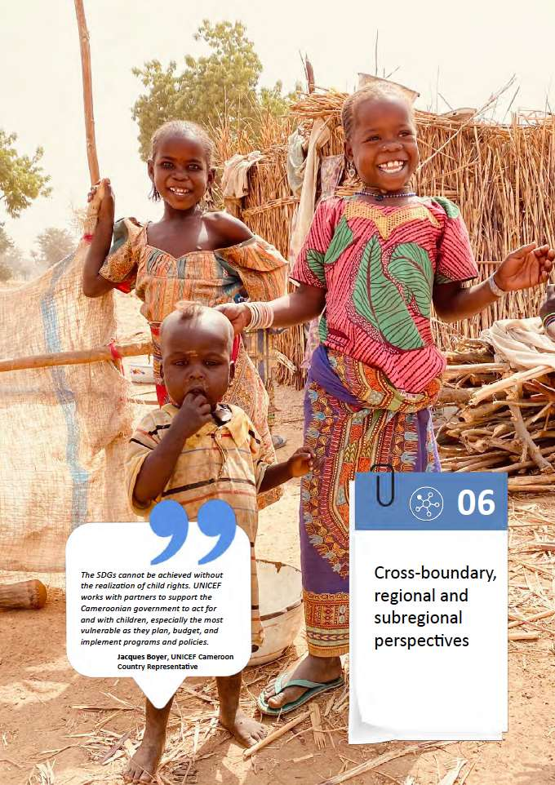

Cross-boundary, regional and subregional perspectives

Political and Conflict Dynamics
Conflict dynamics in neighbouring Nigeria and the Central African Republic continue to affect the overall security situation in Cameroon as well as internal conflict dynamics.
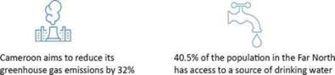
The Nigeria-based Islamic State's West Africa Province jihadist group, commonly known as Boko Haram, started targeting Cameroon in 2013. Concentrated in the Far North region, Boko Haram attacks led to unprecedented levels of security incidents including robbery, destruction of property, murder, kidnapping, military clashes, suicide bombings, and use of IEDs. In addition, the Far North region is impacted by the presence of around 102,000 Nigerian refugees (UNHCR, March 2019) and more than 279,000 IDPs (IOM, December 2019). Over the last year and following a change of tactics from Nigerian security forces, Boko Haram ramped up its attacks on Cameroonian soil, mainly targeting civilians. The security crisis linked to Boko Haram in the Far North has hindered people's access to basic social services. Only 40.5% of the population has access to a source of drinking water against 72.9% at the national level and most schools in this area have been closed since 2014.

Cameroon and Nigeria have developed a good tactical and strategic cooperation in the fight against Boko Haram. Furthermore, both countries are actively involved in regional efforts in the Lake Chad Basin Initiative. This initiative has two components: a military component, within the framework of the Multinational Joint Task Force created in 2015 by the countries affected by Boko Haram; and a civilian component which is aimed at addressing the root causes of the crisis and its socioeconomic consequences through the Regional Strategy for the Stabilization, Recovery, and Resilience of the Boko-Haram-Affected Areas of the Lake Chad Basin Region jointly launched by the African Union and the Lake Chad Basin Commission in 2019.
Spillover effects from the crisis in the Central African Republic affect the East, Adamawa and North regions. These regions host an estimated 278,884 Central African refugees. Their presence and pressure in some of the poorest regions of the country fuel conflicts over natural resources between host and refugee communities, and have significant humanitarian, security (incursions by armed groups), and economic (interruption of activities, such as transport) consequences. However, Cameroon plays a key role in the stabilisation of CAR. The country contributes over 1,000 gendarmes to MINUSCA, the UN peacekeeping mission in CAR.

Economic Dimensions
Much of Cameroon’s trade in goods takes place through cross-border trade, including exports of agricultural products to ECCAS countries and Nigeria. In October 2019, Cameroon ratified the Agreement on the African Continental Free Trade Area (ACFTA). The aim for Cameroon is to make effective use of the agreement with the first trade exchanges set to start in July 2020. Through this agreement, Cameroon is adopting an implementation strategy developed following a participatory process with strong involvement of all national stakeholders (administrations, private sector and civil society).
In order to make the most of this agreement, Cameroon has adopted an ACFTA strategy, backed by an Industrial Plan. This strategy aims to diversify the Cameroonian economy and increase the country's trade with Africa. Moreover, it identifies priority actions such as improving infrastructure, promoting the production and processing of primary products as well as prioritising trade with Nigeria (the continent's leading economic power, with more than 200 million inhabitants) and ECCAS (in particular, the DRC, with more than 90 million inhabitants). These are local markets that can serve as a springboard to more distant markets.
One of the immediate challenges of implementing the trade agreement is the loss of customs revenue, which is straining the state budget, and therefore reducing the available funding for the SDGs. However, subject to reforms that improve the productivity and innovation of Cameroonian companies, these losses will be compensated in the medium term by effective access to a large African market. This would strengthen the achievement of SDGs 8, 9 and 12.
Also, it is worth noting that Cameroon is the only country among the seven Central African states to have signed an interim Economic Partnership Agreement (EPA) with the European Union that gives it preferential access to EU markets. Nevertheless, complying with standards and regulations in force within the EU often constitutes a barrier to trade ("technical barriers to trade" such as sanitary or phytosanitary measures).
In addition, since January 1, 2020, Cameroon is no longer “eligible” for the preferential trade treatments granted by the United States under the African Growth and Opportunity Act (AGOA), a US law encouraging trade with the African continent, within the framework of the American development aid policy. This measure would mainly harm the agrifood sector (Omer Mbadi, 2019).

Social and Environment Dimensions

Health in the Subregion
The Lake Chad countries including Nigeria, Cameroon, Chad and CAR, conducted synchronised activities to combat the wild poliovirus epidemic. The Sahel countries, encompassing Mali, Senegal, Cameroon and Burkina-Faso, implemented a seasonal malaria prevention chemo to address malaria in children aged 3-59 months. For the CEMAC countries, a new sub regional strategy for 2019-2023 integrating HIV/AIDS, tuberculosis and hepatitis has just been launched. A system of grouped purchases of commodities for the fight against HIV/AIDS, tuberculosis and hepatitis has also been established. An important sub regional project directed by OCEAC - the "Projet Prévention VIH/Sida en Afrique Centrale (PPSAC)" - has been developed in 2019 and is being implemented in several countries.

Social Protection Analysis
The African union is becoming increasingly concerned about the social security of migrant workers. This issue drives neighbouring states to sign bilateral and multilateral agreements on social security. In Cameroon, a social security agreement for migrant workers has been approved with France.
A project led by IOM along with the Ministry of Labour and Social Security opened the way to extend social security to Cameroonian migrant workers working in Belgium, for instance. Granting social protection for all Cameroonian migrant workers is still an important matter, as well as the protection for refugees returning to their country of origin.
Cross-border activities between Cameroon and Nigeria are being implemented by several NGOs (Consortia), regarding, for example, the safe and dignified return of Central African and Nigerian refugees or the return of Cameroonian refugees from Nigeria (>60,000 now), which must be prepared on the ground: peace and security must be restored, the infrastructure of basic services rebuilt and equipped. All these measures should also be considered regarding the return of IDPs.

Gender perspectives
Within the African region and subregion, women and girls face several similar issues including child marriages, gender-based violence, harmful traditional practices, discrimination etc. As part of the African Union, and having ratified the African Charter, Cameroon’s engagement with mechanisms such as the African Commission on Human and Peoples Rights, can promote women’s rights and gender integration. Cameroon is also part of the Economic Community for Central African States (ECCAS) and can engage with other member states in the domain to tackle cross-boundary or regional issues affecting women and gender. A regional approach to tackling gender-based violence by the Boko Haram insurgency, human trafficking of women and girls along the lake Chad basin, and others, will be important. The influx of female refugees from Nigeria, Central African Republic and other regions, also must be considered.
Cameroon officially launched the Generation Equality Campaign (2020-2025) in the occasion of the celebration of the 35th edition of International Women's Day, celebrated on 8 March 2020. Generation Equality is a civil society-centered, global gathering for gender equality, convened by UN Women to link all the advocacy elements together, emphasising youth leadership and the strong intergenerational nature of the mobilisation and youth leadership to chart a path for a fresh and bold feminist agenda and to create a multilateral gender-progressive partnership.
Generation Equality will shape action towards gender equality through six action coalitions, namely:
- Gender-based violence
- Economic justice and rights
- Bodily autonomy and sexual and reproductive health and rights
- Feminist action for climate justice
- Technology and innovation for gender equality
- Feminist movements and leadership

Food security regional perspectives
South-south cooperation (SSC) is one of the gateways to foster innovation and to exchange capacity-strengthening support between countries to achieve the SDGs. SSC also creates an “enabling environment” for zero hunger through evidence-based policymaking. The Cost of Hunger in Africa (CoHA) study is an example of such an initiative.
Following the Madrid Parliamentarian Summit on Food and Nutrition Security, the National Parliament of Congo organised, under the leadership of FAO, the ECCAS sub regional Parliamentarian Forum and established the ECCAS Network of Parliamentarian Alliances on Food Security and Nutrition. Each ECCAS member state is required to establish their National Parliamentarian Alliance for Food and Nutrition Security in order to strengthen the engagement of parliamentarians in addressing food insecurity and malnutrition issues. It is expected that with the support of the parliamentarians, a legal framework for food security, the right to adequate food and regulations on food supplements will be developed and implemented, and that countries will provide more funds to achieve food and nutrition security.

Migration and Forced Displacement
Migration is an umbrella term that includes regular voluntary displacements as well as irregular and forced displacements, within the country and internationally. A migrant has no formal definition under the international human rights law, but most experts agree that an international migrant is someone who changes his or her country of usual residence, irrespective of the reason for migration or legal status. Generally, a distinction is made between short-term or temporary migration, covering movements of a duration of three to 12 months, and long-term or permanent migration, referring to a change of country of residence for the duration of one year or more. A refugee, on the contrary, is defined in the 1951 Refugee Convention as “someone who is unable or unwilling to return to their country of origin owing to a well-founded fear of being persecuted for reasons of race, religion, nationality, membership of a particular social group, or political opinion”.
Given its central position between West and Central Africa, Cameroon is a country of departure, transit and arrival of regular and irregular migration. The Government of Cameroon, through the Ministry of External Relations, is increasingly looking into migration and its positive impact on a social, cultural and demographic level, despite the absence of a national migration regulation policy. The recent adoption of the Global Compact for Migration will enable the Government to define such a policy in the near future, in collaboration with UN agencies and civil society organisations.
Since 2010, the country has observed an increase of 214,200 people in its migrant stock (all foreign-born residents present in the country). In 2020, the number of migrants living in Cameroon is expected to reach 505,700 (Migration Data Portal, 2020) having a positive impact on development. The infrastructure and services in Cameroon are attractive to neighbouring countries and stimulate displacement: many Chadian students, for example, cross the border daily to have access to education. Other phenomena, such as internal and transborder transhumance of herders and their cattle, are a form of recurrent migration in the country.
In the meantime, the number of Cameroonian migrants living in neighbouring countries is increasing. Remittances from the Cameroonian diaspora have proved to be an important source of external financing, reaching XAF278.9 billion in 2016. Maximising the productive use of remittances may hold a great potential to make migration work for development. Promoting entrepreneurship and local jobs might contribute to reducing irregular migration, which is still an issue in the region.
Crises and armed conflicts, demographic growth, social injustice and the desire to earn a better life are among the root causes of irregular and often forced displacement dynamics. IDP numbers have risen dramatically over the past few years reaching 800,000 in 2019, and some 60,000 Cameroonians have sought refuge in Nigeria in 2018-19. Besides the spontaneous return of some refugees, IOM and partners have assisted, since 2017, in the protection and reintegration of more than 3,900 Cameroonians who migrated to a neighbouring country, supporting their safe return, reintegration within their community of origin, and economic welfare. IOM has developed partnerships with the Cameroonian Government through the Return and Reinsertion Programme for the Youth of the Diaspora (PARI-Jedi) and with various ministries to cope with underemployment in the country and to foster durable reintegration.
Major security crises in neighbouring countries are also causing forced and irregular transborder migration that needs to be regulated and coped with in the country of origin as well as in Cameroon. Due to the COVID-19 pandemic and the closure of the national borders, migrants also from other countries, who were crossing through while on their way to Europe, have been left stranded in Cameroon.
As of January 2020, the Minawao camp has welcomed 63,098 Nigerian refugees while 46,659 out of camp refugees coming from Nigeria have also been recorded (UNHCR 2020, IOM, 2019). UNHCR has also facilitated the voluntary repatriation of 3,309 CAR refugees to their country of origin (UNHCR, 2020).
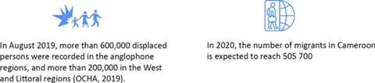
Inside the country, crises and climatic conditions have caused major forced displacements, also having a significant impact on host populations. The Boko Haram insurgency coming from Nigeria, which has heavily impacted the Far North region during the five past years, still triggers lower magnitude displacements due to small scale sporadic attacks. As of December 2019, 381,444 displaced persons (including internally displaced people – IDPs, and returnees) were recorded (IOM, 2019). The situation in the Northwest and Southwest regions are triggering dynamic and massive internal displacements and related humanitarian needs. As of August 2019, more than 600,000 displaced persons were recorded in the anglophone regions and more than 200,000 in West and Littoral regions (OCHA, 2019).
In such a context, the absence of a national migration policy might favour trafficking and smuggling, affecting mostly women and children. Cameroon promulgated a law forbidding smuggling and trafficking in 2011 and the Government has been working with partners, including IOM, towards the eradication of such practices (referencing systems, etc.), but further work still needs to be done to engage public actors, reintegrate victims and sensitise populations. The Government and its partners should develop a response to irregular and forced migration in order to facilitate the integration of displaced populations in their region of displacement, and to discourage unsafe migration. A national migration policy could leverage migration for development inside and outside the CEMAC zone, inhibit the development of irregular channels for coming in and getting out of the country, and prevent vulnerable groups from enduring unethical practices such as smuggling or trafficking.

Environmental vulnerability: The Sudano-Sahelian Zone – Semi-Arid Ecosystem – Forest Ecosystem
For the Sudano-Sahelian agro-ecological zone, the year 1981 marks the beginning of the deterioration of the annual rainfall. Average annual rainfall ranged from a maximum value of 1248 mm in 1965 (decade 2) to 727 mm in 1984 (decade 4 and the drought year of the African Sahel). An overall decrease of 20.39% was recorded, which corresponds to a decadal decrease in mean rainfall of 4.07% over the last six decades.
The drying up of water points and the decrease in water reserves and agricultural yields and stocks, death of livestock, food insecurity and famine, and an increased risk of heat-related mortality (for children, women, the elderly, chronically ill, socially isolated people), as well as an increase in diseases like malaria, colds, measles, cerebrospinal meningitis, typhoid, influenza, cardiovascular disease, respiratory diseases, skin conditions, and death. Other consequences include crop damage, soil erosion, difficulty cultivating due to waterlogging (precipitation), and negative effects on surface and ground water quality, such as the contamination of water supplies, increased risk of death, injury, infectious and respiratory diseases and waterborne diseases (cholera, amoebiasis, gastroenteritis).
The deforestation of the Congo Basin, of which Cameroon is a part, is due to four main groups of immediate causes of deforestation and forest degradation:
- Extension of infrastructure
- Expansion of agriculture
- Wood extraction
- Other factors
These risks put pressure on the achievement of SDGs 8 and 13.
It would be important that each of the Congo Basin countries implements mitigation programmes on the impact of development policies on forest cover. Initiatives could be taken at regional level of the Central African Forest Commission (COMIFAC) to limit the consequences of emergence strategies on the forest. In this perspective, additional studies, for example on how to reconcile the economic development and ecological concerns, would be beneficial.
With regard to the Lake Chad Basin, natural causes, such as drought, advancing desert, changes in climatic conditions, the increasing diversion and withdrawal of water, as well as anthropogenic causes, such as savage and almost permanent deforestation of green spaces for firewood and various other human actions have contributed considerably to reducing the area of Lake Chad to 2,500 km^{2.} This equals a reduction of about 90% compared to the level recorded in the mid 1960s. The situation is exacerbated by Boko Haram, which has accelerated the unsustainable management of natural resources and human migration. The Lake Chad Basin Commission (CBLT) develops regional projects across member countries aiming to reverse trends in the degradation of environmental resources by taking into account security factors, demographic trends, sustainable management of natural resources and climate change.

Exposure and vulnerability to climate change and natural hazards
The Government of Cameroon has estimated the loss of life and property due to landslides, sea level rise and flooding in 38 villages in the coastal zone of Cameroon (MINEF, 2001). Studies by Ellison (1992) on the coastal zone of Cameroon confirmed that agricultural and fishing activities will be affected by the decline in the mangrove population. Mangroves may eventually reach the point of extinction due to erosion and sea level rise caused by climate change.
As indicated in the IPCC report, countries with a coastline, such as Cameroon, are vulnerable to significant loss of life and property in urban and rural coastal communities. The city of Douala is at risk of losing important infrastructure as climate change events intensify. In 1995, the Bessengué bridge already collapsed due to river flooding. Deido, Bonamoussadi, Youpwé, the Bonaberi industrial zone and the Douala International Airport are located in vulnerable areas that may be affected by major floods and storms (MINEF, 2001)[2].

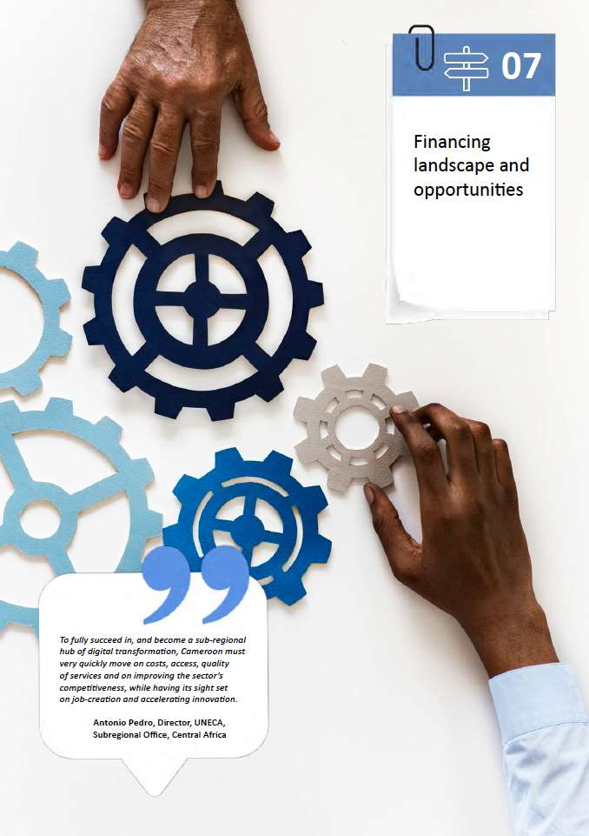

Financing landscape and opportunities

The mapping of sources of financing currently mobilised and mobilisable by Cameroon for development reveals the existence of a real potential for mobilising internal and external resources to fill the gap in financing for development in Cameroon, particularly in the sectors of environment, health, agriculture, water, energy for all, social protection, and the construction of real estate and infrastructure. It emerges that the most promising sources of development financing in Cameroon are:
- Public revenue (innovative taxes for broadening the tax base, including progressive taxation)
- Domestic public or private borrowing
- Public-private partnerships
- Development cooperation (south-south cooperation, global health funds, and green funds)
- Decentralised cooperation, diaspora funds
- Innovative financing mechanisms for SMEs (leasing, venture capital)
Domestic resources (budgetary revenues and domestic borrowing) constitute a major part of public sector financing. In 2017, they accounted for 76% of the financing mobilised by the public sector, i.e. XAF3,104 billion out of a total of XAF4089 billion. External sources (drawings and grants) accounted for 24% or XAF985 billion. For the year 2017, MINFI data indicate that budget revenue amounted to XAF2,975 billion representing 96% of internal public resources, and internal borrowing at XAF129 billion representing 4% of internal public resources.
At the level of budget revenue, non-oil revenue amounted to XAF2,558 billion (88%), and oil revenue was XAF346,2 billion (12%). Non-oil revenue of the State of Cameroon includes all government revenue (fiscal and non-tax), with the exception of oil revenue as defined above. They are grouped into three main categories: tax revenues, customs revenues, and non-tax revenues. For the year 2017, non-oil revenue amounted to XAF2558 billion, broken down into 1,688 billion (66%) in domestic taxes and duties, 710 billion (28%) in customs revenue, 160 billion (6%) in non-tax revenue. Recent developments reveal that non-oil revenues are structurally dependent on tax and duty revenues, especially since the quasi-stagnation of customs revenues due to the entry into force of the EPAs and the security tensions imposed by the Boko Haram and secessionist demands in the Northwest and Southwest regions. This development also reveals that unlike oil revenues, which fluctuate enormously, and whose growth rate fell sharply between 2011 and 2015 and then became negative between 2015 and 2017, non-tax revenues are less volatile. The most stable and therefore the most secure component is that of taxes and duties because despite the particularly difficult domestic and international environment, between 2010 and 2017, the growth rate of tax and duty revenues remained positive.
Compared to other African countries with a similar level of development, analysis of the composition of tax revenues reveals that the contribution of some of these revenues deserves to be significantly increased in Cameroon, since this increase does not always require an increase in the tax rate, but may result from better efficiency in the technique and instruments of collection, or from a broadening of the tax base, which is considerably reduced due to the predominance of the informal sector.
Considering all state revenues, the tax burden would be around 15% in Cameroon, while it reaches 35% in Namibia and Botswana, 32% in Seychelles, 28% in South Africa, 22% in Rwanda, and 18% in Kenya. Taxes on income, profits and capital gains, which represent only about 4.5% of GDP in Cameroon, are much higher in countries with better economic performance such as South Africa (15%), Namibia (13%), Botswana (10%), Seychelles (10%), and Kenya (8%). Similarly, taxes on goods and services, which represent only 5.6% of GDP in Cameroon, reach 6.4% in Kenya and Mauritius, 8.3% in Namibia, 7% in Rwanda, 15.2% in Seychelles, and 10% in South Africa. It thus appears that the fiscal pressure is still very low in Cameroon compared to other African countries and with regard to the minimum required level of 23% to meet the objectives of sustainable development according to the estimate of the Economic Commission for Africa.
At the level of external public financing, the distribution of outstanding external public debt among the various creditors shows that external public borrowing is mainly mobilised from bilateral creditors, followed by multilateral creditors and private creditors (commercial debt). In 2017, the stock of bilateral debt represented 50.48% of the stock of external public debt, the stock of multilateral debt 35.51%, and the stock of commercial debt 14.01%.
Up to 2020, the country should benefit from significant budgetary support from its technical and financial partners, due to the approval by the IMF Board of Directors on 26 June 2017 of an Economic and Financial Programme for Cameroon supported by an extended loan facility of XAF415 billion. To accompany this programme, other important budgetary support will come from the World Bank, the European Union, the African Development Bank and the Agence Française de Développement (AFD).
The recourse to private creditors can be seen as a determination and a declared willingness on the part of the Government of Cameroon to reduce its dependence on international financial assistance, the many conditions of which are sometimes incompatible with project implementation deadlines and economic profitability. It can also be a means of circumventing the numerous conditionalities often imposed by official creditors and it can contribute to increasing the speed of implementation of development projects, provided that these projects are sufficiently mature and that their economic profitability is proven.
Nevertheless, recourse to private borrowing is very costly for the State, since the interest rates charged by official creditors are on average lower than those charged by private creditors. In 2017, the average interest rate on loan agreements with private creditors was 2.5% and the average interest rate on loan agreements with official creditors was 1.26%. Therefore, from a sustainable development perspective, the use of private creditors, who are only interested in the return on invested funds, can help finance projects that contribute to environmental destruction. It is therefore necessary to find the right balance in the search for external financing between borrowing from official creditors and borrowing from private creditors.
Domestic private financing comes mainly from domestic savings, only part of which, owing to the low level of banking in the economy, is channelled through the formal financial system to be injected into development projects. The formal financial circuits that capture national savings include commercial banks, specialised financial institutions, development banks, microfinance institutions, the Caisse Nationale de Prévoyance Sociale (CNPS), insurance companies, etc. The formal financial system is the main channel through which national savings are channelled. When it does not pass through these formal institutions, national savings are mobilised through traditional channels, notably tontines.
The main challenge in mobilising domestic private financing is the low level of national savings, part of which is increasingly captured directly by bond issues issued not only by the Cameroonian government but also by the governments of other CEMAC countries. Between 2010 and 2017, gross domestic savings (the difference between GDP and final consumption expenditure) increased in Cameroon from about XAF2,640 billion to XAF3,843 billion in 2017. However, its evolution is neither regular since a decline was observed between 2014 and 2015, nor sustained compared to countries at a comparable level of development such as Côte d'Ivoire and Ghana.
In spite of the efforts made, the rate of the availability of banking facilities is only 20.4% in the strict sense (percentage of individuals with a bank account) in 2016 and 39.5% in the broad sense. The density of the network is 1.2 bank branches per 100,000 inhabitants in the strict sense, and 3.8 branches in the broad sense.
It should also be noted that the deposits made with banking institutions are mainly sight deposits, which makes it difficult to transform them into loans capable of financing investments whose profitability maturities are by nature longer. The share of sight deposits in the balance sheet of banks has even increased from 51.63% in 2010 to 56.17% in 2017.
In terms of private sector external financing, inward FDI flows have not increased significantly in Cameroon in recent years despite government efforts to make the country more attractive. In 2016, the amount of inward FDI to Cameroon was almost identical to that of 2011 (see Fig. 15). Even if the level reached in 2017 (USD814 billion) is the highest over the entire 2010-2017 period, the fact remains that this flow of financing is volatile and unstable, demonstrating that the country is structurally unattractive. Furthermore, inward FDI flows are low compared to other African countries such as Nigeria, Ethiopia, Ghana, Zambia and the DRC. If Nigeria's position can be understood because of its population and dominant position in oil production, Cameroon's position in relation to Zambia, Ghana and Ethiopia can nevertheless be compared, especially since the country has a relatively more diversified economy than all the other Central African countries.

iHealth financing
An important part of external public financing is funding from the Global Health and Climate Funds. These funds are mainly mobilised within the framework of health financing, which is an important component of the SDGs. The Global Fund to Fight AIDS, Tuberculosis and Malaria (GFATM), created in 2002, is a major donor investing nearly USD4 billion each year in support of national programmes across the world. As a high priority country in the global response to HIV/AIDS, Cameroon has received the 15th largest GFATM allocation in the world in the three-year cycle 2014/2017 (USD288 million). 250 million euros have been allocated for to the grant cycle of 2020-2022 for HIV, TB and Malaria.
The national response to HIV also receives significant funding from the US President’s Emergency Plan for AIDS Relief (PEPFAR). The US financial contribution of HIV/AIDS has tripled in the past two years rising from around USD30 million in 2019 to over USD90 million in 2020.
As noted above in chapter 1, the proportion of the state budget allocated to health in Cameroon is around 4% against the 15% recommended by the 2001 Abuja Declaration. On a per capita basis, significant regional disparities exist in health budget allocation, disadvantaging regions that already feature below average poverty and public health indicators, such as the Far North Region.Cameroonian households contribute about 70% of the total national health expenditure by their own resources (out-of-pocket payments), against 32% average in the African region. Out of every USD100 total expenditure in the health sector, about USD14 comes from public financing against an average of USD47 in the African region. This is a major obstacle to progress towards universal health coverage and achieving SDG 3.
Formal and informal user fees for health care services are a further barrier to people’s access to quality prevention and treatment services, especially for the poorest households. The ministerial directive adopted in April 2019 which has resulted in the elimination HIV related user fees from 1 January 2020 is therefore seen as a major ‘game-changer’ and an important first step toward universal health care in Cameroon. It is expected that this new policy will help expand access to health care services for all.

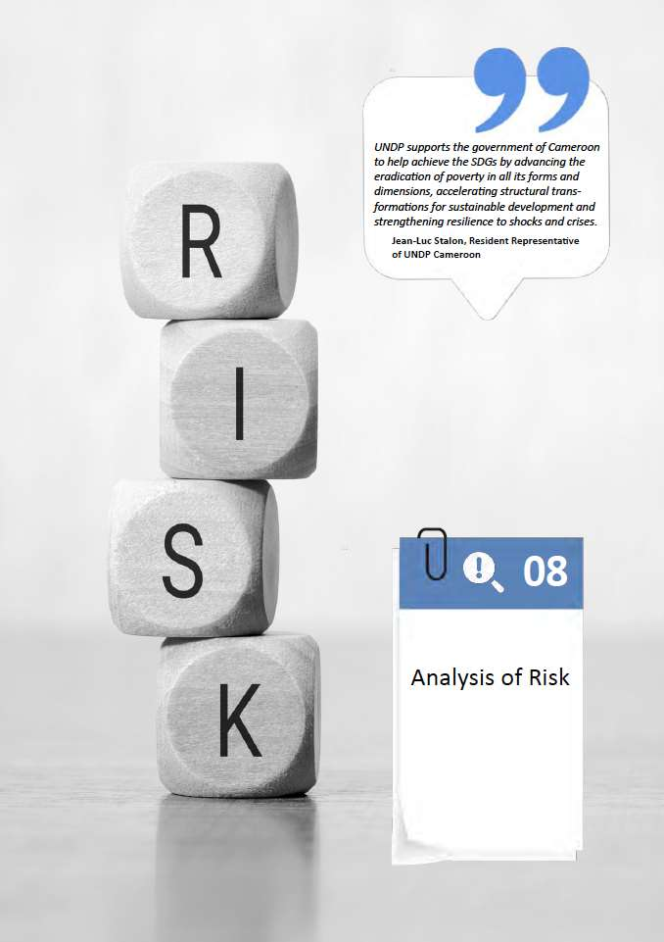

Analysis of risks

Risk analysis
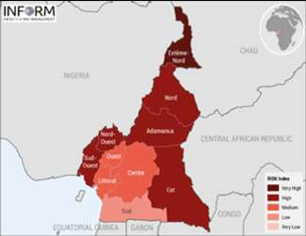
Conflicts and insecurity are the main two risks that impact the development of Cameroon. The three simultaneous crises, described in above chapters, have considerable effects on the living conditions, physical and mental wellbeing and livelihoods of the population. Out of a total of 10 regions, 9 are affected by these challenges. According to the INFORM analysis, the risk index and the degree of exposure to hazards have been increasing steadily for the last three years (Figure 5). The current situation in Cameroon is classified as “at high risk of violent conflict” according to the Global Conflict Risk Index (GCRI) over the next one to four years. The risk of conflict is evaluated at 9.7 on a scale of 10 (OCHA, 2019).
Figure 5: Current overall risk index in Cameroon, October 2019
In terms of natural hazards such as floods or droughts, the 2019 risk index shows that the Far North, the East and the Northwest are considered as high-risk zones. The frequency of the natural disasters (flood or drought) is high in these regions, although the foreseeable impact is moderate.
However, the combination of such a crisis with the current humanitarian situation, persistent insecurity and the COVID-19 epidemic would further affect the quality of life of the people in these regions and would slow down the achievement of the SDG targets. It could put at risk recent gains in social indicators that would heighten gender disparities and inequalities especially among the most vulnerable populations. The COVID-19 outbreak could also further compound vulnerabilities to other epidemics, particularly cholera, which occurs almost annually. Virus outbreaks such as Ebola and COVID-19 are emerging risks for Cameroon.
Limited public investment in food security, health, nutrition and education, as well as neglecting the need to develop the agency of women and youths, are also challenges for achieving the targets of Zero hunger. Currently, national planning does not fully address the root causes of the humanitarian needs, such as the gaps in food security and nutrition.

Economic Risks
COVID-19 has amplified the global economic slowdown and heightened the risks that were facing Cameroon's economy. UNCTAD (2019) among others, predicted a global economic slowdown in 2020 for a number of reasons: rising protectionist measures, trade war between America and China, weakening investment, rising levels of debt almost everywhere, market volatility, no-deal Brexit, mounting uncertainty, etc. There have not been any significant measures to counter these predictions. aFurthermore, the repercussions of the COVID-19 pandemic on the world economy are already being felt and could get worse. . OECD (2020) predicts the global economic growth to fall to 1.5% in 2020, as the pandemic spreads and intensifies. Restrictions on the movement of people, goods and services, and containment measures such as factory closures are expected to sharply cut manufacturing and domestic demand in Asia and Europe. The impact on the rest of the world through business travel and tourism, supply chains, commodities and lower confidence is growing. The economic risk analysis therefore revolves around the COVID-19 pandemic, which has amplified existing risks related to trade, debt, investment, financial flows, government revenues, and many others.

Vulnerability to variations in world commodity prices
Cameroon has a multitude of export products reflecting a certain economic diversification, although rather horizontal and highly concentrated on extractive and agricultural raw materials which are vulnerable to external shocks. Cameroon has high potential for diversifying its economy. The price of crude oil has plummeted by more than 60% since the beginning of 2020 and the prices of primary exports are on a downward trend as a result of COVID-19. The impact on government revenue is serious and could get worse. The conventional channels likely to promote technological development and organisational capacities, such as foreign direct investment (FDI), are not yet sufficiently exploited. Like the rest of the continent, the production system remains low polluting due to the low level of industrialisation. The Economic Commission for Africa (2018) proposes a strategy of vertical diversification towards chemicals, fertilizers, tires and paper are products to be considered for Cameroon (CEA 2019).

High risk of debt distress
According to the IMF’s debt sustainability assessment in January 2020, Cameroon remains at high risk of external and overall public debt distress, but debt remains sustainable (IMF 2020) After reaching XAF8,488 billion at the end of 2018, preliminary IMF estimates suggest that public debt has further increased to around XAF9,429 billion as of the end of September 2019, despite a temporary halt of disbursements subject to rescheduling negotiations with China on disbursed loans and debt forgiveness of about XAF21 billion on interest-free loans.. The estimated debt/GDP ratio stood at 41.5% (Sept 2019), as against 33.3% (Dec 2016) (public and publicly guaranteed debt) at the same period. External multilateral and bilateral Paris Club debt represents around one third of total debt, while bilateral non-Paris Club debt is dominated by China.
To reduce the risk of distress and safeguard debt sustainability, Cameroon needs to: mobilise domestic resources, increase the efficiency of public expenditures, improve debt management practices, prioritise concessional borrowing and limit non-concessional borrowing to very critical projects, strictly adhere to the disbursement plans, strengthen the monitoring and management of government-owned enterprises, accelerate structural reforms to improve competitiveness and achieve economic diversification. COVID-19 has compromised the application of these measures, and made debt repayment almost impossible, while increasing the risk of debt distress. Only a comprehensive restructuring of Cameroon’s external debt could prevent the country from debt distress.

Labour Market Risks
In the context of COVID-19, there could be a reduction in working hours and the pace of production and trade at the level of public administration, markets, enterprises, the informal economy.. The employment rate could have a completely altered trajectory to be at a fairly low level below 70% in 2020, compared to an average of 73% over the last ten years (2010-2019) (ILO 2020). As a result of the pandemic, there is also a risk of a decline in public employment service activities in Cameroon. With the tightening of measures taken by the government to limit the spread of COVID-19, the National Employment Fund has also suspended the physical reception of its targets: job seekers, enterprise management and even non-professional visits since March 2020. With the physical displacement constraints of job seekers or labour-seeking enterprises, the placement rate is likely to fall significantly in 2020. Assuming a realistic decline in the number of labour placements in 2020, the unemployment rate is likely to rise over the next two years with the prolonged effects of the COVID-19 crisis in Cameroon.
Beyond the plausible effects of COVID-19 on decent work, there could be partial layoffs, abusive termination of employment contracts, underutilisation of labour in the event of adjustments planned by companies to compensate for the contraction of activities and the decline in revenues as a result of the measures and effects related to the pandemic.

Social Risks

Gender
Gender disparities, while slowly narrowing, are rooted in social norms and long-standing patterns of exclusion from family and community decision-making that limit women’s opportunities and act as barriers to women entering higher education, vocational training, and senior positions in political and economic structures as well to pursuing their professional careers. Gender-based violence is a major challenge. Sociocultural norms, women’s ignorance of their rights, poverty, and financial dependence on their husbands are factors of gender-based violence , which, despite their illegality and negative impact on development, are still tolerated in the name of culture. At economic level, significant financial costs and expenses incur from work absenteeism and incapacitation resulting in low productivity. Violence also prevents female victims from participating in public life and other development activities in the country.
Despite the ratification of international and regional conventions, the country is facing a big challenge in their domestication in national legal frameworks. Another necessary change is in the attitudes regarding respect for women's and girls' rights, including their reproductive rights.

Environmental risks
The rising temperatures and declining rainfall recorded in the last 50 years has increased the duration of dry seasons with a growing impact on droughts, especially in the Sudano-Sahelian zone and Guinean High Savannah. According to the IPCC (2007), the global average sea level rise between 1993 and 2003 was about 3.1 mm per year. In 2006, the projections for future sea level rise were estimated to be between 9 cm to 38 cm. This rise could exceed 1 m by 2100 (IPCC 2019).
Projections made based on available rainfall data show that the national territory will be subject to a variation in precipitation in the order of -12 to +20 mm of rain per month (from -8 to +17%) in the 2090s. These projections predict increasing pressure on the environment and in particular on biodiversity. The most affected regions, North and Far North, are already classified as semi-arid or arid zones and they will benefit from less rain in the future. The zones of bimodal rain forests and the high savannah zones will record a respective decrease in rainfall by around -7.8% to -19% by 2100. The observed variability will be relatively greater in the Southeast of the country.
The entire Cameroonian territory will be subjected to increasingly rising temperatures. The north of the country will experience an increase ranging from +0.7°C in temperature by 2025 to +4.5°C in 2100. The increases in the rest of the country are estimated at +3.6°C in 2100. The variations in temperature affect water resources (availability, management) on the one hand. On the other hand, they reduce the livelihood opportunities of the populations due to the repercussions, among other things, on agricultural production, rivers (watering of animals), grazing (livestock) and the state of biodiversity.
Climate projections in Cameroon show an increase in the frequency and amplitude of the following extreme events:
- Floods will increase in number, intensity and severity of damage in the Sudano-Sahelian, coastal and forest agro-ecological zones with bimodal rainfall. In fact, projections show at least 5 to 10 floods per year depending on the intensity of rainfall. The rise in sea level would cause the loss of approximately 33,000 ha (30% of the total) mangroves areas.
- Storms will be even more frequent and will occur regularly on the Cameroonian coasts (coastal agroecological zone with single-modal rainfall) causing significant damage.
- Landslides, mudslides, rock falls, among others, will also increase in intensity, number and damage levels in the high plateaus, high savannahs, forests with bimodal rainfall and in the mountainous and hilly areas of the coastal (Mount Cameroon, Roumpi, Manengouba, Nlonako) and Sudano-Sahelian zone (Mandara mountains, Kapsiki, Poli, Tinguelin).
- Soil erosion will increase because of strong winds and increased rainfall. Rising sea levels will increase coastal erosion and accelerate the disappearance of trees and the degradation of mangroves. The loss of land will destroy the sandy beaches in the mangrove areas (Cape Cameroon, Kangue).

As mentioned above, with reference to the future climatic conditions, and in the absence of a coordinated and strategic response, the impact of the changes on the economy and agricultural production will be critical and considerable. In fact, losses linked to droughts could reach 24% of GDP, which could reach USD7.4 billion per year. While for the floods, the potentially affected GDP will reach nearly USD3 billion per year (UNISDR, 2018). Risks resulting from failing urban planning
The current model of unplanned and unmanaged urbanisation is unsustainable. It is likely to lead to increased inequality, the growth of slums and disastrous impacts on climate change.
UN-Habitat projects that as the urban population doubles, the area covered by cities could triple. Such urban expansion is wasteful in terms of land and energy consumption and increases greenhouse gas emissions. It leads to the loss of forests and biodiversity and reduces the availability of land for agriculture.
Unplanned urbanism and urban sprawl increase spatial segregation and inequality between city dwellers, which in turn often lead to higher crime rates and a reduction in social cohesion. Citizens of sprawling cities are also less able to access employment opportunities and basic services. Women are more at risk of exclusion as they are more often charged with care responsibilities for family members, which limits the time available for long commutes.

SDGs | Risk Areas | Risk Factors | Likelihood | Impacts | Early warning indicators
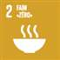  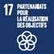 | Food security, agriculture and land  (Risks to people, agriculture, and/or food production in the intervention areas resulting from food production and land issues) | Deterioration of food security | Very likely | Severe | Food Consumption Score
 |  | Increased rates of malnutrition rates | Likely | High | Prevalence of malnutrition among vulnerable population
 |  | Loss, damage to or lack of access to agricultural land and high turnover level of local and regional government bodies' staff supporting food and nutrition sectors impacting proper support to food and nutrition policies and programmes | Moderately Likely | Severe | Lack of production or harvest
 | Internal security  (Risks to the security of the territory, its people, and infrastructure, and to the ability of the international community to operate effectively as a result of security issues)  Political stability  (Risks to the stability of established political and government structures resulting from politically driven factors) | Internal conflicts related to independent armed groups activities in NW/SW  Limited access to intervention areas due to the high level of insecurity | Very likely  Moderately likely | High  Severe | Number of insecurity issues reported in NW/SW  Level of civilian casualties in NW/SW  Inadequate briefing of new staff through proper handover note prepared and shared on policies and programmes implemented in the intervention areas
 | Regional and global influences  (Risks to the integrity, stability, safety and prosperity of the territory and its people as a result of the actions of external factors, or the influence of external events) | High level of political instability & conflict in CAR or regional political instability in neighbor countries  Political transition | Very likely | High | Number of refugees and IDPs in Cameroon  Number and types of attacks attributed to Boko Haram in Cameroon
 | Displacement and migration  (Risks to the population and to the stability of the territory resulting from the pressures associated with displacement and/or migration) | High level of violence in the NW/SW and organised attacks by Boko Haram | Likely | High | Number of insecurity issues reported and related to Boko Haram attacks and conflicts in the NW/SW and East Regions
 | Justice and rule of Law  (Risks to the fair, effective, and comprehensive implementation and application of the principles of justice, the rule of law, and accountability from issues) | Lack of human rights protection instruments  Lack of trust in national judicial bodies: reconsideration of the independence between the judiciary and the executive, access by the population to justice services and issues of corruption in the judicial system.  Insufficient institutional reforms with a limited impact on mitigating of corruption. | Medium | Medium | Corruption Perception Index (ICP)
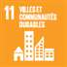  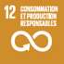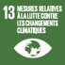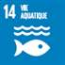 | Environment and climate (risks to ecology, ecosystems and its people, resulting from issues associated with environment, climate, access to culture and natural resources) | Frequent natural/climatic shocks  Increased floods and disasters, drought related to climate change  Deforestation, forest degradation and loss of biodiversity  Increased Water pollution (Human activity in large cities, large industrial sites (extractive industry, port activity, construction of dams, etc.)) | Likely  Medium  Low | Moderate  Medium  Medium | Percentage of households affected by natural shocks (drought and floods mainly)  Evolution rate of pluviometry and temperatures  Annual deforestation rate
 | Social cohesion and non-discrimination  (equality and non-discrimination: risk to social unity and equality resulting from direct and indirect discrimination, horizontal inequalities and demographic trends) | Increase in hate speech:  Increased public unrests  Inequal access to resources including land and education  Lack of public investment for food security, health and nutrition  National planning does not cover the humanitarian needs particularly the gaps on the food security and nutrition in addressing the root causes. | Medium  Medium  Moderately likely | High  Medium  Severe | Frequency of hate speech in media  Number of violent protests  Women's empowerment index  Youth Index  Percentage of girls enrolled in schools
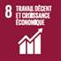 | Economic stability  (risks to the economic, financial and fiscal stability of the country, which could impact governance, social cohesion or people’s ability to satisfy their needs) | Risk of over-indebtedness (Although Cameroon's debt rate remains viable (39% of GDP), the quality and the pace of its debt must be kept under surveillance to remain sustainable and avoid the risk of over-indebtedness).  Insufficient opportunities for youth employment  Drastic reduction of raw materials prices  Negative socioeconomic impact of COVID-19 outbreak | Medium  High  High  High | High  High  High | Debt ratio  Debt service execution rate  Youth unemployment and underemployment rate  Commodity Prices Monitoring
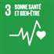 | Public Health  (risk to the population, the economy, and the stability of the territory resulting from actual and emerging public health emergencies) | Exposure to the risks of disease outbreaks such as Cholera and increased emerging risks of Ebola and COVID-19  Massive loss of life due to COVID-19 | Moderately likely  High | High | Number of patients recorded with Cholera  Number of deaths due to COVID-19
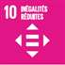  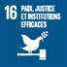 | Democratic space  (risks to democratic and human rights institutions and to civil and political rights resulting from shrinking civic space, exclusion, repression and intimidation) | Low commitment of youth and women in democratic processes both at local and national level  Limited decentralisation process implementation  Limited level of civil society engagement in public policies | Medium  Medium | Medium  High | Number of youth/ women registered on the electoral lists.  Proportion of youth/ female candidates participating in different electoral deadlines  Percentage of implementation of the decentralisation process

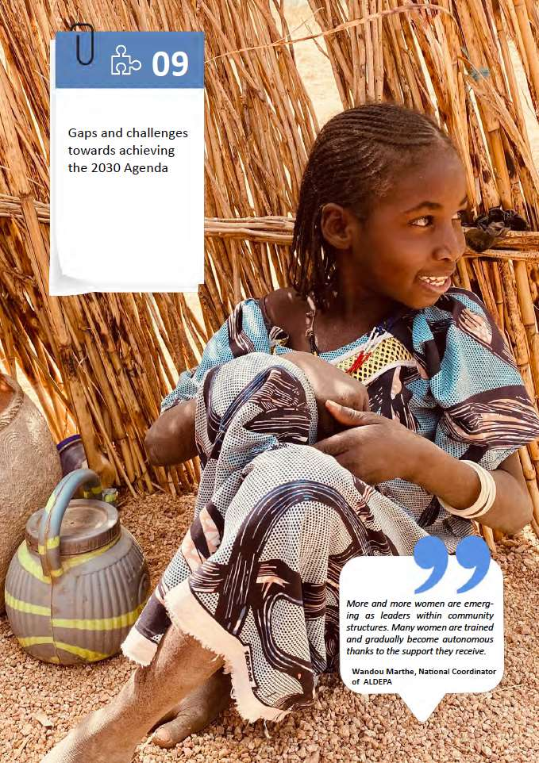

Gaps and challenges towards achieving the 2030 Agenda

Economic Gaps and Challenges
Despite a resilient GDP growth rate of more than 4% in recent years, there are significant challenges to overcome to reach the SDGs by 2030. Among the challenges the following economic issues can be noted:
The challenge of making growth more inclusive: Economic growth remains non-inclusive and does not significantly reduce neither poverty nor inequality. Significant regional disparities remain and the growth does not create formal and decent jobs. As explained in the 2019 National Human Development Report (UNDP 2019), the poverty rate has fallen by only 2.4 percentage points in 7 years, from 39.9% in 2007 to 37.5% in 2014 (with an increase in the number of poor in these two periods). The GINI index increased by 13% over the same period reflecting a worsening of consumption inequality among the population. Spatially, the poverty gaps have widened between rural and urban areas. While the incidence of poverty has significantly decreased in urban areas, from 12.2% in 2007 to 8.9% in 2014, in rural areas it has increased from 55.0% to 56,8%. There is also an impoverishment of certain regions of the country, especially those in the north of the Far North and the North. A large part of the Cameroonian population is left behind economically. Weak structural transformation of the economy: The economy is characterised by the decline of agriculture and shrinking manufacturing activities (source of sustainable growth), and an increase in the services sector (vector of computerisation).. According to the report of the second Survey on Employment and the Informal Sector (EESI 2, 2010) in Cameroon, the number of Informal Production Units (IPU) was estimated in 2010 at just over 2.5 million, of which 86 % are one-person businesses. These companies were the main provider of jobs in 2010, employing 90.5% of the workforce. This situation indicates a level of precariousness on the labour market. The informal agricultural sector dominates with 53.0% of active workers against 37.5% for the non-agricultural informal sector
An unattractive business environment for foreign and even local investment. The World Bank Doing Business 2020 report ranks Cameroon 167th out of 190 countries (166th in the 2019 report). In Africa, Cameroon is ranked 34th out of the 50 countries taken into account. The three worst ranking areas of Cameroon are cross-border trade (186th), payment of taxes and duties (181st) and transfer of property (175th). Improving the business climate is important for promoting inclusive growth, driven by the private sector. Much effort is required in the areas of digitisation of tax payments, facilitation of cross-border trade and customs governance, as well as land tenure, particularly in urban areas and agro-industrial production zones.
The infrastructure deficit: the availability, quality and cost of infrastructure is a considerable brake on economic activities in Cameroon, both in urban areas and rural areas. The World Economic Forum's competitiveness index (2013-2014) ranked Cameroon 128th out of 148 countries in terms of quality of infrastructure (IMF 2014; p.7). The inadequacy of the infrastructure is perceived by the business community as one of the three main problems in Cameroon. Dominguez-Torres and Foster (2011, p.3) estimated that if Cameroon increased the quality of its infrastructure to the level of other countries with a similar income, the country would have a potential growth gain of 3.3%. The sectors mostly concerned are transport and energy infrastructure.
The Cameroonian authorities have launched in recent years a vast programme aimed at improving and increasing the supply of electrical energy through the development of national hydroelectric potential, for the supply of clean and renewable energy, and to reduce the costs of production. Several dams and hydroelectric plants are under construction. However, the current total production capacity, 741 MW, represents only around 6% of the country's total hydroelectric potential (12,000 MW)

Challenges regarding the coverage and quality of SDG data at the national level
Cameroon has adopted all 17 SDGs. To monitor progress towards the achievement of the selected goals, 151 targets have been selected as well as about 217 indicators. The National Baseline Report showed that only 48% of the indicators were reported. This finding calls for urgent action regarding the inclusion of SDG reporting in national priorities. Particular emphasis should be placed on statistics from administrative sources, statistics on the environment and climate change, and statistics on the rural sector. On the other hand, the respect for the periodicity of censuses and major surveys (RGPH, ECAM, EESI, EDS-MICS, RGE), as well as the conduct of statistical surveys and studies for the different sectors (rural, education, health, industry, infrastructure, trade, governance, peace and security) should be prioritised.
With regard to the management and steering of the education system for example, there is a lack of reliable and up-to-date statistical data in the sector to inform decision-making due to the slow implementation of an integrated Education Management Information System (EMIS), including data on Education in Emergencies (ESU). Furthermore, it should be noted that the education system has not been prepared to anticipate and respond to the crises that the country is experiencing, which tends to reinforce the difficulties and structural inequalities of the system. Indeed, several reforms envisaged at the beginning of the implementation of the SSEF in 2013 have not seen the light of day or brought the expected results. These include, among others, the decentralisation process, basic education, which gave rise to great hope for meeting the commitments and targets of the SDG 4 in connection with the establishment of a basic education of at least 9 to 12 years, the policy of building complete schools, the development and implementation of a national reading plan, the mechanisms for managing flows in secondary education and vocational training.

Level of disaggregation of available data
The level of disaggregation of data is also among the limitations that have affected the monitoring of progress towards the achievement of the SDGs. Indeed, it emerged from the analyses that most baseline surveys are conducted at the regional level. Considering more relevant themes and disaggregation (gender, subnational, infra-annual) in statistical production should be a priority (level of communal disaggregation)

Accessibility of data and participation of the country in global surveys
One of the strategic thrusts of the National Statistics Development Strategy Document relates to improving the archiving, dissemination and use of data.Some points for improvement concern the regular preparation and compliance with the dissemination schedule, ensuring a wider dissemination of the information produced, and facilitating the accessibility of data produced to the public. Given the country's participation in global surveys, particular emphasis should be placed on data archivingthrough the centralisation and dematerialisation of the products of the National Statistical Information System (SNIS).

National capacity building opportunities
The National Statistics Development Strategy Document defines as another strategic focus area the strengthening of human, material, technological and financial capacities. This could constitute an opportunity for the United Nations, in particular through:
- Training SNIS staff on statistical themes (big data, open data, etc.)
- Contribution to the improvement of working tools for quality statistical production, including disaggregated data production and analysis
- Contribution to upgrading the technological and statistical infrastructure of the SNIS
- Support for strengthening the financing mechanism of SNIS, including a transparent and accountable tracking and monitoring mechanism for building trust and for more regular studies
- Support for strengthening the coordination and governance of the national statistical system, including the relationship with the sectorial ministries
- Support for the improvement of the national urban governance and mechanism to increase the capacities of urban practitioners at municipal and regional level
Support for the enhancement of the institutional capacities and increased investments in national institutions involved in the production of housing and urban development, health and social protection

Gaps in the Health Sector
Pillar of the health system | Gaps to be filled | Difficulties encountered
Governance |  | Insufficient coordination of various supports to the government
Financing of the health sector | Financing of the health sector, less than 15% of the state budget | Non-effective resource mobilisation for health
Human resources | Quantitative and qualitative insufficiency of human resources in health | Irrational distribution of human resources
Drugs and equipment | Persistent running out of essential drugs | The logistics management system for drugs not under the control of the health personnel concerned
Service offer | The quality of care offered still needs to be improved | Persistence of geographical and financial barriers to access to care
Health information | The quality of routine data | Low coverage in terms of the internet network

Challenges and gaps on governance

Proposals for anti-corruption action and improvement of service quality
Fighting corruption and improving the quality of service requires determined and multidimensional action from leaders and other stakeholders such as parliament, the judiciary, civil society and national institutions responsible for fighting corruption and improving the performance of public administrations.
The course of action to combat corruption and improve the quality of service should make it possible to provide concrete and sustainable responses. These should concern:
- Support for the operationalisation of the recommendations of the CONAC annual reports
- Support for the operationalisation of a service quality standard
- Support for the digitalisation of procedures and the use of innovative technologies to the benefit of users and investors
- Improvement of Cameroon's legal arsenal and anticorruption system
- Production of knowledge in the fight against corruption
- Capacity building of national actors in the fight against corruption (training on the use of tools and/or dissemination of innovative and original tools developed to fight corruption (whistle-blowers))
- Protection of whistle-blowers and witnesses of corruption
- Capacity building of ordinary citizens, awareness-raising (refusing to be an actor of corruption)
- Training of anticorruption actors on anticorruption mechanisms
- Advocacy for the efficient financing of anticorruption institutions
- Identification and implementation of asset recovery mechanisms
- Support for the establishment of a mechanism for the declaration of assets and property
- Support for the development of local and regional instruments to improve transparency, good governance and citizen participation as mechanisms for preventing and combating corruption (regional or local corruption index) and improving local governance (participatory, innovative and sustainable tools)

Challenges and gaps on decentralisation and local development
The first General Assemblies of the Commune of 2019 drew up the following list of challenges:
- Non-full application of the existing normative framework and the less than optimal functioning of certain organs and bodies
- Low yield of local taxation, which constitutes a brake on the financial autonomy of the communes
- Insufficient quantity and quality of human resources
- Deficit in infrastructure and various equipment
- Low citizen participation and insufficient transparency in the management of local public affairs
- Low level of mutualisation of efforts in the context of intermunicipal cooperation
- Insufficient synergy of action between the different actors in the sector, specifically between technical and financial partners
- Weakness or absence of a decentralised cooperation policy

Proposal for support measures in the field of decentralisation and local development
In order to meet the needs of the population in terms of support for decentralisation and local development, the following action should be taken:
- Support the implementation of the special status of the Northwest and Southwest Regions, in application of the GDN recommendations
- Support the localisation of SDGs
- Support strengthening citizen participation in decision-making
- Support accountability in the management of decentralised local authorities, and allocation and expenditure of resources
- Support socioeconomic development
- Support decentralised cooperation

Challenges related to freedom of participation and expression
Challenges related to the freedoms of participation and expression are not among the 52 priority targets chosen by the Cameroonian government in its SDG ownership strategy. Challenges to achieving SDG 16:
- The ineffectiveness of remedies against the obstacles to the freedoms of assembly and public demonstration.
- On the infrastructural level, the poor state and inconsistency of internet networks throughout the country are barriers to access to information.
- A collective agreement for journalists and professionals in the field of social communication has been adopted since 2008 but is not applied by press owners.
- The establishment of a legal mechanism for the protection of journalists in conflict zones and in the coverage of public political demonstrations.
- It is necessary to improve access to information originating from public institutions and make it more available to all information professionals and the general public.

Gaps and challenges related to the environment and forestry
Challenges related to sustainable forest management, biodiversity conservation and forest carbon enhancement:

- Lack of reliable data and skills, scattered pilot studies by non-comprehensive projects
- Lack of institutional support for forest carbon accounting, monitoring and management
Challenges related to decentralisation of forest management, livelihood improvement and poverty reduction:

- Municipalities and local communities lack skills and financial resources to comply with the forest law requirements related to forest inventories and the forest management plan
- Elite and business operators' capture of community forest returns (investment in forest inventories, forest management plans)
- Low financial returns to local communities and local municipalities from community and communal forests to improve livelihoods, boost local development and reduce poverty
Challenges related to reversing climate change trends in vulnerable regions (Northern region):

- Improving the resilience of local populations to climate change impacts
- Setting innovative approaches, forest and landscape restoration and climate smart agriculture to deal with the population increase (including the displaced population) and adverse climatic conditions

Gaps and challenges related to urban governance
Urban governance faces many challenges, the most urgent of which are: (i) the lack of coordination of interventions in the urban sector; (ii) the weak capacities of decentralised local authorities to develop local policies in the service of citizens; (iii) the weak capacities of civil society to assume its role in urban governance; (iv) urban insecurity, a factor of disinvestment and social risks; (v) the precariousness of urban districts and the deficit in basic social services.
To address the challenges, the following measures are recommended:
- Promote consultation and coordination between public and private actors for the construction of functional and sustainable cities
- Strengthen the urban project management capacities of the CTDs for an effective management of urban planning and management skills
- Strengthen the capacity of civil society to become better involved in the management of urban development in CPCs and to fulfil its duties of citizen control
- Prevent urban insecurity and promote "Safer Cities”
- Improve the quality of life in slums and prevent urban precariousness
- Strengthen the capacity of urban actors to integrate the environmental dimension into urban planning and development choices

References

- National Human Development Report, Inclusive Growth, Inequalities and Exclusions, 2019
- Briefing Note for Countries, Human Development Report, 2019
- National Gender Policy Document, 2010-2020
- Cameroon 2035 National Vision, 2009
- Contribution Paper of PLAVOLCAM (network of Volunteer-Involving Organizations) for the Voluntary National Review (VNR) 2019
- Voluntary National Review Report (VNR), 2019
- Leaving No One Behind in the Sustainable Development Goals Cameroon Report, 2020
- African Development Bank (2020), African Economic Outlook 2020: Training the African workforce of tomorrow. AfDB, Abidjan. Available at: https://www.afdb.org/fr/documents/perspectives-economic-en-afrique-2020
- Economic Commission for Africa, Economic Report on Africa (2018): STEPS Cameroon. Structural transformation, employment, production and society CEA, Addis Ababa. Available at: https://www.uneca.org/sites/default/files/uploaded-documents/STEPS/2018/cameroon.pdf
- Economic Commission for Africa, Economic Report on Africa (2017): Industrialization and urbanization for the transformation of Africa. CEA, Addis Ababa. Available at: https://www.uneca.org/fr/publications/rapport-%C3%A9conomique-sur-l%E2%80%99afrique-2017
- International Monetary Fund (IMF) (2019). Cameroon: Fourth Review under the Extended Credit Facility Arrangement and Requests for Waivers of Nonobservance of Performance Criteria and Modification of Performance Criteria-Press Release; Staff Report; and Statement by the Executive Director for Cameroon. IMF Country Report no. 19/247. Available in English at: https://www.imf.org/en/Publications/CR/Issues/2019/07/24/Cameroon-Fourth-Review-under-the-Extended-Credit-Facility-Arrangement- and-Requests-for-48525
- Frota, L., 2007. Agir sur les facteurs multidimensionnels de l’exclusion sociale, s.l.: Département de la Sécurité Sociale du BIT
- Ministry of Agriculture, C., 2019. Cadre Harmonisé. November
- MINHDU, 2019. Etudes sur l’offre et la demande du logement et de parcelles à usage d’habitation au Cameroun
- UNDP, 2018. Analyse de la relation entre la décentralisation et l’inclusion au Cameroun, s.l.: UNDP
- UNDP, 2019. National Human Development Report. Cameroon: UNDP
- UNHCR, 2020. Number of People in Concern in Cameroon [https://data2.unhcr.org/en/documents/download/73909 [Accessed 2020]
- UNOCHA, 2019. PLAN DE RÉPONSE HUMANITAIRE, JANVIER-DÉCEMBRE 2019. Cameroon: UNOCHA
- UN-Habitat, 2019. Catalogue of services and projects for sustainable, inclusive, safe and resilient urbanization in the Republic of Cameroon by 2035
- UN-Habitat Country Programme Document (2020 - 2025)
- WFP, 2017. Zero Hunger, Food security and Nutrition Strategic Review, Cameroon: WFP
- ITC. Cameroon Domestic and Foreign Market Access Overview: Trade Policy and Business Environment, http://www.intracen.org/country/cameroon/Domestic-and-Foreign-Market-Access/
- Jeune Afrique, Cameroun : les États-Unis privent le pays de son traitement commercial préférentiel, https://www.jeuneafrique.com/850708/politique/cameroun-les-etats-unis-privent-le-pays-de-son-traitement-commercial-preferentiel/
- Omer Mbadi, Exclusion du Cameroun de l’Agoa : quels seront les secteurs touchés ?, 12 novembre 2019, https://www.jeuneafrique.com/853443/economie/cameroun-les-produits-agroalimentaires-menaces-par-lexclusion-americaine-de-lagoa/
- OIM, 2019. Stability index Dashboard 1 (12 – 25 August 2019), https://displacement.iom.int/reports/cameroon-%E2%80%93-stability-index-dashboard-1-12%E2%80%9425-august-2019?close=true
- OIM, 2019. Enquête sur les intentions de retours à l’Extrême-nord, Round 19 (9-16 octobre 2019), https://displacement.iom.int/reports/cameroun-%E2%80%94-enqu%C3%AAte-sur-les-intentions-de-retour-ronde-19-9%E2%80%9416-octobre-2019?close=true
- OIM, 2019. Rapport sur les déplacements à l’Extrême Nord Round 20 (25 novembre-6 décembre 2019), https://displacement.iom.int/reports/cameroun-%E2%80%94-rapport-sur-les-d%C3%A9placements-20-25-novembre-%E2%80%93-6-d%C3%A9cembre-2019?close=true
- ILO-MINEFOP, National Employment Policy and Implementation plan (NEP2020-2024)
- ILO-MINTSS, 2019, Baseline report on the decent work related SDG
- ILO-MINEFOP, PPEVC-2017, Programme de promotion des emplois verts au Cameroun
- UNHCR, Evaluation des impacts du COVID-19 sur les moyens de subsistance des réfugiés urbains (Yaoundé et Douala), Avril 2020
- 2018/2019 Statistical Yearbook of the Ministry of Basic Education
- 2018/2019 Statistical Yearbook of the Ministry of Secondary Education
- Analysis of the education and training sector in Cameroon (RESEN), 2020
- Strategy Document for the Education Sector of the UNESCO Multisectoral Regional Office in Yaoundé, Strategy Note for the 39 C / 5 - 2018-2021UNESCO, 2016, Inventaire des musées du Cameroun

Annexes

1. Cameroon UNCCA: overview of findings and recommendations
The Government of Cameroon and the United Nations in Cameroon are developing the new UN Sustainable Development Cooperation Framework (Cooperation Framework) for the period 2021-2025. The Cooperation Framework will outline the UN development system´s collective commitment to support sustainable development in Cameroon in line with national, regional and global development priorities. As an independent, impartial and collective analysis of the sustainable development context in Cameroon, the Common Country Analysis (CCA) provides the analytical basis and identifies core challenges and opportunities for the Cooperation Framework. The CCA has been undertaken by UN experts stationed in Cameroon and enriched through multi-stakeholder consultations.
The purpose of this document is to provide an analytical overview of the central findings and recommendations of the CCA to facilitate the prioritisation process for the Cooperation Framework. The document is structured around four multi-sectoral and interlinked main recommendations, which are each supported by evidence-based sub-recommendations.

1.1 Transform the economy to achieve inclusive and sustainable growth

Cameroon is a lower-middle income country endowed with rich natural resources and untapped potential. While its GDP has been growing at around 3% per year during the past two decades, the growth rate is below the 5.5% envisioned in the national development strategy and insufficient to realise Cameroon´s aspiration of becoming an industrialized, upper-middle income country by 2035. Cameroon´s economic progress has also not translated into poverty reduction; in fact, between 2007 and 2014 the number of poor people increased by 13.4% and the poverty rate reached 37.5%. According to the CCA, the main challenges for economic growth and private sector development are the prevalence of corruption, lack of quality infrastructure, limited access to production factors such as credit, human resources and energy, and the prevailing insecurity and humanitarian problems facing the country. Cameroon´s situation can be understood through the over-reliance on revenues from natural resources and lingering governance challenges, which has negative socio-economic consequences overall, such as reduced tax base of other productive activities, inadequate social services to citizens and limited development of non-extractive sectors like agriculture and manufacturing.
Cameroon´s economy is characterised by relatively low unemployment, but very high underemployment and an exceptionally large informal sector. High underemployment indicates that the productivity of the labour force is not fully utilised and that people earn less than they could. The large informal sector indicates that people lack the security and protection of formal employment; enterprises, especially micro and small enterprises, do not access financial services and other benefits of formalisation; and the state is losing income in the form of tax revenues. Cameroon should, therefore, establish a regulatory and investment environment that promotes the transition to formality and encourages enterprises to expand, innovate and create formal employment. Addressing existing deficits in the ratification and application of international labour standards would support the aim for structural transformation that raises the quality and productivity of work. Furthermore, a central objective should be to ensure that the relatively low youth unemployment rate (6%) remains low in the future, amidst growing pressure from continued high population growth in a youthful society and the expected changes in labour markets brought by industrialisation, mechanisation and digitalisation. The CCA observes that there is already a mismatch between labour supply and demand, i.e. that the skill-sets of young graduates and the demands of enterprises offering decent jobs do not meet. This is supported by the data that most students in higher education (81%) are oriented towards the humanities and social sciences. Young people will need skills in science, technology and engineering for the country to harness the employment-generating potential of the green economy and the fast-growing digital sector, which are both priorities for the government. The digital sector currently accounts for around 5% of GDP.

Cameroon´s economy is relatively more diversified than those of its neighbours, but the country is still primarily exporting un-processed primary products and importing processed products. This situation leaves Cameroon vulnerable to commodity price volatility on global markets. The country also loses out on the higher premiums that processed export products can generate and it must rely on imports to fulfil the demands for higher-value goods in its domestic market. Comprehensive investments in education, skills development and innovation are needed to improve Cameroon´s total factor productivity and increase its share in regional and global higher value chains. A key challenge will be to couple increases in productivity with employment-generation, as better productivity often means less labor-intensive methods of production in sectors such as the extractive industries and manufacturing. The tendency is also true in agriculture where the shift to larger mechanized farms reduces the need for low-skilled manual labour, as has, for example, happened in South Africa with dire consequences for rural employment and poverty. With the agricultural sector employing 62% of the labour force, Cameroon must ensure that the expected surplus labour caused by the mechanization of agriculture may find work in other emerging sectors. The transition to a green economy will create new opportunities for employment and entrepreneurship but will also require new skills and competencies.

Cameroon´s trade with the sub-region and the African continent should be strengthened for domestic and regional stability. Currently, trade with fellow members of the Economic Community of Central African States (ECCAS) accounts for only 6% of exports and 1% of imports. Trade within ECCAS and the wider continent should be expanded to strengthen resilience towards disruptions in the global economy, gain access to new and potentially fast-growing markets, and contribute to regional integration and stability through closer trade relationships. Cameroon´s position as a coastal country between West and Central Africa supports its potential to become a gateway to land-locked neighbors. However, the ongoing conflicts in the region, notably in Nigeria and the Central African Republic, and the poor governance records of Cameroon´s neighbors are obstacles for open and competitive business. Governance challenges and prevailing insecurity issues, especially in the Far North, Northwest and Southwest regions, are also contributing to a worsening business climate within Cameroon. Thus, as the country aims to attract more foreign direct investment into green and sustainable economic sectors, establishing a secure, predictable and open investment environment both domestically and regionally will be essential. For this, Cameroon should also reduce the regulatory influence of its numerous state-owned enterprises, strengthen registration and enforcement of property rights, and improve access to financial services.

COVID-19 is likely to reduce Cameroon´s GDP growth to –1.2%, due to among others declining global and domestic demand and a contraction of domestic import-dependent supply. Public finance could be hit hard as tax and customs revenues are expected to fall and overall fiscal expenditures are expected to rise, pulled by the health sector. Domestic tax revenues and loans account for 76% of public sector funding (2017), which means that a sudden drop in these income streams will have a significant impact on the state´s ability to deliver services. The situation is worsened by the likely decline in foreign direct investment as the heightened uncertainty associated with the pandemic make investors to postpone or cancel investments. Mobilising resources for economic stimulus packages and advocating for debt review and restructuring will be important to address the effects of COVID-19. Cameroon´s low tax-to-GDP ratio, 12.3% (average 2013-17), suggests that in the longer term the country should work to widen its tax base to be able to improve areas that are critical for prosperity, such as infrastructure, health and education. Formalising the large informal sector would be an important step in this direction.

1.2 Promote comprehensive investments in quality and inclusive human development to counter long-term impacts of the ongoing humanitarian crises

Cameroon´s population is growing fast, and many are being left behind. The current population is 26.5 million and the median age is 18.7 years. With an annual growth rate that is above continental average, Cameroon´s population is projected to reach 33.7 million by 2030 and 50.6 million by 2050. The immediate drivers of population growth are linked to high fertility, early marriages, high desired family size and limited family planning, while the deeper causes most likely relate to complex issues of poverty, gender inequality and traditional values. The growing population is putting pressure on the weak health and education systems and contributing to deforestation and other forms of environmental degradation. Population growth is also fuelling urbanisation, which, if allowed to continue in its present rapid and unplanned form, can increase spatial segregation, urban inequality and risk for climate related disasters. Cameroon should strengthen efforts to reduce the fertility rate and thus improve its chances to harness the demographic dividend. According to the CCA, the size of the poor population has similarly been increasing, with many groups being further left behind, such as such women, girls, boys, persons with disabilities, rural dwellers, indigenous hunters and gatherers, LGBTI, older people, as well as migrants, internally displaced people, refugees and host communities. Poverty is concentrated in the Far North, North, Adamawa and Eastern regions, where 90% of the people requiring humanitarian support reside. The reasons for social exclusion are many, including insecurity and cross-border conflicts, poor resilience to climatic and socio-economic shocks, poor access to water and sanitation affecting especially girls and women, the weak education system, and the overall absence of social safety nets.

Cameroon´s food and nutrition insecurity is severe and deteriorating. Food insecurity is very high in areas affected by conflicts in the Far North, Northwest and Southwest regions, where the latter two regions have seen agricultural production decline by nearly 40%. Repeated floods, droughts and market disruptions undermine community resilience in the northern regions. Overall, approximately 3 million people in Cameroon need food and livelihood related assistance, with rural households (22.2%) being more vulnerable than urban households (10%). Analysis based on March 2020 data, suggests that COVID-19 will further worsen the food insecurity of more than 4.8 million people in ten regions. Conflict mediation, climate-smart agricultural practices and resilience building are crucial longer-term approaches needed to improve food security. The Global Nutrition Report (2018) noted that Cameroon is on track to meet infant breastfeeding targets. While there is reportedly some progress in the nutritional status of children under five years, almost 57% still suffer from anemia, 29% are stunted and 11% are overweight. Among adults, particularly women, 41.4% suffer from anemia, 16.4% from obesity and 6.9% of diabetes. Malnutrition hampers physical and cognitive development, compromises the immune system, increases susceptibility to communicable and noncommunicable diseases, and restricts productivity and the overall attainment of human potential. Thus, the promotion of healthy diets and sustainable food production should be integrated into all development programmes, especially in health, education and rural development.

Cameroon´s health system is underfunded, of poor quality and inequitable. In recent years, the health sector has received between 3.89% – 5.01% of the state budget, which is far behind the 15% recommended by the Abuja Declaration. Inadequate funding and the mounting pressures from the country´s humanitarian emergencies lower the quality and coverage of the health system, which is plagued by lack of infrastructure, equipment and medical staff. Health system failure is most severe in remote rural areas and conflict-affected areas in the Far North, Northwest and Southwest regions, where for example poor sexual and reproductive health services affect youth and girls. Formal and informal user fees pose a further barrier to poor households´ access to health care and make it more difficult for the country to achieve its ambition of providing universal quality health care to all by 2035. Parasitic and infectious diseases, notably malaria and HIV, dominate the epidemiological profile, but the CCA also notes a strong surge in non-communicable diseases. This is likely to result from lifestyle changes, more frequent consumption of processed food and increases in environmental pollution. Low access to safe drinking water (39% in rural areas), inadequate sanitation facilities (18% access improved toilets in rural areas) and poor hygiene practices also affect health and nutrition, and cause one in five children to suffer from diarrhoea. The situation is most alarming in the Far North region, where more than 50% of the population lack access to an improved water source and 22% practice open defecation. Cameroon needs to balance immediate interventions that prevent, reduce and treat disease and illness, with interventions that promote multi-sectoral regulations, infrastructure, behavior and societal practices that help people become and stay healthy in the longer-term. Maintaining essential services during the COVID-19 crises should be a priority, as modelling anticipates major service disruptions that could result in spikes of 11% and 16% in child and maternal mortality respectively. Cameroon should also further strengthen its capacity on health security and response, as observed by the 2017 evaluation of the International Health Regulations.

Cameroon´s education system is characterized by low enrolment, high drop-out rates and poor learning outcomes. Like health, the education system suffers from low and declining government funding and the dire consequences of the ongoing armed conflicts. The strong demographic growth, as noted above, is placing additional weight on the sector. The educational challenges start forming at an early age, as only 20% of children in rural areas and 55% in urban areas attend preschool. Too many children never start primary school (15%) and only 53% continue to secondary school. The low enrolment and high drop-out rates are coupled with worryingly poor learning outcomes, as 2/3 of pupils do not possess expected skills at the end of primary school. Considerable and growing differences can be noted in the attendance of girls and boys on every step on the educational ladder, indicating serious gender disparities. Overall, almost twice as many women than men are without an education. In a broader sense, the weaknesses of the educational system contribute to continued ignorance about women's rights and gender equality. Recognising the multiple synergies between education and all other areas of sustainable development, it is imperative that Cameroon urgently mobilises investments for the sector and finds ways to deliver educational services to children and young people amidst the continuing and most likely prolonged conflicts and humanitarian emergencies, including the COVID-19 pandemic.

1.3 Prioritise conflict resolution and peacebuilding, and strengthen democratic governance processes and protection of human rights

Cameroon’s ongoing conflicts hinder sustainable development and require prioritisation of conflict prevention and peacebuilding. Cameroon is experiencing three simultaneous conflicts that affect nine out of the country’s ten regions and cause considerable harm to the physical, mental, and economic well-being of the population. The Far North region has been the target of violent attacks by the Nigeria-based Boko Haram since 2013, which have displaced hundreds of thousands of people. Despite bilateral and regional cooperation involving Nigeria and Cameroon, the attacks have recently increased. The North, Adamawa and East regions suffer from spill over effects from the conflict in the Central African Republic, including from tensions caused by the influx of large numbers of refugees. Finally, in the Northwest and Southwest regions, initially peaceful protests have since the end of 2017 turned to an armed and escalating separatist uprising that is displacing people in several regions. The CCA notes that the main conflict divers include weak governance systems, competition over natural resources, and perceptions of political marginalisation. The government has initiated institutional, political, legislative and policy measures to resolve the conflicts, and it recognises the role of young people and women in emergency response, conflict resolution and peacebuilding. The WB, EU and UN are providing strategy development support to address the conflicts in the Northern and Eastern regions, while both the WB and the OECD are conducting assessments and analysis of the crises in the Northwest and Southwest regions. The government and partners recognise the need for coherence and coordination between humanitarian, development and peacebuilding efforts and are working within the framework of one collective outcome. It is evident that solving the conflicts and easing the humanitarian emergencies are prerequisites for the emergence of a cohesive and functioning society in Cameroon. Political will at the highest level and continued international engagement is required to successfully conclude the conflict prevention and resolution, as well as peacebuilding, processes both at the national and regional level.

The quality and accountability of Cameroon´s democratic governance systems need to be deepened. While Cameroon transitioned to a multi-party system in 1990 and is a signatory to the African Charter on Democracy, Elections and Governance, the country’s democratic institutions and processes could be deepened. The CCA observes that the civil society is vibrant, but also divided along political lines and has limited influence over political and public policy processes. Similarly, women´s political representation is limited, despite modest recent improvements. The judiciary’s limited resources, accountability and independence remain a concern. The results from Afrobarometer (2016-2018) indicate that the governance system has limited trust among citizens, as only 33% of Francophone and 7% of Anglophone respondents are satisfied with the functioning of democracy. The likely cause for the dissatisfaction is the pervasive corruption that undermines people's access to quality public services and basic needs in terms of health, education, energy, water and other productive goods and services. Cameroon´s ranking in international governance and corruption indexes is below continental average and has been deteriorating in recent years. The government has ratified UN and AU anti-corruption conventions and established relevant institutions and strategies to combat corruption. Yet, it seems that substantive measures for structural and behavioural change at all levels of governance have not yet taken place. The government needs to operationalise its declared willingness to fight corruption through practical actions that improve the transparency, performance, and responsiveness of public services. Civil society organisations and the media will need support to promote demands for higher transparency and accountability especially at the local level, in line with the new citizen participation concept embedded in the December 2019 Decentralisation Code.

Cameroon´s cooperation with human rights mechanisms is commendable, but implementation is insufficient to protect rights of vulnerable populations. Cameroon is party to most international and regional human rights instruments, has made progress in ratifying core conventions and protocols, and is up to date with the submission of reports to all treaty bodies, except for the pending report to the Convention on the Elimination of All Forms of Discrimination against Women (CEDAW). In 2014, Cameroon issued a standing invitation to Special Procedures mandate holders to visit the country without restrictions; however, no visits have yet taken place. Cameroon´s central challenge seems to be the effective implementation of recommendations by the human rights instruments, likely due to the absence of a dedicated inter-ministerial mechanism for the coordination of tracking, reporting, follow-up and implementation of the various recommendations. The spread of recommendations from the Universal Periodic Review conducted in 2018, indicate that Cameroon’s main human rights concerns, apart from the legal and general framework of implementation, relate to civil and political rights, economic, social and cultural rights, as well as the rights of women and children. Gender-based violence and domestic violence against women and girls is common, and gender inequalities, discrimination and abuse exist across sectors. Almost every third girl child is married before the age of 18, with dire consequences for their present and future physical and mental health, wellbeing, educational performance, and overall agency. Similar challenges hinder the protection of the rights of both women and children, such as the weak alignment of national laws with international standards, limited human and financial resources, poor coordination among ministries and organizations working in the area, and, most importantly, deeply enshrined social norms that reproduce discriminatory and violent socio-cultural practices. Finally, access to justice is limited in Cameroon, in particular for vulnerable groups. The insecurity and destruction of infrastructure linked to the crisis in the Northwest and Southwest regions have made it even harder to access justice in these regions.

1.4 Continue the good progress on climate change action and invest in sustainable management of natural resources

Cameroon must continue its work to combat climate change, balancing holistic mitigation and adaptation efforts. Cameroon is experiencing changing and decreasing rainfall patterns, affecting especially the already semi-arid or arid regions of Far North and North. Climate projections show an increase in the frequency and amplitude of floods, rising sea level, storms, mudslides and soil erosion. The country´s greenhouse gas emissions are expected to increase over the next years. As around 80% of rural populations count on the benefits of biodiversity for their livelihoods, Cameroon is very vulnerable to changes in the climate. In fact, a study in 2017 identified four sectors of the economy as highly vulnerable: agro-forestry, transport, energy and urban development. In response, the government has initiated several legislative, institutional and policy measures to strengthen its resilience and adaptive capacity. The CCA notes that SDG 13 – Climate action, is the only SDG where Cameroon is on track or maintaining SDG achievement. The country has, for example, signed and ratified most environment-related international conventions, established a climate change unit with a coordination mandate within the Ministry of Environment, Nature Protection and Sustainable Development, and adopted a National Climate Change Adaptation Plan. The absence of reliable data poses a major challenge both for measuring progress against all targets under SDG 13 and for informed decision-making on climate resilience. Going forward, Cameroon will need to increasingly transition to a green economy as means to reduce greenhouse gas emissions and stimulate the creation of decent and green jobs. It will also need to build climate resilience through adaptation actions such as climate-smart agricultural practices, especially at the community level in the most disaster-prone and conflict-affected regions. Finally, the country´s cities need to integrate disaster risk reduction approaches to urban planning and better control urbanization to limit waste, pollution and the growth of slums.

Cameroon needs to shift to natural resource management to counter the dire and far-reaching consequences of deforestation and forest degradation. Cameroon´s forests cover 39,8% of the national territory and constitute a vast reservoir of genetic resources. The forests of southern and eastern Cameroon are part of the Congo Basin forest, recognised as an important carbon sink and called a planetary lung. Between 2008-2010, the forest sector represented 2.7% of the country´s overall GDP. However, anthropogenic deforestation and degradation are threatening the existence of the forests, and subsequently the survival of diverse natural ecosystems and the livelihoods of forest populations. Deforestation is also reducing the potential for carbon dioxide sequestration and thus accelerating global warming. The rate of plant cover loss has increased rapidly since 2000, and projections indicate that the already high rate could triple in certain agro-ecological zones. The drivers are numerous and inter-linked, including population growth, wood extraction (commercial, wood energy, charcoal), the extension of agriculture (itinerant and permanent) and the extension of infrastructure (transport, housing, private companies and public services). Cameroon should integrate sustainable management of natural resources into the six main sectors of its green economy model. Further, it should ensure that rural communities and marginalised populations, such as indigenous peoples, have access to modern energy sources and are engaged in collective efforts to reduce over-exploitation of natural environments.

- Methodology for the elaboration of 2020 Cameroon UNCCA

2.1 Definition
The UN CCA (or CCA for short) is defined as the UN System’s independent, impartial and collective assessment (i.e., a description of a country situation) and analysis (i.e., a description of their causes and implications) of a country situation for its internal use in developing the Cooperation Framework. It examines progress, gaps, opportunities vis-à-vis a country’s commitment to achieving the 2030 Agenda, UN norms and standards, and the principles of the UN Charter, including as reflected in the Cooperation Framework Guiding Principles.
2.2 CCA as a key milestone of the UNSDCF
The CCA is not an end in itself but rather serves as providing strong analytical insight to help to UN System better elaborate a demand driven-orientate programme approach which is appropriately tailored to the needs of the country on its path towards achieving Agenda 2030. It is in this light that in collaboration with Regional DCO, the PMT agreed on a UNSDCF roadmap which places the CCA as a key intermediary output in the process.
2.3 Organisation of the Core Team comprised of UN Experts
In line with DCO’s strong recommendation that the new generation CCAs for the UNSDCF be completed by UN experts and not handed off to consultants as was previously the case, UN RCO took the leadership by setting up a technical team structured within 5 integrated pillars: (i) Economic, (ii) Political (Called Democratic Governance in the Cameroonian context); (iii) Social, (iv) Environment and (v.) Monitoring and Evaluation. Each of these pillars had co-leads from the UN Agencies. Owing to the heterogeneous complexity of the social pillar, its work was structured along 7 integrated sub-clusters: (i) Education, (ii) Health, (iii) WASH, (iv) Zero Hunger, (v) Social Protection, (vi) Women Empowerment and Gender Equality and the (vii) HDP Nexus with co-leads themselves. These co-leads coordinated their respective teams and submitted analytical input in line with the ToRs elaborated by RCO in line with the CCA outline.
2.4 The Analytical Process
As per the UNSDCF guide, the UN CCA draws from and adds to existing data, statistics, analyses, reviews, research, capacities and resources from within and outside the UN system. This includes inter alia national and sector specific development visions and strategies, national budget allocations, and of development financing from domestic and international, private and public sources towards these international commitments. On the basis of this, the different groups were requested to produce their analysis on the basis of the most relevant and updated data and documentations (reviews and strategic documents) in their respective domains. Some these documentations included the Voluntary National Review, the Human Development Report, the Multi-Stakeholder Engagement Project Report, the Leave No One Behind Report, the National Development Strategy, sectoral strategies etc.

2.5 Multi-Stakeholder Engagement in the CCA Process
The UNSDCF guide underscores the CCA as a powerful process to engage with relevant stakeholders, through continuous and inclusive dialogue to address amongst others complex issues of inequality and exclusion. To ensure multi-stakeholder engagement, which provides further insight for analysis, several key consultations were held in a build up to the elaboration of the CCA, three of which stand out as the most crucial.
First, the most fundamental of these consultations in relation to the SDGs is the 2019 Voluntary National Review (VNR) which was elaborated by use of a participative approach in view of assessing the progress and challenges faced by Cameroon on its path towards achieving Agenda 2030. In fact, the 2019 VNR involved consultation of all development stakeholders including the Government, the Parliament, the private sector, civil society, Councils, Technical and Financial Partners (PTF), Youth Associations, the media and academics.
Secondly, multi stakeholder consultations were also used in the elaboration of the Human Development Report, which was a foundational process and document for the CCA process as illustrated in the CCA/UNSDCF roadmap.
Finally, under the leadership of RCO and with funding from UNDESA, a multi-stakeholder engagement for the SDGs project was undertaken in 2020 through which several stakeholders including youth, civil society, the press and women groups were consulted on the means of strengthening their participation for the achievement of the SDGs in Cameroon
As part of the CCA process there are planed consultations with the Government (via the Ministries of External Relations and of the Economy Planning and Regional Development) and with civil society.
Unfortunately, it must be underlined that the prevalence of the COVID-19 pandemic and the consequent social distancing measures have not made physical consultations any easier, thus shifting the approach towards the use of digital tools on whose use one must nonetheless pay keen attention to possible bias of the outcomes that may be reflective of the digital divide in the country.
The table below recapitulates further detail on the most relevant consultations that informed the CCA process.

Event or report | Stakeholders consulted in the process | Consultation thematic areas | Time (month/year) | Availability of Report
VNR 2019 | Government, Parliament, private sector, civil society, Councils, Technical and Financial Partners (PTF), Youth Associations, media and academics. | All the SDGs | January – June 2019 | Yes
HDR 2019 | Government, private sector, civil society, Councils, Technical and Financial Partners (PTF), Youth Associations, media and academics. | All SDGs | 2019 | Yes
Project “Strengthening the multi-stakeholder dimension of SDG mainstreaming” | Government, civil society, Youth Associations, media and academics | SDG 17 | January 2020 | Yes
UNDAF Mid-Term Review | Government | All the SDGs | June – Nov. 2019 | Yes
CCA Consultations with CSOs | CSOs | All the SDGs | June 2020 | Pending
CCA Consultations with Government | Government | All the SDGs | July 2020 | Pending

Source Institut National de la Statistique
Law No. 90/053 of 19 December 1990 on Freedom of Association, as amended by Law No. 99/011 of 20 July 1999; Law No. 90/055 of 19 December 1990 on the Regime of Public Assemblies and Demonstrations; Law No. 90/054 of 19 December 1990 on the Maintenance of Public Order.
The freedoms of expression, press and communication guaranteed by the Constitution are mainly exercised within the framework of the following legislative instruments: Law No. 90/52 of 19 December 1990 on the freedom of social communication, amended by Law No. 96/04 of 4 January 1996; Law No. 2010/013 of 21 December 2010 governing electronic communications in Cameroon, amended and supplemented by Law No. 2015/006 of 20 April 2015, Law No. 90/55 of 19 December 1990 on the regime of public meetings and demonstrations.
UNESCO, Convention on the Protection and Promotion of the Diversity of Cultural Expressions, 2005.
CERDOTOLA, 2012, La cartographie administrative des langues du Cameroun, Éditions Cerdotola, Yaoundé, p. IX.
UNESCO, 2016, Inventaire des musées du Cameroun.
“Proud of our linguistic and cultural diversity, an enriching feature of our national identity, but profoundly aware of the imperative need to further consolidate our unity, solemnly declare that we constitute one and the same Nation, bound by the, same destiny, and assert our firm, determination to build the Cameroonian Fatherland on the basis of the ideals of fraternity, justice and progress”.
Law n. 2000/011 of December 19, 2000 relating to copyright and related rights governs the copyright of works in the literary or artistic field; Decree No. 2015 / 39797PM of September 25, 2015 sets the terms of application of the law, successively reviewed in relation to certain provisions in Decree No. 2016/4281 / PM of September 21, 2016, as well as the Order n.090 / CAB / PM of September 29, 2015 on the organization and functioning of the Control Commission of collective management organizations.
The 1954 Hague Convention for the Protection of Cultural Property in the Event of Armed Conflict (UNESCO, 1954); UNESCO Convention concerning the measures to be taken to prohibit and prevent the import, export and transfer of illegal property in cultural property (1970); UNESCO Convention for the Protection of the World Cultural Heritage and natural (1972); UNESCO Convention for the Safeguarding of the Intangible Cultural Heritage (2003); Convention for the Protection and Promotion of the Diversity of Cultural Expressions (2005); the Berne Convention on the International Protection of Literary and Artistic Property (1886) and Universal Copyright Convention (1952), revised in Paris on July 24, 1971; Marrakesh Treaty on exceptions and limitations aimed at facilitating access for the visually impaired and people with other reading difficulties of printed texts to published works (2013); Beijing Treaty on Audiovisual Performances (2012); Agreement amending the Bangui Agreement establishing an African intellectual property organization; Agreement on Trade-Related Aspects of Intellectual Property - TRIPS (1996); Manila Declaration of 10 October 1980 on world tourism; Amman Declaration (1982) on peace through tourism; Resolution of the General Assembly of the United Nations of December 21, 2001 relating to the World Code of Ethics for Tourism (1972); World Charter of the World Tourism Organization; Declaration of June 14, 1982 on peace through tourism; Yaoundé Declaration of May 6, 2011 of the Ministers in charge of tourism in the CEMAC zone.
OECD (2020). Coronavirus: The world economy at risk. OECD Interim Economic Assessment, 2 March
ECA (2020). Economic Effects of the COVID-19 on Africa. UN Economic Commission for Africa. Addis Ababa, 18 March
GICAM (2020). Covid-19: Impact sur les Entreprises au Cameroun ; April
Government of Cameroon (2020). Evaluation des Effets Socioeconomiques du covid19 au Cameroun (Phase 1): Principaux résultats de l’enquête d’opinion réalisée auprès des ménages et des entreprises du 26 avril au 10 mai 2020
Source: Surveys conducted by the Government of Cameroon (May 2020) and GICAM (April 2020). NB: The discrepancy between the results could be explained by the fact that the GICAM survey involved mostly formal sector firms (big and small), while 34% of the firms in the government survey were of the informal sector. Sample sizes: government survey (770) and GICAM survey (100)
The government survey does not take into consideration partially laid-off workers
UN (2020). Shared Responsibility, Global Solidarity: Responding to the socio-economic impacts of COVID-19, p. 8. New York, March
CEMAC (2020). Incidences economiques et financieres du Covid-19 sur les economies de la CEMAC et esquisses de solutions. Programme des Réformes Economiques et Financières de la CEMAC. March
The BEAC Monetary Policy Committee met on 27 March 2020 to examine impact of Covid-19 on member economies
IMF (2020). Cameroon: Fifth Review Under the Extended Credit Facility Arrangement and Request for a Waiver of Non-observance of a Performance Criterion and Modification of Performance Criteria—Debt Sustainability Analysis
Details of GICAM’s proposals are available on their website: https://www.legicam.cm/index.php/p/les-premieres-propositions-du-gicam-au-gouvernement
Education Sector Strategy Document of the UNESCO Multisectoral Regional Office in Yaoundé, Strategy Note for the 39 C / 5 - 2018-2021
This is the case of the one hundred or so volunteer clubs (Dec. 2018) operating in rural areas and of the community mediators (3,500), who are permanent popular education volunteers working in villages and neighbourhoods, PLAVOLCAM Study for 2019 VNR.
Just under a quarter of Cameroon's population lives on less than USD 1.9 a day. According to the 2018 DHS, 29% of children under five are stunted or chronically malnourished and 14 per cent are severely stunted. The same source indicates that 24% of adolescent girls aged 15-19 in Cameroon have started their reproductive life, of which 5% are pregnant with their first child and 19% have had at least one child. In Cameroon, 1 in 5 girls aged 15-19 is already married. HIV prevalence among people aged 15-49 is 2.7% (3.4% among women and 1.9% among men).
The students’ enrolment rate during the school year 2019/2020 is estimated based on 2018/2019 data and available UNESCO projections, insofar as the 2019/2020 statistical yearbook do not are yet published.
UNCHR, Evaluation des impacts du COVID-19 sur les moyens de subsistance des réfugiés urbains (Yaoundé et Douala), Avril 2020
Report on the baseline situation of decent work related SDGs in Cameroon, MINTSS, ILO Cameroon, 2019
FAO (2015) Forest resource assessment. See: http://www.fao.org/3/a-i4808e.pdf
According to the results of the third General Population and Housing Census (RGPH), the population in the 0-17 age group accounted for 50.6 per cent of the total population in 2005, or 8,828,875 children in absolute terms. In other words, slightly more than half of Cameroon's population is made up of children, which reflects the extreme youthfulness of the population and places a heavy burden on the State of Cameroon and on households.
UN-Habitat Country Programme Document 2020 - 2025
UN-Habitat Country Programme Document (2020 - 2025)
UN-Habitat Country Programme Document (2020 - 2025)
UN-Habitat COVID-19 Response and Recovery Strategy for sub-Saharan Africa, 10 April 2020
The priorities of the NDP are based on the strategic pillars of the new National Employment Policy and its implementation plan (NEP, MINEFOP, ILO, 2019).
UN-Habitat Country Programme Document (2020 - 2025)
Rep of Cameroon. 2017. National Contextualisation and Prioritisation Document for the Sustainable Development Goals (SDGs) in Cameroon
VIO Data, PLAVOLCAM study for 2019 VNR
United Nations Volunteers (UNV) numbers, PLAVOLCAM Study for 2019 VNR
MINHDU, 2019, Etudes sur l’offre et la demande du logement et de parcelles à usage d’habitation au Cameroun
Link to contribution of humanitarian assistance to collective outcomes
Link to UNDAF mid-term review (strategic priorities)
Link to integration of HDP nexus into frameworks, strategies and plans
This can already start in the assessment and data collection, data analysis phase; e.g. cooperation across clusters (multisectoral, spatial analysis) to cover the complexity, e.g. in urban areas
Link to Recovery and Peace Consolidation Strategy
Link to HDP nexus Cameroon – Packages of intervention
ILO, 2015, Indigenous Peoples of Cameroon: A guide for Media professionals (pg 14, 16)
OIM, 2019. Rapport sur les déplacements à l’Extrême Nord Round 20 (25 novembre – 6 décembre 2019)
Extract from the analysis of the Cameroonian education system 2020 (RESEN), currently being validated.
Namely the Forced Labour Convention, 1930 (No. 29); the Freedom of Association and Protection of the Right to Organise Convention, 1948 (No. 87); the Right to Organise and Collective Bargaining Convention, 1949 (No. 98); the Equal Remuneration Convention, 1951 (No. 100); the Abolition of Forced Labour Convention, 1957 (No. 105); the Discrimination (Employment and Occupation) Convention, 1958 (No. 111); the Minimum Age Convention, 1973 (No. 138); and the Worst Forms of Child Labour Convention, 1999 (No. 182).
The Labour Inspection Convention, 1947 (No. 81); the Employment Policy Convention, 1964 (No. 122); and the Tripartite Consultation (International Labour Standards) Convention, 1976 (No. 144).
The Occupational Safety and Health Convention, 1981 (No. 155) and its Protocol of 2002; the Occupational Health Services Convention, 1985 (No. 161); the Safety and Health in Construction Convention, 1988 (No. 167); the Chemicals Convention, 1990 (No. 170); the Prevention of Major Industrial Accidents Convention, 1993 (No. 174); Safety and Health in Mines Convention, 1995 (No. 176); and the Promotional Framework for Occupational Safety and Health Convention, 2006 (No. 187).
The Labour Inspection (Agriculture) Convention, 1969 (No. 129).
The Labour Statistics Convention, 1985 (No. 160).
The Employment Service Convention, 1948 (No. 88) and the Private Employment Agencies Convention, 1997 (No. 181).
Namely the Freedom of Association and Protection of the Right to Organise Convention, 1948 (No. 87), and the Right to Organise and Collective Bargaining Convention, 1949 (No. 98)
International Covenant on civil and Political Rights; International Covenant on Economic, Social and Cultural Rights; International Convention on the Rights of the Child; Convention on the Elimination of Discrimination against Women; Convention against Torture and other cruel, inhuman or degrading treatments or punishment; International Convention on the Elimination of All Forms of Racial Discrimination.
United Nations Economic Commission for Africa (2019)
According to the definition set by the International Organization for Migration (IOM), a migrant is “an umbrella term, not defined under international law, reflecting the common lay understanding of a person who moves away from his or her place of usual residence, whether within a country or across an international border, temporarily or permanently, and for a variety of reasons. The term includes a number of well-defined legal categories of people, such as migrant workers; persons whose particular types of movements are legally-defined, such as smuggled migrants; as well as those whose status or means of movement are not specifically defined under international law, such as international students.”
According to UNDESA, international migrants represent 3.5 per cent of global population but produce more than 9 per cent of global GDP.
UNCTAD (2019). Trade and Development Report 2019: Financing a Global Green New Deal. United Nations, Geneva
IMF (2020). Cameroon: Fifth Review Under the Extended Credit Facility Arrangement and Request for a Waiver of Non-observance of a Performance Criterion and Modification of Performance Criteria—Debt Sustainability Analysis.
Evaluation rapide des effets possibles du COVID-19 sur l’emploi et le marché du travail.
OIM, 2019. Stability index Dashboard 1 (12 – 25 August 2019) OIM, 2019. Enquête sur les intentions de retours à l’Extrême-nord, Round 19 (9-16 octobre 2019) OIM, 2019. Rapport sur les déplacements à l’Extrême Nord Round 20 (25 novembre-6 décembre 2019)
Worldometer, 2020. Elaboration of data by UN Department of Economic and Social Affairs, Population Division. World Population Prospects: The 2019 Revision. See: https://www.worldometers.info/world-population/cameroon-population/, 16 July 2020.
In 2014, 31% of women aged 20-24 years had got married before the age of 18. CCA, 2020.
UNICEF Cameroon, 2020. See: https://www.unicef.org/cameroon/english/education.html, 16 July 2020.
Cameroon adopted a National Action Plan for Women, Peace and Security (NAP 1325) in November 2017, and the government has elevated youth issues to a national priority. CCA, 2020.
Women’s representation at governance institutions is as follows: 34% in the National Assembly, 26% at the senate, 24% in the municipal councils and only 9% of councils are headed by women. CCA, 2020.
In the latest Ibrahim Index of African Governance, Cameroon scored below continental average and was ranked 36/54 countries. Its rank has been deteriorating throughout the 2008-2017 period. Mo Ibrahim Foundation, 2018 Ibrahim Index of African Governance.
In the latest Corruption Perception Index by Transparency International, Cameroon scored below the continental average (25 compared to 32) and was ranked 153/180. Transparency International. See: https://www.transparency.org/en/countries/cameroon, 16 July 2020.
Core conventions that are still to be ratified: the International Convention on the Protection of All Migrant Workers and Members of Their Families; the International Convention on the Protection of All Persons from Enforced Disappearance; and the International Convention on the Rights of Persons with Disabilities. Optional protocols: the Second Protocol to the International Covenant on Civil and Political Rights on the Abolition of the Death Penalty; the Optional Protocol to the International Covenant on Economic, Social and Cultural Rights; the Second Optional Protocol to the Convention on the Rights of the Child and the Optional Protocol to the Convention against Torture. CCA, 2020.
United Nations Sustainable Development Cooperation Framework Guidance, UNSDG, 2019, p. 14
UNSDCF Guide, p. 15.
Idem
Voluntary National Review p. 4.

